CALCULUS · UNIT 8: DIFFERENTIAL EQUATIONS  Cold Case: Newton’s Cooling  Use differential equations, slope fields, and Euler’s method to solve a mystery with Newton’s Law of Cooling. | CP1  2–3 class periods

Name: ________________________________ Date: ______________ Period: ______
The Scenario
A mug of cocoa was found on the desk of a missing museum key. The temperature of the cocoa was measured twice, and the room temperature is known. Newton’s Law of Cooling says the cocoa cools at a rate proportional to the difference between its temperature and the room.
You will use differential equations to decide when the cocoa was poured and which suspect was in the room at that time.
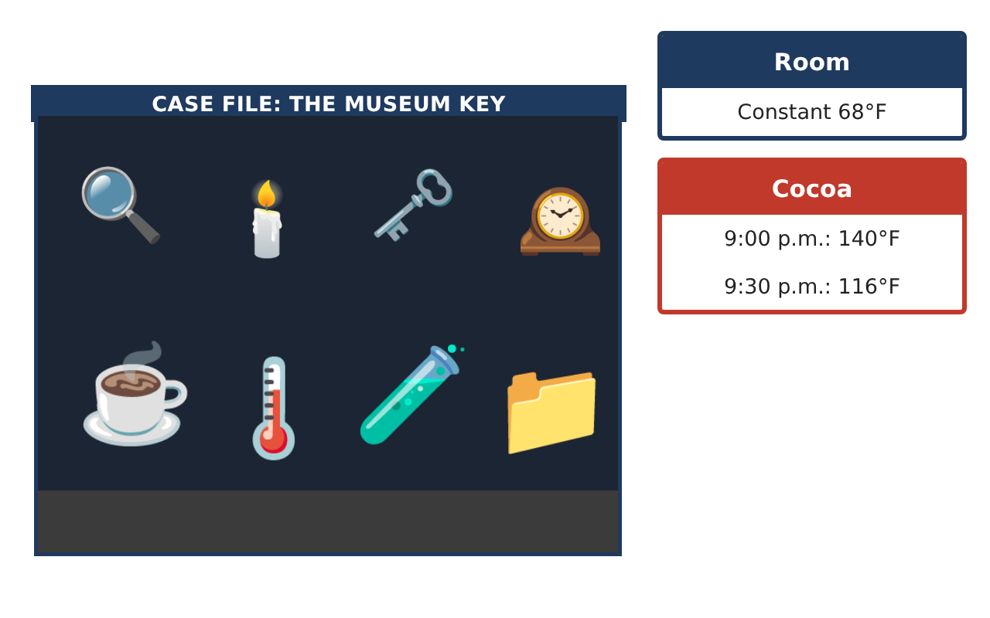
Learning Goals
- I can use slope fields and Euler’s method to approximate solutions.
- I can solve separable differential equations.
- I can apply exponential models to solve problems.
Project Timeline
When | What you will do
Day 1 | Euler’s Method
Day 2 | Separation of Variables
Day 3 | Case Analysis
Final | Case File Report + reflection
Part 1: Euler’s Method
Day 1 · $\frac{dT}{dt}$ = −0.0135(T − 68), T(0) = 140 at 9:00 p.m.
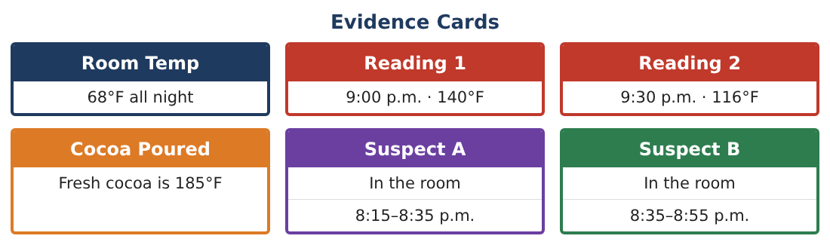
1. Use Euler’s method with Δt = 10 min to estimate T(30).

2. Compare with the measured 116°F. Is Euler’s estimate an over- or underestimate? Why?

3. Sketch the slope field and your Euler path.

4. Find $\frac{d²T}{dt²}$ in terms of T and use it to explain the concavity.

Part 2: Separation of Variables
Day 2 · Solve $\frac{dT}{dt}$ = −k(T − 68), T(0) = 140.
5. Separate and integrate to find the general solution.

6. Use T(0) = 140 and T(30) = 116 to find A and k.

7. Find when the cocoa was 185°F.

8. Find when the cocoa reaches 80°F.

Part 3: Case Analysis
Day 3 · Use the Evidence Cards.
9. The thermometer may be off by ±2°F at 9:30 (114–118°F). Find the range of possible pour times.

10. Does the uncertainty change which suspect is implicated?

11. Write the case file with the model, calculations, and conclusion.

Final Product: Case File Report
Your final product must include:
- Euler approximation with error discussion
- Separable solution with constants
- Pour time and later temperatures
- Uncertainty analysis
- Case file
Reflection
R1. Why does separation of variables give an exponential solution?

R2. How can measurement error affect a conclusion?

Scoring Rubric
Criteria | 4 – Exceeds | 3 – Meets | 2 – Approaching | 1 – Beginning
Mathematical Accuracy | All calculations and solutions are correct; answers include units and are checked. | Nearly all work is correct; minor errors do not change conclusions. | Several errors; some conclusions are affected. | Many errors or missing work.
Reasoning & Justification | Clear, complete explanations connect every answer to the situation; uses precise vocabulary. | Explanations are mostly clear and connected to the situation. | Explanations are brief or partly unclear. | Little or no explanation.
Application & Design | Differential equations are analyzed and solved correctly and used to reach a justified verdict. Goes beyond the minimum with a creative, realistic choice. | Differential equations are analyzed and solved correctly and used to reach a justified verdict. | Design is incomplete or only partly uses the math from the unit. | Design is missing or unrelated to the unit math.
Communication & Presentation | Case file includes the model, slope field, calculations, uncertainty, and verdict. Polished, organized, and visually engaging. | Case file includes the model, slope field, calculations, uncertainty, and verdict. Organized and easy to follow. | Product is missing required parts or is hard to follow. | Product is mostly missing.

