CALCULUS · UNIT 8: DIFFERENTIAL EQUATIONS  Cold Case: Newton’s Cooling  Use differential equations, slope fields, and Euler’s method to solve a mystery with Newton’s Law of Cooling. | Honors  2–3 class periods

Name: ________________________________ Date: ______________ Period: ______
The Scenario
A mug of cocoa was found on the desk of a missing museum key. The temperature of the cocoa was measured twice, and the room temperature is known. Newton’s Law of Cooling says the cocoa cools at a rate proportional to the difference between its temperature and the room.
You will use differential equations to decide when the cocoa was poured and which suspect was in the room at that time.
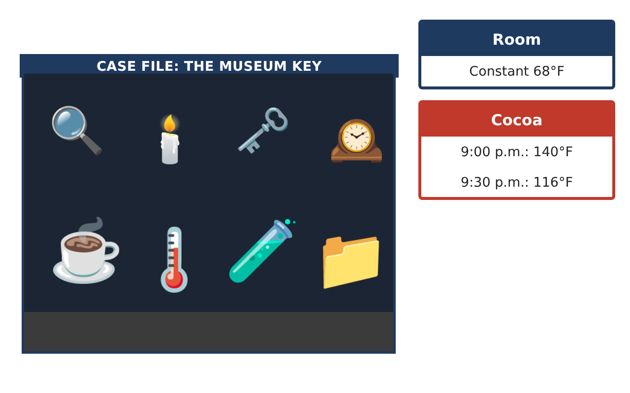
Learning Goals
- I can analyze differential equations qualitatively and analytically.
- I can solve separable equations with initial conditions, including logistic models.
- I can evaluate a model’s assumptions.
Project Timeline
When | What you will do
Day 1 | Qualitative Analysis
Day 2 | Analytic Solution
Day 3 | Verdict
Final | Case File Report + reflection
Part 1: Qualitative Analysis
Day 1 · $\frac{dT}{dt}$ = −k(T − R), R = room temperature.
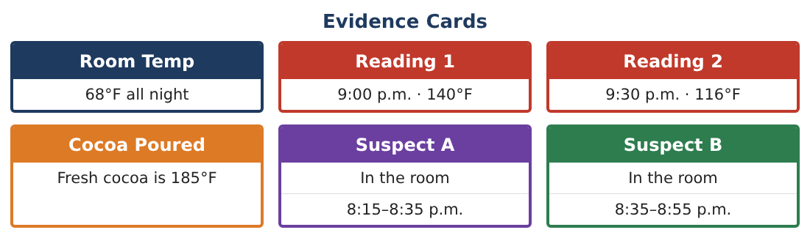
1. Classify the equilibrium T = R as stable or unstable. Explain with the slope field.

2. Show that every solution approaches R and find $\frac{dT}{dt}$ when T = R + 20 in terms of k.

3. Use Euler’s method with Δt = 15 min from T(0) = 140 to T(30) (k ≈ 0.0135). Find the error compared with 116.

4. Explain how halving Δt changes the error.

Part 2: Analytic Solution
Day 2 · Use the Evidence Cards.
5. Solve the IVP and find the pour time.

6. The room heater turned off at 9:00 p.m. and the room cooled: R(t) = 68 − 0.05t. Write the new differential equation. Why is it no longer separable?

7. Rumor spreads in the museum by the logistic model $\frac{dP}{dt}$ = 0.4P(1 − $\frac{P}{200}$), P(0) = 10. Find P(t).

8. When do half of the 200 staff know the rumor?

Part 3: Verdict
Day 3 · Combine the evidence.
9. Using the thermometer uncertainty (±2°F at 9:30), find the range of pour times.

10. Suspect A left at 8:35. Suspect B claims the cocoa was poured at 8:40. What temperature would the cocoa have had at 9:00 if poured at 8:40? Does this agree with the evidence?

11. Write the case file with the model, assumptions, uncertainty, and verdict.

Final Product: Case File Report
Your final product must include:
- Stability and slope-field analysis
- Euler error study
- Analytic solution and non-separable extension
- Logistic rumor model
- Case file with verdict
Reflection
R1. What assumptions does Newton’s Law of Cooling make?

R2. How does a logistic model differ from exponential growth?

Scoring Rubric
Criteria | 4 – Exceeds | 3 – Meets | 2 – Approaching | 1 – Beginning
Mathematical Accuracy | All calculations and solutions are correct; answers include units and are checked. | Nearly all work is correct; minor errors do not change conclusions. | Several errors; some conclusions are affected. | Many errors or missing work.
Reasoning & Justification | Clear, complete explanations connect every answer to the situation; uses precise vocabulary. | Explanations are mostly clear and connected to the situation. | Explanations are brief or partly unclear. | Little or no explanation.
Application & Design | Differential equations are analyzed and solved correctly and used to reach a justified verdict. Goes beyond the minimum with a creative, realistic choice. | Differential equations are analyzed and solved correctly and used to reach a justified verdict. | Design is incomplete or only partly uses the math from the unit. | Design is missing or unrelated to the unit math.
Communication & Presentation | Case file includes the model, slope field, calculations, uncertainty, and verdict. Polished, organized, and visually engaging. | Case file includes the model, slope field, calculations, uncertainty, and verdict. Organized and easy to follow. | Product is missing required parts or is hard to follow. | Product is mostly missing.

