CALCULUS · UNIT 7: APPLICATIONS OF INTEGRALS  Glass Vase Studio  Use area between curves and volumes of revolution to design glass vases and bottles. | CP1  2–3 class periods

Name: ________________________________ Date: ______________ Period: ______
The Scenario
Lumen Glass Studio makes vases, bottles, and paperweights. Each design is a curve spun around an axis, the logo is a region between two curves, and glass is priced by volume.
You will use integrals to calculate the area and volume of each design and price the products.
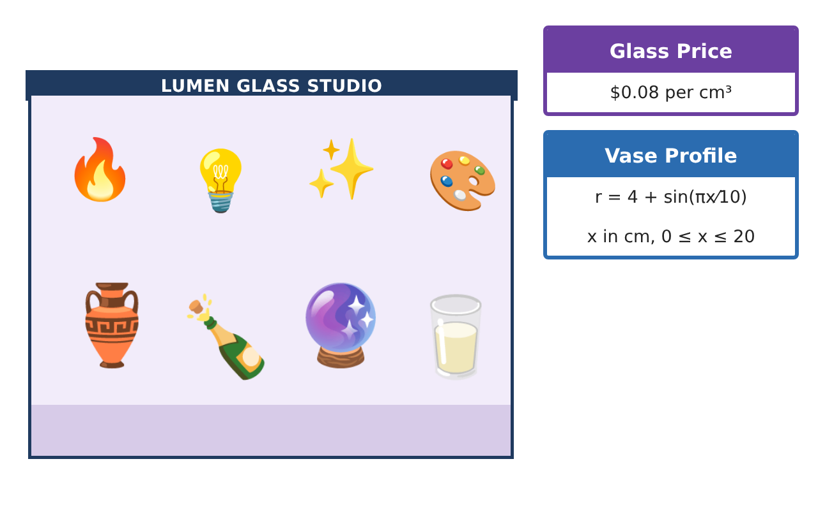
Learning Goals
- I can find areas between curves.
- I can find volumes with the disc and washer methods.
- I can find volumes with known cross sections.
Project Timeline
When | What you will do
Day 1 | Logo & Labels
Day 2 | Vases
Day 3 | Paperweight & Production
Final | Product Design Portfolio + reflection
Part 1: Logo & Labels
Day 1 · Use the Design Specification Cards.
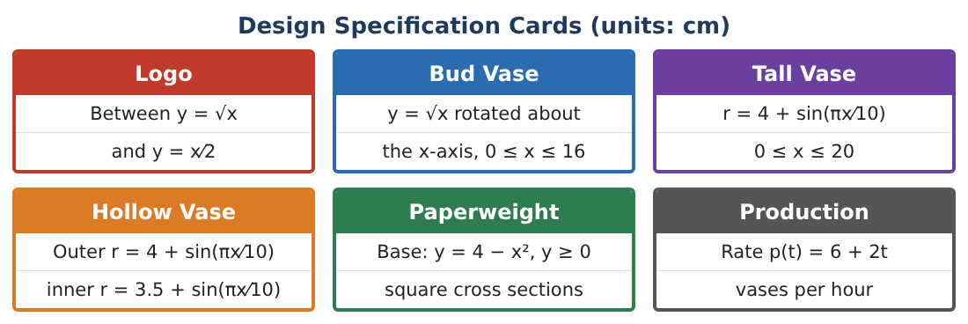
1. Find the area of the logo between y = √x and y = $\frac{x}{2}$.

2. Find the area of the same region by integrating with respect to y.

3. A label is the region between y = 4 − x² and y = x + 2. Find its area.

4. Explain when integrating in y is easier than in x.

Part 2: Vases
Day 2 · Use the Design Specification Cards.
5. Find the volume of the solid tall vase r = 4 + sin($\frac{πx}{10}$), 0 ≤ x ≤ 20.

6. Find the volume of glass in the hollow vase (washer method).

7. Find the glass cost of the hollow vase and the volume of water it holds.

8. Find the volume of the bud vase y = √x rotated about the x-axis for 0 ≤ x ≤ 16.

Part 3: Paperweight & Production
Day 3 · Base: region under y = 4 − x², above y = 0. Square cross sections perpendicular to the x-axis.
9. Find the volume of the paperweight.

10. Find the glass cost.

11. Production rate p(t) = 6 + 2t for 0 ≤ t ≤ 4. Find total vases and price the day’s glass if each is a hollow vase.

Final Product: Product Design Portfolio
Your final product must include:
- Logo and label areas (both methods)
- Solid and hollow vase volumes
- Paperweight cross-section volume
- Production and cost
- Design portfolio
Reflection
R1. How is the washer method related to the disc method?

R2. How do cross sections generalize volume?

Scoring Rubric
Criteria | 4 – Exceeds | 3 – Meets | 2 – Approaching | 1 – Beginning
Mathematical Accuracy | All calculations and solutions are correct; answers include units and are checked. | Nearly all work is correct; minor errors do not change conclusions. | Several errors; some conclusions are affected. | Many errors or missing work.
Reasoning & Justification | Clear, complete explanations connect every answer to the situation; uses precise vocabulary. | Explanations are mostly clear and connected to the situation. | Explanations are brief or partly unclear. | Little or no explanation.
Application & Design | Areas and volumes are set up and evaluated correctly and used to price and design products. Goes beyond the minimum with a creative, realistic choice. | Areas and volumes are set up and evaluated correctly and used to price and design products. | Design is incomplete or only partly uses the math from the unit. | Design is missing or unrelated to the unit math.
Communication & Presentation | Portfolio includes diagrams, integrals, results, and prices. Polished, organized, and visually engaging. | Portfolio includes diagrams, integrals, results, and prices. Organized and easy to follow. | Product is missing required parts or is hard to follow. | Product is mostly missing.

