CALCULUS · UNIT 7: APPLICATIONS OF INTEGRALS  Glass Vase Studio  Use area between curves and volumes of revolution to design glass vases and bottles. | Honors  2–3 class periods

Name: ________________________________ Date: ______________ Period: ______
The Scenario
Lumen Glass Studio makes vases, bottles, and paperweights. Each design is a curve spun around an axis, the logo is a region between two curves, and glass is priced by volume.
You will use integrals to calculate the area and volume of each design and price the products.
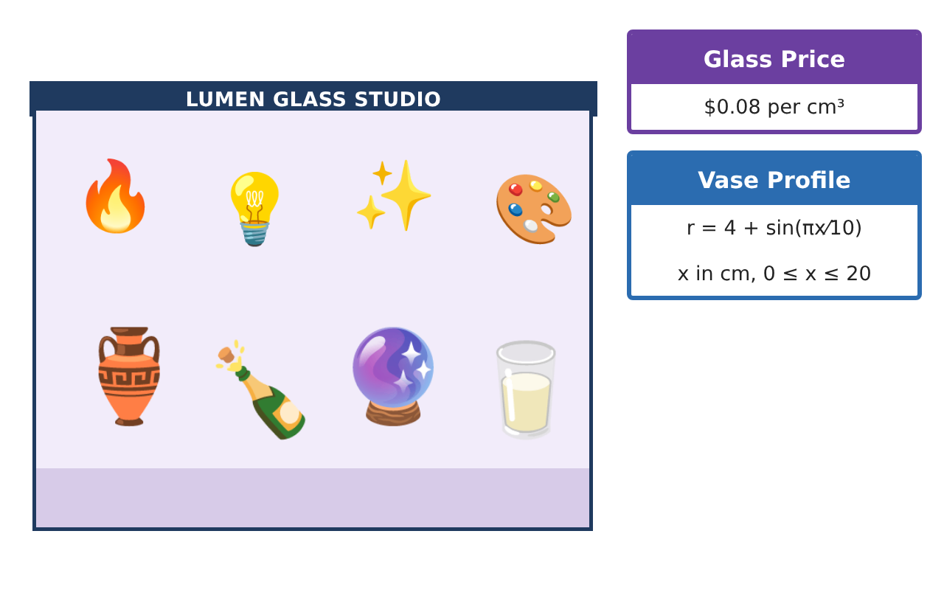
Learning Goals
- I can set up and evaluate area and volume integrals about any axis.
- I can compare methods and use technology appropriately.
- I can optimize a design using integral models.
Project Timeline
When | What you will do
Day 1 | Logo Design
Day 2 | Vase Engineering
Day 3 | Paperweights
Final | Product Design Portfolio + reflection
Part 1: Logo Design
Day 1 · Use the Design Specification Cards.
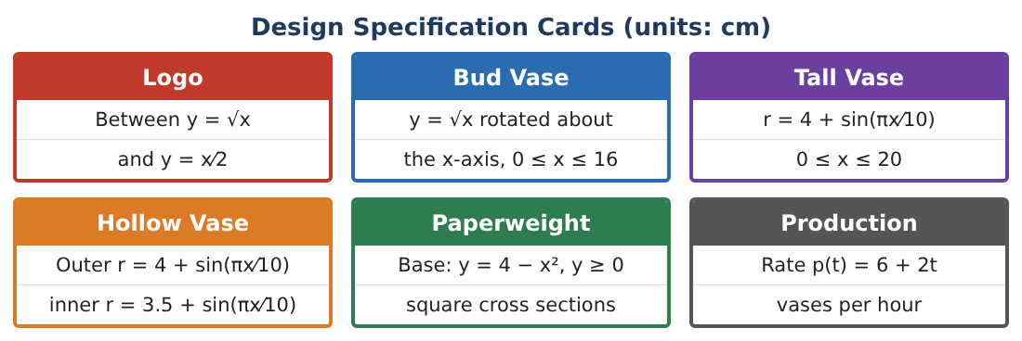
1. Find the area between y = √x and y = $\frac{x}{2}$ and the line x = 9 (two regions).

2. Find k so the vertical line x = k splits the logo (0 ≤ x ≤ 4) into two equal areas.

3. Rotate the logo about the x-axis. Find the volume (washer method).

4. Rotate the logo about the line y = −1. Find the volume.

Part 2: Vase Engineering
Day 2 · Hollow vase: outer 4 + s, inner 3.5 + s, s = sin($\frac{πx}{10}$), 0 ≤ x ≤ 20.
5. Find the glass volume and the inside (water) volume.

6. The wall thickness is changed to w (inner r = 4 − w + s). Write the glass volume as a function of w.

7. The vase must hold at least 850 cm³ of water. What is the greatest wall thickness allowed?

8. Find the glass cost for that thickness.

Part 3: Paperweights
Day 3 · Base under y = 4 − x², y ≥ 0.
9. Compare the volumes with square and semicircular cross sections perpendicular to the x-axis.

10. Rotate the base about the y-axis. Use the disc method in y to find the volume.

11. Write the design portfolio with three products, their integrals, volumes, and prices.

Final Product: Product Design Portfolio
Your final product must include:
- Logo areas including split and rotations
- Vase thickness optimization
- Paperweight comparisons
- Prices for each product
- Design portfolio
Reflection
R1. How does rotating about a different axis change the radius?

R2. Why did the water-volume requirement limit wall thickness?

Scoring Rubric
Criteria | 4 – Exceeds | 3 – Meets | 2 – Approaching | 1 – Beginning
Mathematical Accuracy | All calculations and solutions are correct; answers include units and are checked. | Nearly all work is correct; minor errors do not change conclusions. | Several errors; some conclusions are affected. | Many errors or missing work.
Reasoning & Justification | Clear, complete explanations connect every answer to the situation; uses precise vocabulary. | Explanations are mostly clear and connected to the situation. | Explanations are brief or partly unclear. | Little or no explanation.
Application & Design | Areas and volumes are set up and evaluated correctly and used to price and design products. Goes beyond the minimum with a creative, realistic choice. | Areas and volumes are set up and evaluated correctly and used to price and design products. | Design is incomplete or only partly uses the math from the unit. | Design is missing or unrelated to the unit math.
Communication & Presentation | Portfolio includes diagrams, integrals, results, and prices. Polished, organized, and visually engaging. | Portfolio includes diagrams, integrals, results, and prices. Organized and easy to follow. | Product is missing required parts or is hard to follow. | Product is mostly missing.

