CALCULUS · UNIT 4: APPLICATIONS OF DERIVATIVES  Package Design Studio  Use optimization, related rates, and curve analysis to design packaging for a juice company. | CP2  2–3 class periods

Name: ________________________________ Date: ______________ Period: ______
The Scenario
Fresh Squeeze Juice is launching a new drink and needs packaging that uses as little material as possible. The bottling plant fills cone-shaped tanks, and the marketing team wants to understand the sales curve.
You will use derivatives to design the package, control the filling process, and analyze sales.
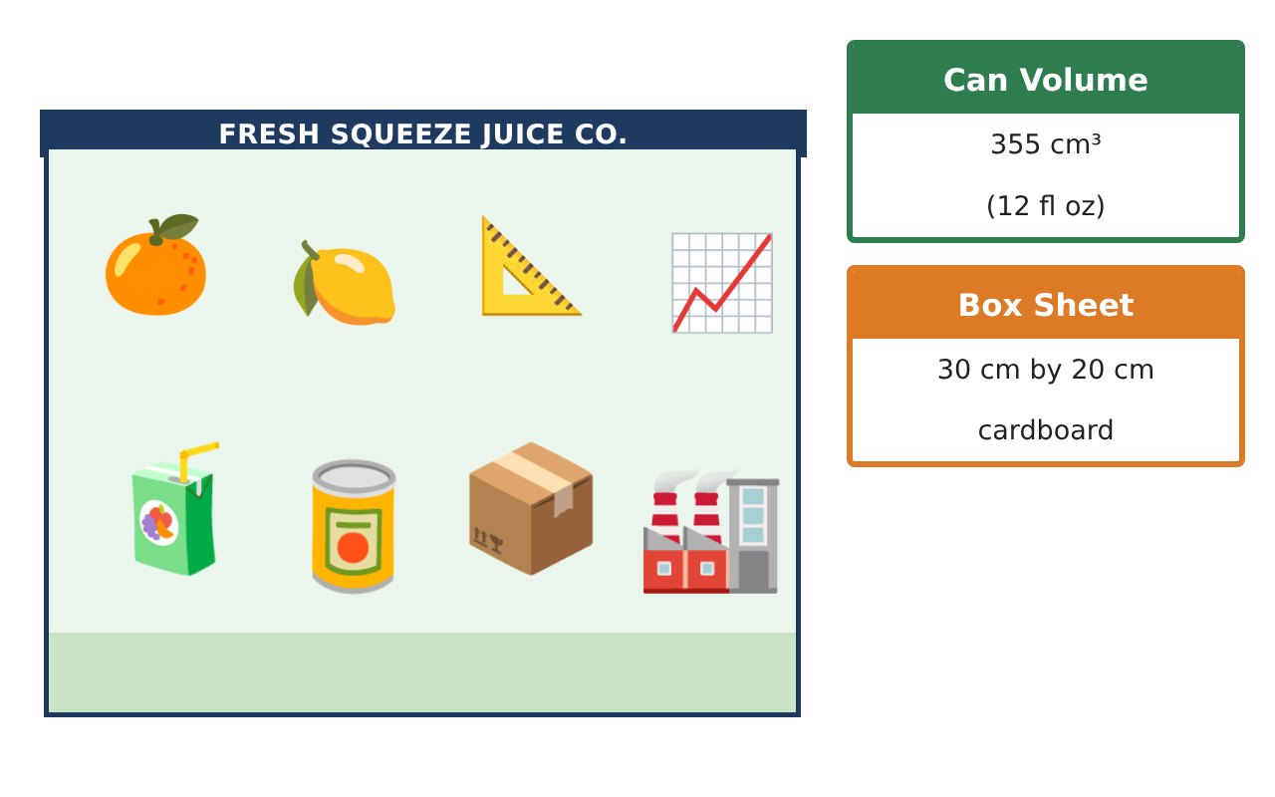
Learning Goals
- I can find critical points and use them to find maximums and minimums.
- I can use related rates with a given formula.
- I can describe where a function increases and decreases.
Project Timeline
When | What you will do
Day 1 | Open Box
Day 2 | Filling the Tank
Day 3 | Sales Curve
Final | Design Proposal + reflection
Part 1: Open Box
Day 1 · Cut squares of side x from each corner of a 30 cm by 20 cm sheet and fold up the sides.
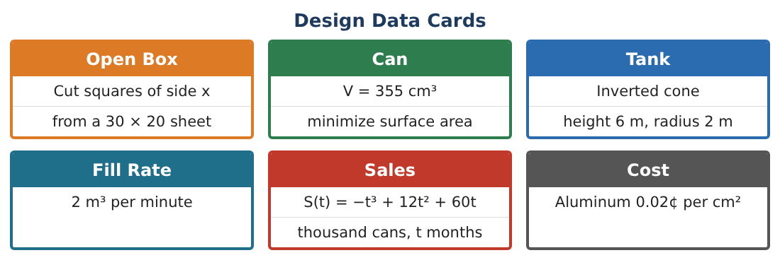
1. Write the volume V(x) = x(30 − 2x)(20 − 2x).
Starter: Multiply out x(30 − 2x)(20 − 2x)

2. What is the domain of x?

3. Find V′(x) and the critical point in the domain.

4. Find the maximum volume.

Part 2: Filling the Tank
Day 2 · Juice fills a tank at 2 m³ per minute.
5. A cylinder tank has radius 2 m, so V = 4πh. Find $\frac{dh}{dt}$.

6. Explain why $\frac{dh}{dt}$ is constant for a cylinder.

7. A cone tank fills faster at the bottom. Explain why using its shape.

8. If juice drains at 0.5 m³/min while filling at 2 m³/min, what is the net $\frac{dV}{dt}$?

Part 3: Sales Curve
Day 3 · S(t) = −t³ + 12t² + 60t (thousand cans).
9. Find S′(t) and when sales are increasing on 0 ≤ t ≤ 12.

10. When are total sales at a maximum? Find the value.

11. Write one recommendation for the company using your results.

Final Product: Design Proposal
Your final product must include:
- Optimal box with justification
- Tank rate calculations
- Sales analysis
- One recommendation
- Design proposal
Reflection
R1. Why do you check the endpoints and critical points?

R2. What does S′(t) = 0 mean for sales?

Scoring Rubric
Criteria | 4 – Exceeds | 3 – Meets | 2 – Approaching | 1 – Beginning
Mathematical Accuracy | All calculations and solutions are correct; answers include units and are checked. | Nearly all work is correct; minor errors do not change conclusions. | Several errors; some conclusions are affected. | Many errors or missing work.
Reasoning & Justification | Clear, complete explanations connect every answer to the situation; uses precise vocabulary. | Explanations are mostly clear and connected to the situation. | Explanations are brief or partly unclear. | Little or no explanation.
Application & Design | Optimization, related rates, and curve analysis are set up, solved, and justified correctly. Goes beyond the minimum with a creative, realistic choice. | Optimization, related rates, and curve analysis are set up, solved, and justified correctly. | Design is incomplete or only partly uses the math from the unit. | Design is missing or unrelated to the unit math.
Communication & Presentation | Proposal includes diagrams, derivative work, justifications, and recommendations. Polished, organized, and visually engaging. | Proposal includes diagrams, derivative work, justifications, and recommendations. Organized and easy to follow. | Product is missing required parts or is hard to follow. | Product is mostly missing.

