CALCULUS · UNIT 4: APPLICATIONS OF DERIVATIVES  Package Design Studio  Use optimization, related rates, and curve analysis to design packaging for a juice company. | Honors  2–3 class periods

Name: ________________________________ Date: ______________ Period: ______
The Scenario
Fresh Squeeze Juice is launching a new drink and needs packaging that uses as little material as possible. The bottling plant fills cone-shaped tanks, and the marketing team wants to understand the sales curve.
You will use derivatives to design the package, control the filling process, and analyze sales.
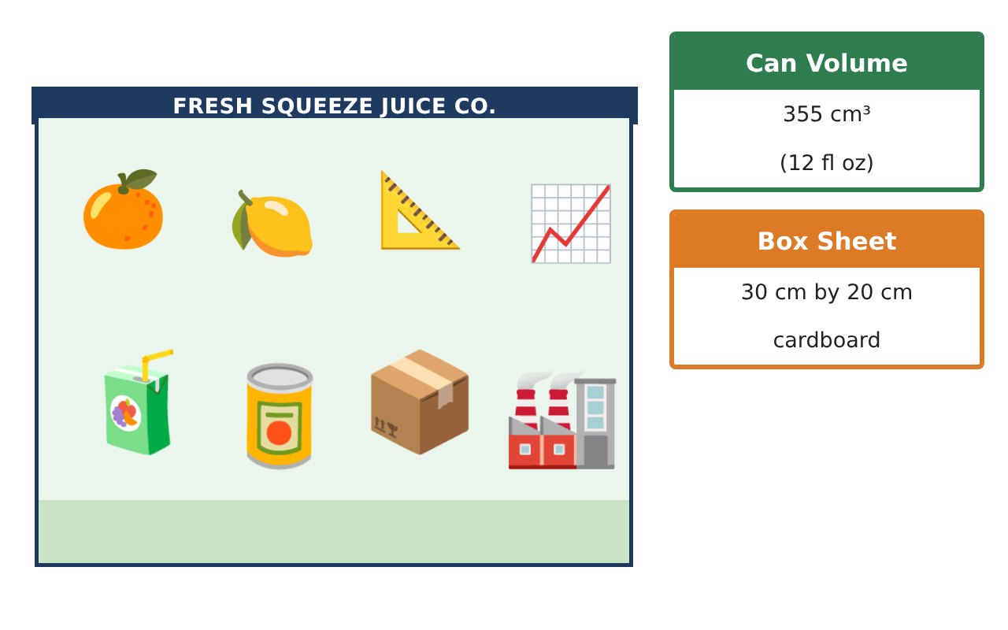
Learning Goals
- I can model and solve optimization problems with constraints and costs.
- I can solve related-rates problems with changing geometry.
- I can use derivatives, theorems, and linearization to justify conclusions.
Project Timeline
When | What you will do
Day 1 | Cost Optimization
Day 2 | Tank Dynamics
Day 3 | Sales Theorems
Final | Design Proposal + reflection
Part 1: Cost Optimization
Day 1 · A 355 cm³ can. The top and bottom are thicker and cost 0.05¢ per cm²; the side costs 0.02¢ per cm².
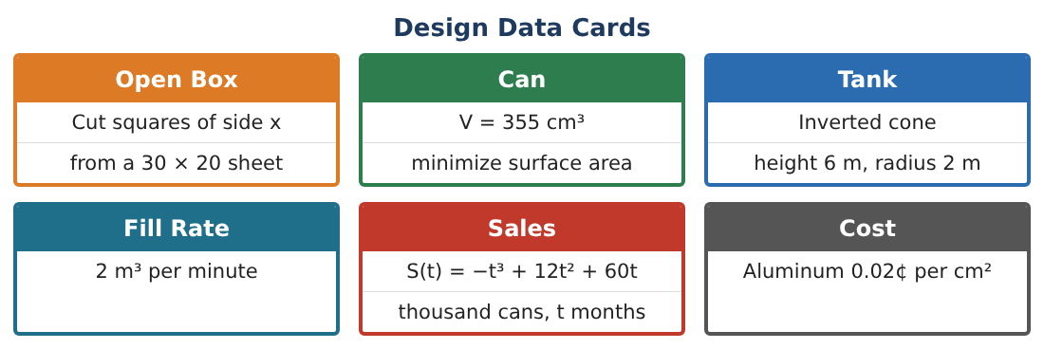
1. Write the cost C(r).

2. Find the radius that minimizes cost and the height.

3. Compare with the minimum-area can. Why is the cost-optimal can taller?

4. Find the minimum cost per can and the savings per million cans versus r = 3.84 cm.

Part 2: Tank Dynamics
Day 2 · Inverted cone h = 6 m, r = 2 m. Fills at 2 m³/min and leaks at 0.1h m³/min.
5. Write $\frac{dV}{dt}$ and then $\frac{dh}{dt}$ as a function of h.

6. Find $\frac{dh}{dt}$ when h = 3 m.

7. Is there a height where the level stops rising? Is it inside the tank?

8. Use linearization of V(h) = $\frac{πh³}{27}$ at h = 3 to estimate the volume added when h goes from 3 to 3.1 m.

Part 3: Sales Theorems
Day 3 · S(t) = −t³ + 12t² + 60t, 0 ≤ t ≤ 12.
9. Use the EVT to find the absolute max and min of S on [0, 12].

10. Find the maximum of the growth rate S′ on [0, 12] and justify it.

11. Write the design proposal: can dimensions, tank controls, and the sales timeline, each justified with calculus.

Final Product: Design Proposal
Your final product must include:
- Cost-optimized can with comparison
- Tank model with leak and linearization
- EVT and growth-rate analysis
- Savings estimate
- Design proposal
Reflection
R1. How did changing the cost structure change the optimal shape?

R2. Why does linearization work well for small changes?

Scoring Rubric
Criteria | 4 – Exceeds | 3 – Meets | 2 – Approaching | 1 – Beginning
Mathematical Accuracy | All calculations and solutions are correct; answers include units and are checked. | Nearly all work is correct; minor errors do not change conclusions. | Several errors; some conclusions are affected. | Many errors or missing work.
Reasoning & Justification | Clear, complete explanations connect every answer to the situation; uses precise vocabulary. | Explanations are mostly clear and connected to the situation. | Explanations are brief or partly unclear. | Little or no explanation.
Application & Design | Optimization, related rates, and curve analysis are set up, solved, and justified correctly. Goes beyond the minimum with a creative, realistic choice. | Optimization, related rates, and curve analysis are set up, solved, and justified correctly. | Design is incomplete or only partly uses the math from the unit. | Design is missing or unrelated to the unit math.
Communication & Presentation | Proposal includes diagrams, derivative work, justifications, and recommendations. Polished, organized, and visually engaging. | Proposal includes diagrams, derivative work, justifications, and recommendations. Organized and easy to follow. | Product is missing required parts or is hard to follow. | Product is mostly missing.

