CALCULUS · UNIT 1: PRECALCULUS REVIEW  Phone Battery Lab  Review function families by modeling a phone’s battery, charging, and app data. | Honors  2–3 class periods

Name: ________________________________ Date: ______________ Period: ______
The Scenario
A phone company wants a student lab to test its new phone. The battery drains while streaming, charges quickly at first and then slowly, the screen brightness follows the sunlight, and the data plan has a price that changes after a limit.
You will use the function families you need for calculus to model the phone and answer the company’s questions.
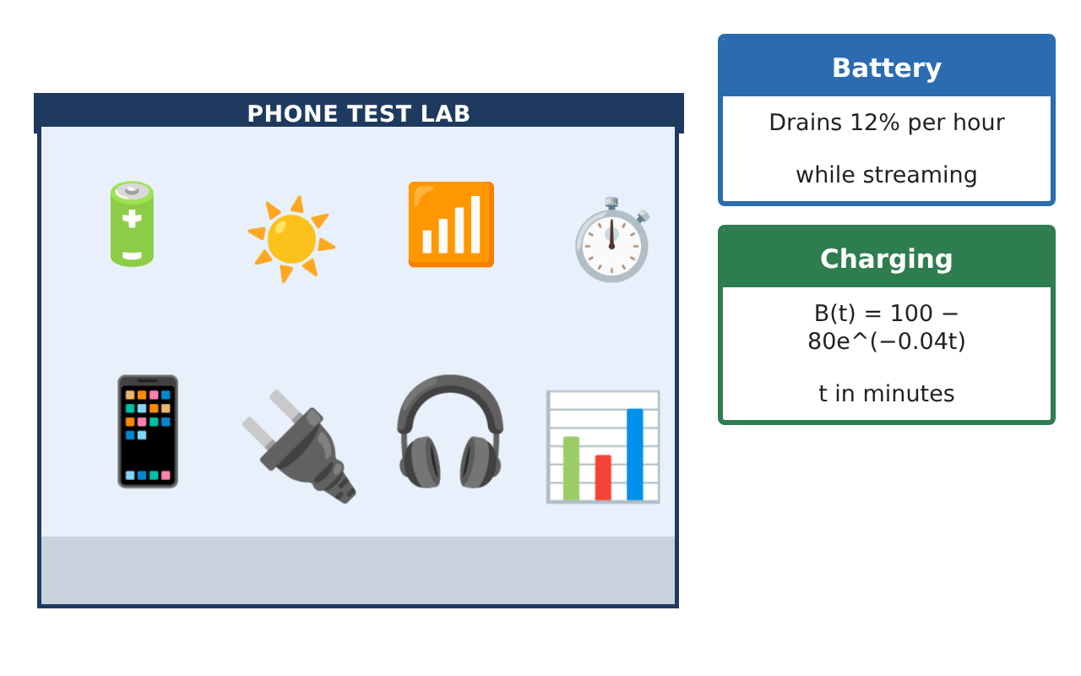
Learning Goals
- I can model with function families and analyze their behavior.
- I can use rates of change and limits informally.
- I can justify model choices with data and reasoning.
Project Timeline
When | What you will do
Day 1 | Model Analysis
Day 2 | Composite Models
Day 3 | Brightness & Rates
Final | Battery Lab Report + reflection
Part 1: Model Analysis
Day 1 · Use the Lab Data Cards.
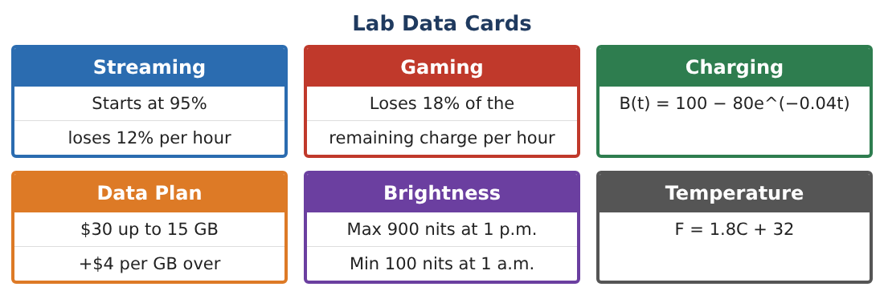
1. Show algebraically that B(t) never reaches 100.

2. Find the time for B to go from 50% to 90% and compare with 20% to 50%.

3. Estimate the instantaneous rate of change of B at t = 30 using a symmetric difference with h = 0.1.

4. As h → 0, what value do the difference quotients for B at t = 0 approach? Use h = 1, 0.1, 0.01.

Part 2: Composite Models
Day 2 · Combine functions.
5. The phone’s temperature in °C while charging is C(B) = 25 + 0.12B. Find C(B(t)) and its value at t = 60.

6. Find the inverse of S(t) = 95 − 12t and of G(t) = 95(0.82)ᵗ.

7. Gaming drains 18% per hour. Find the equivalent continuous rate k in G = 95eᵏᵗ.

8. Explain why the streaming model eventually gives impossible values but the gaming model does not.

Part 3: Brightness & Rates
Day 3 · L(t) = 400 cos($\frac{π}{12}$(t − 13)) + 500.
9. Find the average rate of change of L from 7 a.m. to 9 a.m. and from 12 p.m. to 2 p.m. Explain the difference.

10. Estimate when brightness changes fastest. Justify with the graph.

11. Write the lab report with a model for each phone feature and one question calculus could answer next.

Final Product: Battery Lab Report
Your final product must include:
- Charging analysis with difference quotients
- Composite temperature model
- Inverse and continuous-rate forms
- Brightness rates of change
- Lab report with next questions
Reflection
R1. How do difference quotients preview the derivative?

R2. Why choose exponential rather than linear models for charging?

Scoring Rubric
Criteria | 4 – Exceeds | 3 – Meets | 2 – Approaching | 1 – Beginning
Mathematical Accuracy | All calculations and solutions are correct; answers include units and are checked. | Nearly all work is correct; minor errors do not change conclusions. | Several errors; some conclusions are affected. | Many errors or missing work.
Reasoning & Justification | Clear, complete explanations connect every answer to the situation; uses precise vocabulary. | Explanations are mostly clear and connected to the situation. | Explanations are brief or partly unclear. | Little or no explanation.
Application & Design | Models for battery, charging, plans, and brightness are built and used correctly. Goes beyond the minimum with a creative, realistic choice. | Models for battery, charging, plans, and brightness are built and used correctly. | Design is incomplete or only partly uses the math from the unit. | Design is missing or unrelated to the unit math.
Communication & Presentation | Lab report includes models, graphs, calculations, and conclusions. Polished, organized, and visually engaging. | Lab report includes models, graphs, calculations, and conclusions. Organized and easy to follow. | Product is missing required parts or is hard to follow. | Product is mostly missing.

