CALCULUS · UNIT 5: ANTIDERIVATIVES AND DEFINITE INTEGRALS  Solar Energy Audit  Use Riemann sums, antiderivatives, and definite integrals to measure a school’s solar energy. | CP1  2–3 class periods

Name: ________________________________ Date: ______________ Period: ______
The Scenario
Your school installed solar panels on the roof. A meter records the power output (in kilowatts) every two hours, but the principal wants to know the total energy (in kilowatt-hours) produced each day.
Energy is the accumulation of power over time. You will estimate and calculate it with Riemann sums and integrals.
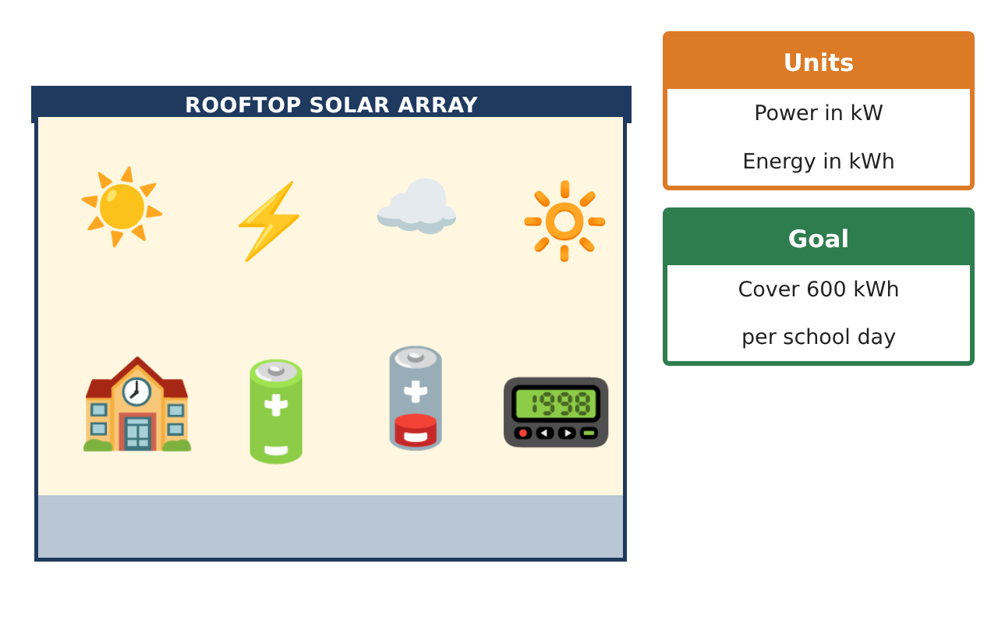
Learning Goals
- I can approximate definite integrals with Riemann and trapezoidal sums.
- I can find antiderivatives and evaluate definite integrals.
- I can use properties of definite integrals.
Project Timeline
When | What you will do
Day 1 | Data Sums
Day 2 | Antiderivatives & Integrals
Day 3 | Upgrade Plan
Final | Energy Audit Report + reflection
Part 1: Data Sums
Day 1 · Use the Power Meter Readings (Δt = 2 h).

1. Find the left, right, and trapezoidal sums.

2. Use a midpoint sum with 3 intervals of 4 hours (midpoints 8 a.m., 12 p.m., 4 p.m.).

3. Power increases from 6 a.m. to noon. On that interval, is the left sum an over- or under-estimate? Why?

4. Write the energy from 6 a.m. to 6 p.m. as a definite integral using P(t).

Part 2: Antiderivatives & Integrals
Day 2 · P(t) = 72 − 2(t − 6)², t hours after 6 a.m.
5. Expand P(t) and find an antiderivative.

6. Find the energy from 6 a.m. to 12 p.m. and from 12 p.m. to 6 p.m.

7. Use properties to find ∫₀¹² P(t) dt from the two halves.

8. Find ∫₁₂⁰ P(t) dt and explain the sign.

Part 3: Upgrade Plan
Day 3 · Goal: 600 kWh per day.
9. If each new panel adds 4% to P(t), how many panels are needed so ∫₀¹² P dt ≥ 600?

10. A cloudy day has power 0.6P(t). Find the energy and the shortfall.

11. Write the audit report with a graph, sums, and integrals.

Final Product: Energy Audit Report
Your final product must include:
- Four Riemann-type estimates
- Antiderivative and definite integrals
- Integral properties
- Upgrade plan
- Audit report
Reflection
R1. How do Riemann sums connect to definite integrals?

R2. Why is the midpoint sum often more accurate?

Scoring Rubric
Criteria | 4 – Exceeds | 3 – Meets | 2 – Approaching | 1 – Beginning
Mathematical Accuracy | All calculations and solutions are correct; answers include units and are checked. | Nearly all work is correct; minor errors do not change conclusions. | Several errors; some conclusions are affected. | Many errors or missing work.
Reasoning & Justification | Clear, complete explanations connect every answer to the situation; uses precise vocabulary. | Explanations are mostly clear and connected to the situation. | Explanations are brief or partly unclear. | Little or no explanation.
Application & Design | Riemann sums, antiderivatives, and definite integrals are computed correctly and used to judge the energy goal. Goes beyond the minimum with a creative, realistic choice. | Riemann sums, antiderivatives, and definite integrals are computed correctly and used to judge the energy goal. | Design is incomplete or only partly uses the math from the unit. | Design is missing or unrelated to the unit math.
Communication & Presentation | Audit report includes data, sums, integrals, graphs, and a recommendation. Polished, organized, and visually engaging. | Audit report includes data, sums, integrals, graphs, and a recommendation. Organized and easy to follow. | Product is missing required parts or is hard to follow. | Product is mostly missing.

