CALCULUS · UNIT 5: ANTIDERIVATIVES AND DEFINITE INTEGRALS  Solar Energy Audit  Use Riemann sums, antiderivatives, and definite integrals to measure a school’s solar energy. | CP2  2–3 class periods

Name: ________________________________ Date: ______________ Period: ______
The Scenario
Your school installed solar panels on the roof. A meter records the power output (in kilowatts) every two hours, but the principal wants to know the total energy (in kilowatt-hours) produced each day.
Energy is the accumulation of power over time. You will estimate and calculate it with Riemann sums and integrals.
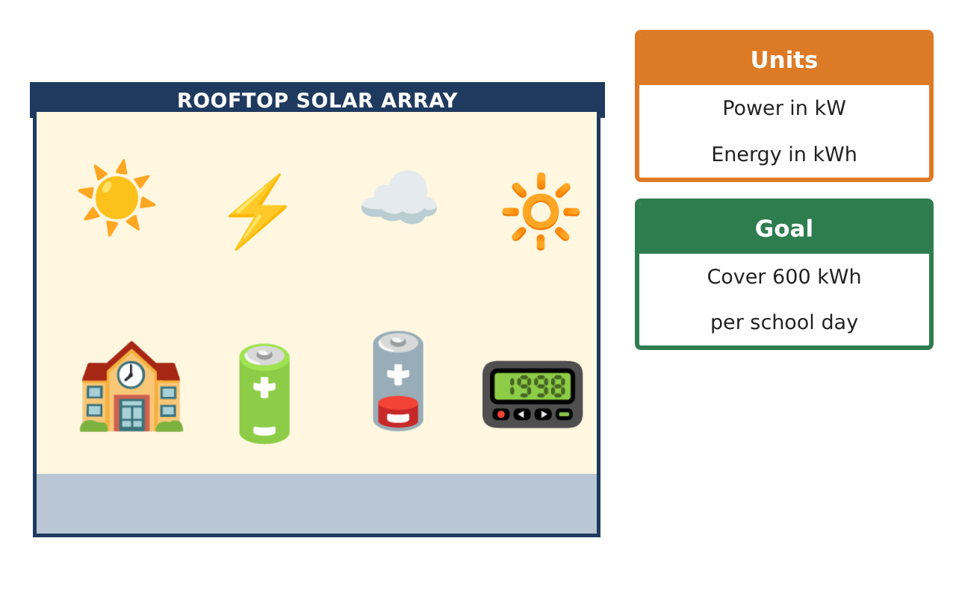
Learning Goals
- I can estimate accumulated energy with Riemann sums.
- I can find basic antiderivatives.
- I can evaluate a definite integral with an antiderivative.
Project Timeline
When | What you will do
Day 1 | Estimate the Energy
Day 2 | Antiderivatives
Day 3 | Power Model
Final | Energy Audit Report + reflection
Part 1: Estimate the Energy
Day 1 · Use the Power Meter Readings. Each interval is 2 hours.
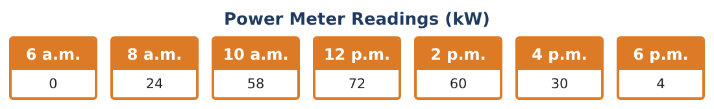
1. Find the left Riemann sum for 6 a.m. to 6 p.m.
Starter: 2 × (sum of the left readings)

2. Find the right Riemann sum.

3. Find the trapezoidal sum (average of left and right).

4. Is the school reaching its 600 kWh goal? By how much is it short?

Part 2: Antiderivatives
Day 2 · Find each antiderivative.
5. ∫ 6x² dx

6. ∫ (4x − 3) dx

7. ∫ cos x dx

8. Why do we add + C?

Part 3: Power Model
Day 3 · A model for the power is P(t) = 72 − 2(t − 6)² kW, where t is hours after 6 a.m. (0 ≤ t ≤ 12).
9. Find P(0), P(6), and P(12).

10. Evaluate ∫₀¹² P(t) dt = ∫₀¹² (72 − 2(t − 6)²) dt.

11. Compare the model with your trapezoidal estimate and recommend whether to add panels.

Final Product: Energy Audit Report
Your final product must include:
- Left, right, and trapezoidal sums
- Antiderivatives with + C
- Definite integral of the power model
- Comparison with the goal
- Energy audit report
Reflection
R1. Why does the area under a power graph give energy?

R2. Why are left and right sums different?

Scoring Rubric
Criteria | 4 – Exceeds | 3 – Meets | 2 – Approaching | 1 – Beginning
Mathematical Accuracy | All calculations and solutions are correct; answers include units and are checked. | Nearly all work is correct; minor errors do not change conclusions. | Several errors; some conclusions are affected. | Many errors or missing work.
Reasoning & Justification | Clear, complete explanations connect every answer to the situation; uses precise vocabulary. | Explanations are mostly clear and connected to the situation. | Explanations are brief or partly unclear. | Little or no explanation.
Application & Design | Riemann sums, antiderivatives, and definite integrals are computed correctly and used to judge the energy goal. Goes beyond the minimum with a creative, realistic choice. | Riemann sums, antiderivatives, and definite integrals are computed correctly and used to judge the energy goal. | Design is incomplete or only partly uses the math from the unit. | Design is missing or unrelated to the unit math.
Communication & Presentation | Audit report includes data, sums, integrals, graphs, and a recommendation. Polished, organized, and visually engaging. | Audit report includes data, sums, integrals, graphs, and a recommendation. Organized and easy to follow. | Product is missing required parts or is hard to follow. | Product is mostly missing.

