CALCULUS · UNIT 5: ANTIDERIVATIVES AND DEFINITE INTEGRALS  Solar Energy Audit  Use Riemann sums, antiderivatives, and definite integrals to measure a school’s solar energy. | Honors  2–3 class periods

Name: ________________________________ Date: ______________ Period: ______
The Scenario
Your school installed solar panels on the roof. A meter records the power output (in kilowatts) every two hours, but the principal wants to know the total energy (in kilowatt-hours) produced each day.
Energy is the accumulation of power over time. You will estimate and calculate it with Riemann sums and integrals.
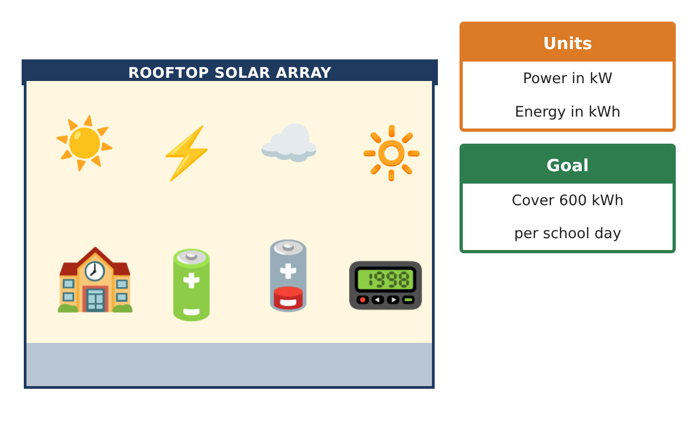
Learning Goals
- I can analyze Riemann sums and their error.
- I can evaluate integrals using antiderivatives and u-substitution.
- I can build and compare integral models.
Project Timeline
When | What you will do
Day 1 | Error Analysis
Day 2 | Better Models
Day 3 | Upgrade Analysis
Final | Energy Audit Report + reflection
Part 1: Error Analysis
Day 1 · Use the Power Meter Readings and P(t) = −2t² + 24t.

1. Compute the trapezoidal sum with the data and with the model values at t = 0, 2, …, 12.

2. Find the exact integral of the model and the error of the model’s trapezoidal sum. Why is it an underestimate?

3. Write the limit of a right Riemann sum that equals ∫₀¹² (−2t² + 24t) dt.

4. Which data reading disagrees most with the model? What might explain it?

Part 2: Better Models
Day 2 · A bell-shaped model: Q(t) = 72 sin($\frac{πt}{12}$) kW.
5. Find ∫₀¹² 72 sin($\frac{πt}{12}$) dt using substitution.

6. Compare Q with the data at 8 a.m. and 4 p.m. Which model fits better?

7. Find ∫ t e^(−t²) dt using u-substitution and explain each step.

8. Find the average power over the day using Q.

Part 3: Upgrade Analysis
Day 3 · Goal: 600 kWh per day using model Q.
9. How many 4% panels are needed so the energy reaches 600 kWh?

10. Battery storage starts charging when power exceeds 40 kW. Find when Q(t) > 40 and the energy above 40 kW.

11. Write the audit report comparing the models, with error analysis and your recommendation.

Final Product: Energy Audit Report
Your final product must include:
- Trapezoid error analysis
- Limit-of-sums definition
- Sine model with u-substitution
- Upgrade and storage analysis
- Audit report
Reflection
R1. How does concavity tell you whether a trapezoidal sum over- or underestimates?

R2. Why choose one model over another when both are reasonable?

Scoring Rubric
Criteria | 4 – Exceeds | 3 – Meets | 2 – Approaching | 1 – Beginning
Mathematical Accuracy | All calculations and solutions are correct; answers include units and are checked. | Nearly all work is correct; minor errors do not change conclusions. | Several errors; some conclusions are affected. | Many errors or missing work.
Reasoning & Justification | Clear, complete explanations connect every answer to the situation; uses precise vocabulary. | Explanations are mostly clear and connected to the situation. | Explanations are brief or partly unclear. | Little or no explanation.
Application & Design | Riemann sums, antiderivatives, and definite integrals are computed correctly and used to judge the energy goal. Goes beyond the minimum with a creative, realistic choice. | Riemann sums, antiderivatives, and definite integrals are computed correctly and used to judge the energy goal. | Design is incomplete or only partly uses the math from the unit. | Design is missing or unrelated to the unit math.
Communication & Presentation | Audit report includes data, sums, integrals, graphs, and a recommendation. Polished, organized, and visually engaging. | Audit report includes data, sums, integrals, graphs, and a recommendation. Organized and easy to follow. | Product is missing required parts or is hard to follow. | Product is mostly missing.

