CALCULUS · UNIT 9: AP CALCULUS REVIEW  Water Park Engineering  Review AP Calculus by engineering a water park: rates, motion, accumulation, area, volume, and differential equations. | Honors  2–3 class periods

Name: ________________________________ Date: ______________ Period: ______
The Scenario
Splash Valley Water Park is opening next summer and has hired your engineering team. The pool fills from pumps, rafts float down the lazy river, the wave pool has a curved shape, and the chlorine must stay safe.
Each part of the project is written like an AP free-response question. Show every setup, use correct units, and justify your answers.
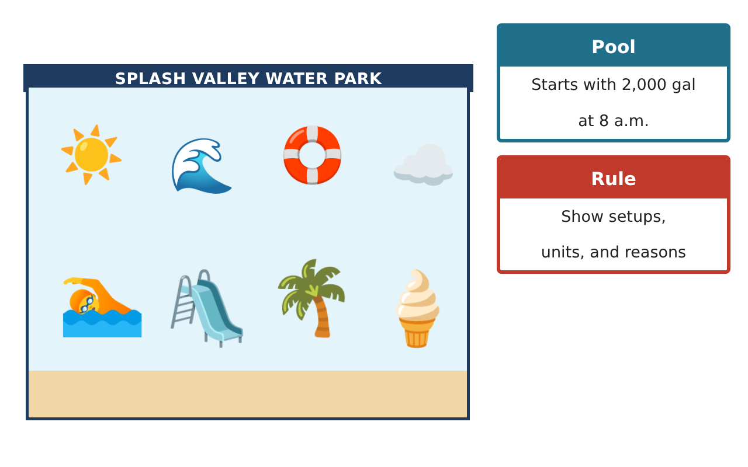
Learning Goals
- I can answer AP-style questions with complete justification.
- I can connect rates, accumulation, motion, geometry, and differential equations.
- I can write and solve my own AP-style question.
Project Timeline
When | What you will do
Day 1 | Pool Accumulation
Day 2 | Raft Motion
Day 3 | Design Your Own FRQ
Final | AP-Style Engineering Portfolio + reflection
Part 1: Pool Accumulation
Day 1 · Pump Rate Table; drain D(t) = 100 + 0.5t gal/min; W(0) = 2,000 gal.
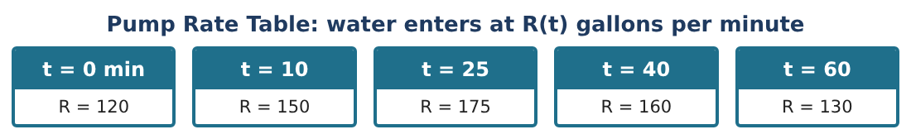
1. Write W(t) as an expression involving an integral.

2. Estimate W(60) using a right Riemann sum for R.

3. Find the time on [0, 60] when W is greatest, given R(t) − D(t) > 0 on (0, 52) and < 0 on (52, 60). Justify.

4. Find the average rate of draining over 0 ≤ t ≤ 60.

Part 2: Raft Motion
Day 2 · v(t) = 3 sin($\frac{πt}{6}$) ft/min, x(0) = 0. A second raft has position y(t) = 0.2t² − t.
5. Find all times in (0, 12) when the first raft’s speed is increasing.

6. Find the distance between the rafts at t = 6.

7. Is there a time when the rafts have the same velocity? Justify with the IVT.

8. Find the average velocity of the first raft from t = 0 to t = 9.

Part 3: Design Your Own FRQ
Day 3 · Wave pool between y = 9 − x² and y = x + 3; chlorine $\frac{dC}{dt}$ = −0.2C + 0.3 (a feeder adds chlorine).
9. Find the volume if cross sections perpendicular to the x-axis are semicircles.

10. Find the equilibrium chlorine level and solve with C(0) = 3. Is the level safe (1 to 3 ppm) in the long run?

11. Write and solve your own four-part AP-style question about the park, with a scoring guide.

Final Product: AP-Style Engineering Portfolio
Your final product must include:
- Accumulation function with justification
- Motion analysis of two rafts
- Semicircle cross-section volume
- Chlorine differential equation with equilibrium
- Your own FRQ with a scoring guide
Reflection
R1. What makes a justification complete on the AP exam?

R2. How do the big ideas of calculus (rates and accumulation) connect in this project?

Scoring Rubric
Criteria | 4 – Exceeds | 3 – Meets | 2 – Approaching | 1 – Beginning
Mathematical Accuracy | All calculations and solutions are correct; answers include units and are checked. | Nearly all work is correct; minor errors do not change conclusions. | Several errors; some conclusions are affected. | Many errors or missing work.
Reasoning & Justification | Clear, complete explanations connect every answer to the situation; uses precise vocabulary. | Explanations are mostly clear and connected to the situation. | Explanations are brief or partly unclear. | Little or no explanation.
Application & Design | Each AP-style part is set up and solved correctly with units and justifications. Goes beyond the minimum with a creative, realistic choice. | Each AP-style part is set up and solved correctly with units and justifications. | Design is incomplete or only partly uses the math from the unit. | Design is missing or unrelated to the unit math.
Communication & Presentation | Portfolio presents every part clearly with setups, answers, units, and reasoning. Polished, organized, and visually engaging. | Portfolio presents every part clearly with setups, answers, units, and reasoning. Organized and easy to follow. | Product is missing required parts or is hard to follow. | Product is mostly missing.

