6TH GRADE MATH · UNIT 4: EXPRESSIONS AND EQUATIONS  Arcade Party Planner  Write expressions and solve equations to plan a birthday party at the arcade. | CP2  2–3 class periods

Name: ________________________________ Date: ______________ Period: ______
The Scenario
Your cousin wants a birthday party at Pixel Palace Arcade. Each guest needs a game card, the party room costs a flat fee, and prizes are bought with tickets.
You will write expressions and solve equations to compare party packages and plan a party that fits the budget.
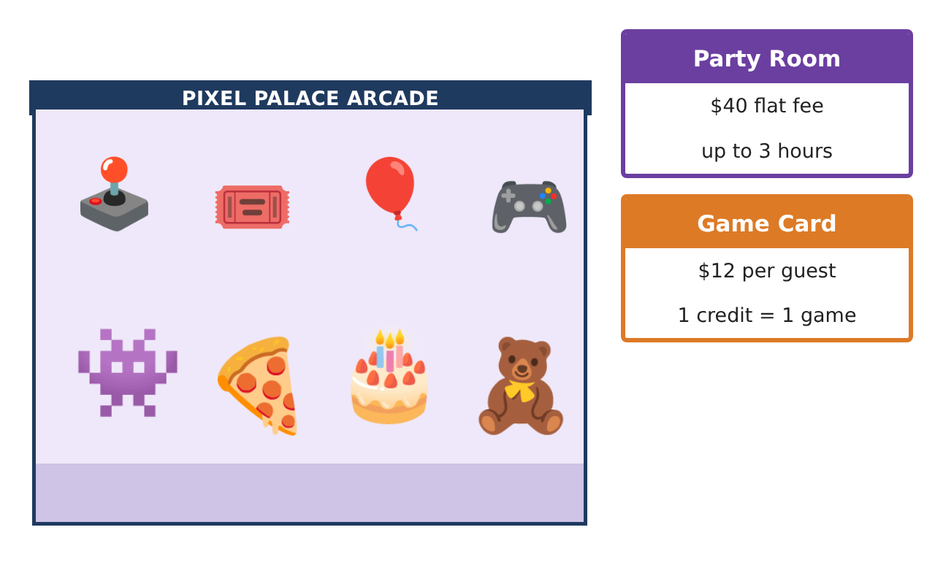
Learning Goals
- I can write expressions with a variable for real costs.
- I can evaluate expressions by substituting values.
- I can solve one-step equations to answer questions.
Project Timeline
When | What you will do
Day 1 | Write the Costs
Day 2 | Use the Properties
Day 3 | Solve and Plan
Final | Party Package Proposal + reflection
Part 1: Write the Costs
Day 1 · Let g be the number of guests.
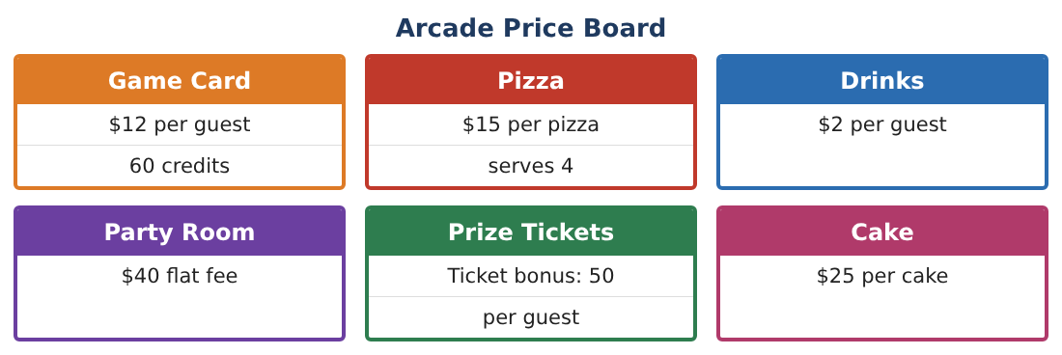
1. Write an expression for the cost of game cards for g guests.
Starter: ___ × g

2. Write an expression for the cost of game cards and drinks for g guests.

3. Write an expression for the total cost of the room, game cards, and drinks.

4. Evaluate your total-cost expression for 8 guests.

Part 2: Use the Properties
Day 2 · Expressions can be written in more than one way.
5. Show that 12(g + 2) and 12g + 24 are equal when g = 5.

6. Pizzas cost $15. Write two equivalent expressions for the cost of p pizzas and 1 cake.

7. A prize costs 2⁵ tickets. How many tickets is that?

8. Write an expression for the number of pizzas needed for g guests if each pizza serves 4.

Part 3: Solve and Plan
Day 3 · Write and solve an equation for each question.
9. The game cards cost $132. How many guests came?
Starter: 12g = 132, so g = 132 ÷ ___

10. Each guest gets 50 bonus tickets. The group has 600 bonus tickets. How many guests are there?

11. Plan a party for 10 guests with game cards, drinks, the room, pizza, and cake. Find the total cost.

Final Product: Party Package Proposal
Your final product must include:
- An expression for each cost
- Your total-cost expression
- The cost for your guest list
- One equation you solved
- A party flyer with prices
Reflection
R1. What does the variable g stand for in your expressions?

R2. How did you check your equation answers?

Scoring Rubric
Criteria | 4 – Exceeds | 3 – Meets | 2 – Approaching | 1 – Beginning
Mathematical Accuracy | All calculations and solutions are correct; answers include units and are checked. | Nearly all work is correct; minor errors do not change conclusions. | Several errors; some conclusions are affected. | Many errors or missing work.
Reasoning & Justification | Clear, complete explanations connect every answer to the situation; uses precise vocabulary. | Explanations are mostly clear and connected to the situation. | Explanations are brief or partly unclear. | Little or no explanation.
Application & Design | Expressions and equations model every cost correctly and are used to compare packages and plan within the budget. Goes beyond the minimum with a creative, realistic choice. | Expressions and equations model every cost correctly and are used to compare packages and plan within the budget. | Design is incomplete or only partly uses the math from the unit. | Design is missing or unrelated to the unit math.
Communication & Presentation | Proposal includes expressions, a comparison table, solved equations, and a clear recommendation. Polished, organized, and visually engaging. | Proposal includes expressions, a comparison table, solved equations, and a clear recommendation. Organized and easy to follow. | Product is missing required parts or is hard to follow. | Product is mostly missing.

