6TH GRADE MATH · UNIT 1: RATIOS, RATE, PERCENT AND PROPORTIONS  Bake Sale Boss  Scale recipes, compare prices, and price your treats for a school bake sale. | CP1  2–3 class periods

Name: ________________________________ Date: ______________ Period: ______
The Scenario
Your class is running a bake sale to raise money for a field trip. The recipes you found make the wrong number of treats, the store sells ingredients in different sizes, and you need to set prices that make a profit.
You will use ratios, rates, and percents to scale recipes, find the best buys, and plan a booth that earns as much money as possible.
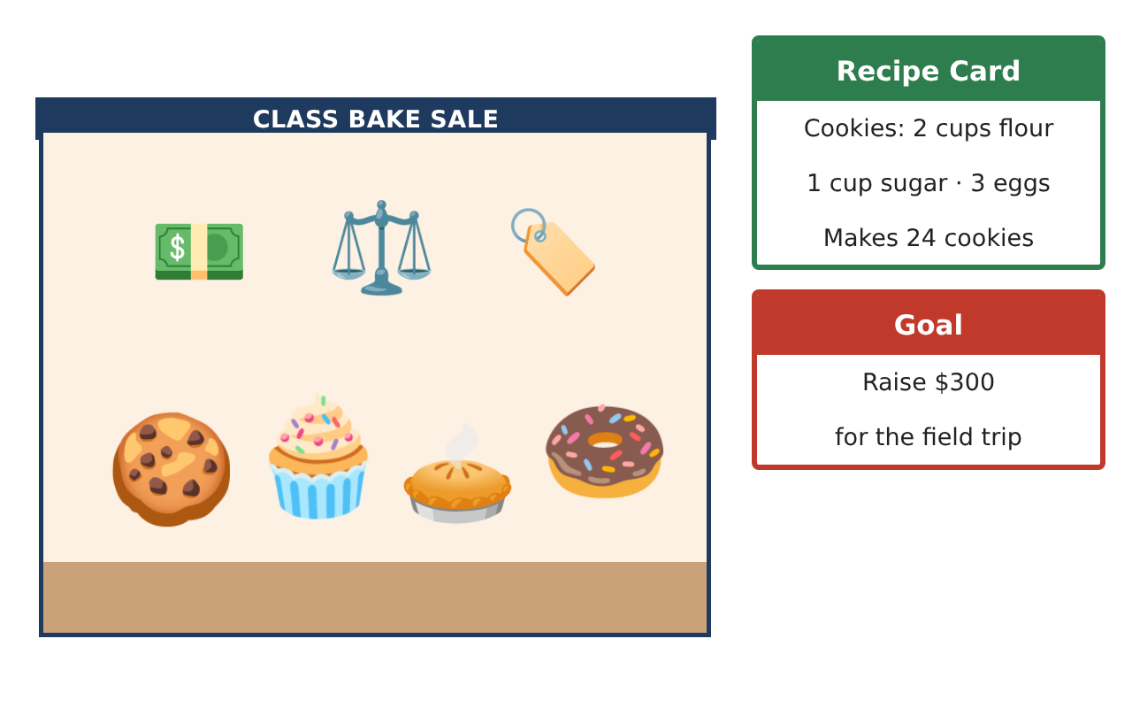
Learning Goals
- I can scale a recipe using ratio tables and equivalent ratios.
- I can compare unit rates to choose the best buy.
- I can use percents to find discounts, profit, and progress toward a goal.
Project Timeline
When | What you will do
Day 1 | Recipes & Ratios
Day 2 | Unit Prices & Shopping
Day 3 | Pricing & Profit
Final | Bake Sale Business Plan + reflection
Part 1: Recipes & Ratios
Day 1 · Use the Recipe Card: 2 cups flour, 1 cup sugar, and 3 eggs make 24 cookies.
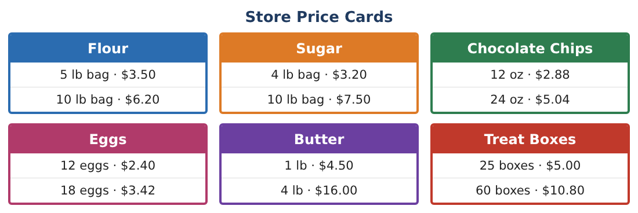
1. Write the ratio of flour to sugar to eggs. What is the ratio of eggs to cookies in simplest form?

2. How much flour, sugar, and how many eggs are needed for 180 cookies?

3. A muffin recipe uses 3 cups of flour for 12 muffins. Which uses more flour per treat, a cookie or a muffin? How many times as much?

4. You have 15 cups of flour to share between cookies and muffins. Find one combination that uses all the flour, and give the number of each treat.

Part 2: Unit Prices & Shopping
Day 2 · Use the Store Price Cards.
5. Find the unit price of each item on both price cards (per pound, per ounce, per egg, or per box). Circle the better buy for each item.

6. You need 9 cups of sugar. 1 pound of sugar is about 2.25 cups. How many pounds do you need, and which bag (or bags) should you buy?

7. You need 30 eggs. Find the cheapest way to buy them and the cost.

8. Explain why the better unit price is not always the cheapest choice for your shopping list.

Part 3: Pricing & Profit
Day 3 · Your supplies cost $45 in total. The goal is to raise $300 over three bake sales.
9. You sell 150 cookies at $0.50 and 40 muffins at $1.25. Find your total sales and your profit.

10. What percent of the $300 goal is your profit? How much more do you need?

11. Design a price list with at least three treats. Predict how many of each you will sell and show that your plan earns at least $\frac{1}{3}$ of the goal at one sale.

Final Product: Bake Sale Business Plan
Your final product must include:
- Scaled recipes for every treat
- Shopping list with unit prices and total cost
- Price list with at least three treats
- Profit calculation and percent of the goal
- A booth sign with one percent discount
Reflection
R1. Explain how equivalent ratios and unit rates are connected.

R2. How did percents help you decide whether your plan was on track?

Scoring Rubric
Criteria | 4 – Exceeds | 3 – Meets | 2 – Approaching | 1 – Beginning
Mathematical Accuracy | All calculations and solutions are correct; answers include units and are checked. | Nearly all work is correct; minor errors do not change conclusions. | Several errors; some conclusions are affected. | Many errors or missing work.
Reasoning & Justification | Clear, complete explanations connect every answer to the situation; uses precise vocabulary. | Explanations are mostly clear and connected to the situation. | Explanations are brief or partly unclear. | Little or no explanation.
Application & Design | Recipes are scaled correctly, best buys are justified with unit prices, and prices are set with percents to meet the goal. Goes beyond the minimum with a creative, realistic choice. | Recipes are scaled correctly, best buys are justified with unit prices, and prices are set with percents to meet the goal. | Design is incomplete or only partly uses the math from the unit. | Design is missing or unrelated to the unit math.
Communication & Presentation | Business plan includes scaled recipes, a shopping list, a price list, profit, and a booth sign. Polished, organized, and visually engaging. | Business plan includes scaled recipes, a shopping list, a price list, profit, and a booth sign. Organized and easy to follow. | Product is missing required parts or is hard to follow. | Product is mostly missing.

