6TH GRADE MATH · UNIT 1: RATIOS, RATE, PERCENT AND PROPORTIONS  Bake Sale Boss  Scale recipes, compare prices, and price your treats for a school bake sale. | Honors  2–3 class periods

Name: ________________________________ Date: ______________ Period: ______
The Scenario
Your class is running a bake sale to raise money for a field trip. The recipes you found make the wrong number of treats, the store sells ingredients in different sizes, and you need to set prices that make a profit.
You will use ratios, rates, and percents to scale recipes, find the best buys, and plan a booth that earns as much money as possible.
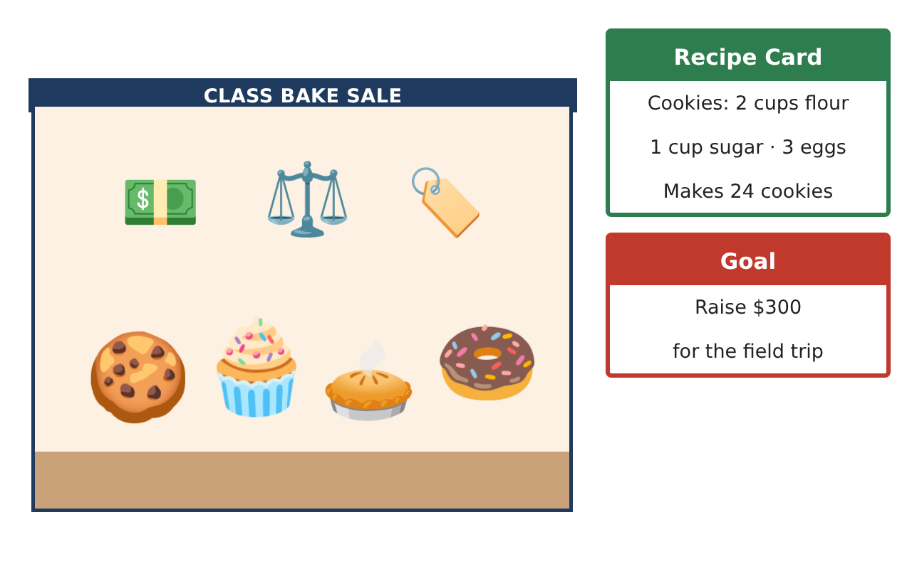
Learning Goals
- I can scale multi-ingredient recipes and use ratio reasoning with unit conversions.
- I can use unit rates and total cost to optimize a shopping plan.
- I can use percent increase, decrease, and markup to set prices and meet a goal.
Project Timeline
When | What you will do
Day 1 | Recipe Engineering
Day 2 | Shopping Optimization
Day 3 | Pricing Strategy
Final | Bake Sale Business Plan + reflection
Part 1: Recipe Engineering
Day 1 · Use the Recipe Card: 2 cups flour, 1 cup sugar, and 3 eggs make 24 cookies.
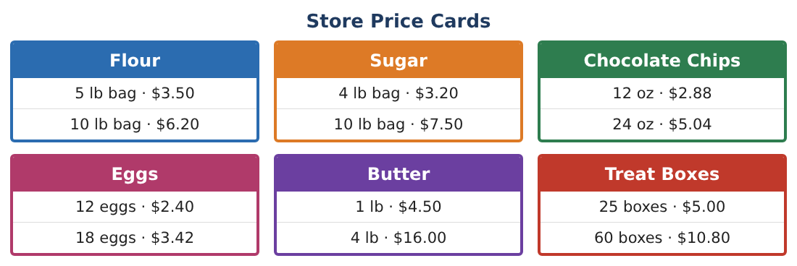
1. A customer wants a batch of 30 cookies. Find the amount of each ingredient. Give eggs to the nearest whole egg and explain your rounding choice.

2. A double-chocolate version keeps the flour : sugar ratio but uses 1.5 cups of sugar per batch. How much flour is needed per batch?

3. 1 cup of flour weighs about 125 grams. How many kilograms of flour do you need for 240 cookies?

4. Muffins use 3 cups of flour per batch of 12, and cookies use 2 cups per batch of 24. You have 12 cups of flour and want twice as many cookies as muffins. Using whole batches, how many of each can you make?

Part 2: Shopping Optimization
Day 2 · Use the Store Price Cards. Your budget for supplies is $40.
5. Find the percent savings per unit when you buy the larger chocolate-chip bag instead of the smaller one.

6. You need 36 eggs, 8 lb of flour, 4 lb of sugar, and 2 lb of butter. Find the cheapest combination of packages and the total cost.

7. With the rest of your $40 budget, how many full 60-packs of treat boxes can you buy? How much money is left?

8. Is the larger package ever worse even though its unit price is lower? Use your numbers to explain.

Part 3: Pricing Strategy
Day 3 · Your supplies cost $50. The goal is $300 profit over three sales.
9. You mark up each cookie 150% over its ingredient cost of $0.20. What is the selling price? Then you give a 20% end-of-day discount. What is the final price, and what is the percent change from the original selling price?

10. Last sale you sold 160 cookies at $0.50. If you raise the price to $0.60, you predict sales drop by 15%. Compare the revenue for both prices.

11. Design a pricing plan for three treats (with at least one percent discount) that reaches the $300 goal in three sales. Justify it with a table.

Final Product: Bake Sale Business Plan
Your final product must include:
- Scaled recipes with unit conversions
- Optimized shopping plan within the $40 budget
- Pricing strategy with markup, discount, and percent change
- Revenue comparison table
- Recommendation memo explaining how you reach the $300 goal
Reflection
R1. When can a larger package be a worse buy even with a lower unit rate? Generalize your answer.

R2. How do markup and discount percents interact? Is a 20% markup followed by a 20% discount the original price?

Scoring Rubric
Criteria | 4 – Exceeds | 3 – Meets | 2 – Approaching | 1 – Beginning
Mathematical Accuracy | All calculations and solutions are correct; answers include units and are checked. | Nearly all work is correct; minor errors do not change conclusions. | Several errors; some conclusions are affected. | Many errors or missing work.
Reasoning & Justification | Clear, complete explanations connect every answer to the situation; uses precise vocabulary. | Explanations are mostly clear and connected to the situation. | Explanations are brief or partly unclear. | Little or no explanation.
Application & Design | Recipes are scaled correctly, best buys are justified with unit prices, and prices are set with percents to meet the goal. Goes beyond the minimum with a creative, realistic choice. | Recipes are scaled correctly, best buys are justified with unit prices, and prices are set with percents to meet the goal. | Design is incomplete or only partly uses the math from the unit. | Design is missing or unrelated to the unit math.
Communication & Presentation | Business plan includes scaled recipes, a shopping list, a price list, profit, and a booth sign. Polished, organized, and visually engaging. | Business plan includes scaled recipes, a shopping list, a price list, profit, and a booth sign. Organized and easy to follow. | Product is missing required parts or is hard to follow. | Product is mostly missing.

