6TH GRADE MATH · UNIT 6: GEOMETRY  Dream Bedroom Makeover  Use area, surface area, and volume to redesign a bedroom on a budget. | CP2  2–3 class periods

Name: ________________________________ Date: ______________ Period: ______
The Scenario
A TV show is giving a student a bedroom makeover, and your design team is in charge. You need new flooring, a rug, paint for the walls, and storage boxes, and everything must fit the budget.
You will use area, surface area, and volume to measure the room, plan materials, and present your design.
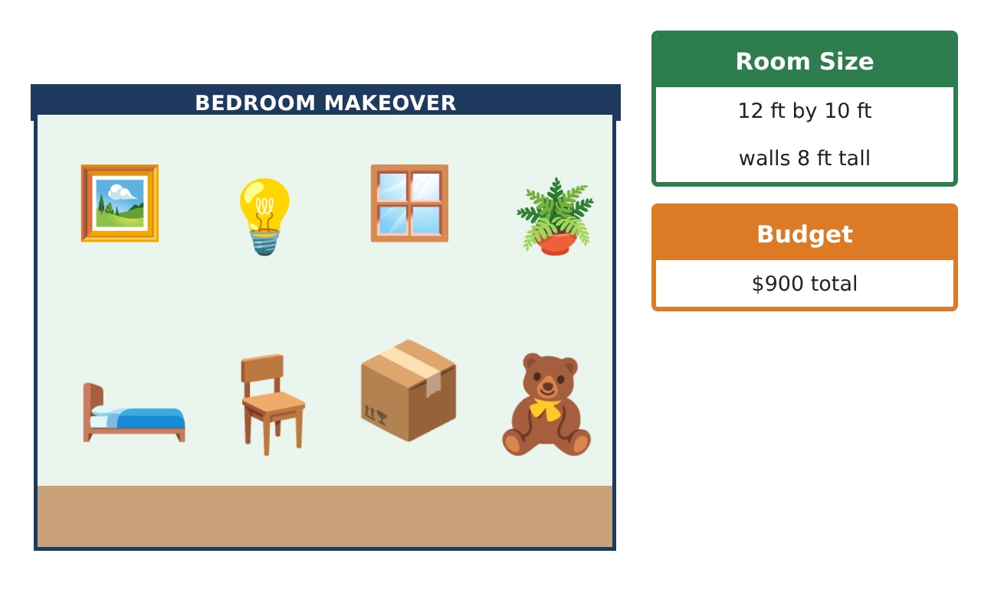
Learning Goals
- I can find the area of rectangles, triangles, and composite shapes.
- I can use a net to find surface area.
- I can find the volume of a rectangular prism.
Project Timeline
When | What you will do
Day 1 | Floor Plan
Day 2 | Paint the Walls
Day 3 | Storage & Budget
Final | Makeover Design Board + reflection
Part 1: Floor Plan
Day 1 · The room is a rectangle 12 ft long and 10 ft wide.
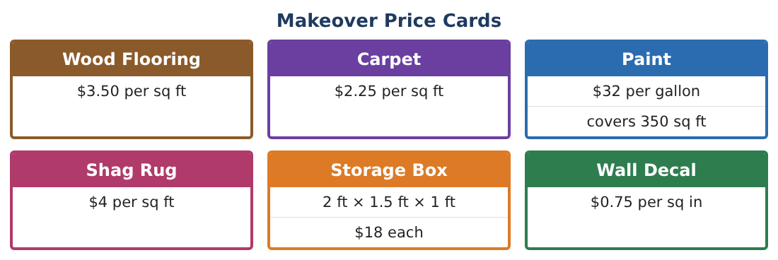
1. Find the area of the floor.
Starter: A = l × w = ___ × ___

2. Find the cost to cover the floor with carpet.

3. A triangle rug has a base of 6 ft and a height of 4 ft. Find its area.

4. An L-shaped desk top is made of a 5 ft by 2 ft rectangle and a 3 ft by 2 ft rectangle. Find its area.

Part 2: Paint the Walls
Day 2 · The walls are 8 ft tall.
5. Find the area of one long wall (12 ft by 8 ft) and one short wall (10 ft by 8 ft).

6. Find the total area of all four walls.

7. One gallon of paint covers 350 sq ft. How many gallons do you need? What does it cost?

8. Draw the net of a storage box (rectangular prism) 2 ft by 1.5 ft by 1 ft.

Part 3: Storage & Budget
Day 3 · Use the Makeover Price Cards.
9. Find the volume of one storage box.

10. You buy 3 boxes. What is their total volume and total cost?

11. Add up your carpet, paint, rug ($4 per sq ft), and boxes. Is it under the $900 budget?

Final Product: Makeover Design Board
Your final product must include:
- A floor plan with the dimensions
- Area of the floor and the rug
- Wall area and paint needed
- Volume of your storage
- Price list and total cost
Reflection
R1. Why is area measured in square feet but volume in cubic feet?

R2. How did the net help you find surface area?

Scoring Rubric
Criteria | 4 – Exceeds | 3 – Meets | 2 – Approaching | 1 – Beginning
Mathematical Accuracy | All calculations and solutions are correct; answers include units and are checked. | Nearly all work is correct; minor errors do not change conclusions. | Several errors; some conclusions are affected. | Many errors or missing work.
Reasoning & Justification | Clear, complete explanations connect every answer to the situation; uses precise vocabulary. | Explanations are mostly clear and connected to the situation. | Explanations are brief or partly unclear. | Little or no explanation.
Application & Design | Areas, surface areas, and volumes are computed correctly and used to choose materials within the budget. Goes beyond the minimum with a creative, realistic choice. | Areas, surface areas, and volumes are computed correctly and used to choose materials within the budget. | Design is incomplete or only partly uses the math from the unit. | Design is missing or unrelated to the unit math.
Communication & Presentation | Design board shows the floor plan, calculations, materials list, and total cost. Polished, organized, and visually engaging. | Design board shows the floor plan, calculations, materials list, and total cost. Organized and easy to follow. | Product is missing required parts or is hard to follow. | Product is mostly missing.

