6TH GRADE MATH · UNIT 6: GEOMETRY  Dream Bedroom Makeover  Use area, surface area, and volume to redesign a bedroom on a budget. | Honors  2–3 class periods

Name: ________________________________ Date: ______________ Period: ______
The Scenario
A TV show is giving a student a bedroom makeover, and your design team is in charge. You need new flooring, a rug, paint for the walls, and storage boxes, and everything must fit the budget.
You will use area, surface area, and volume to measure the room, plan materials, and present your design.
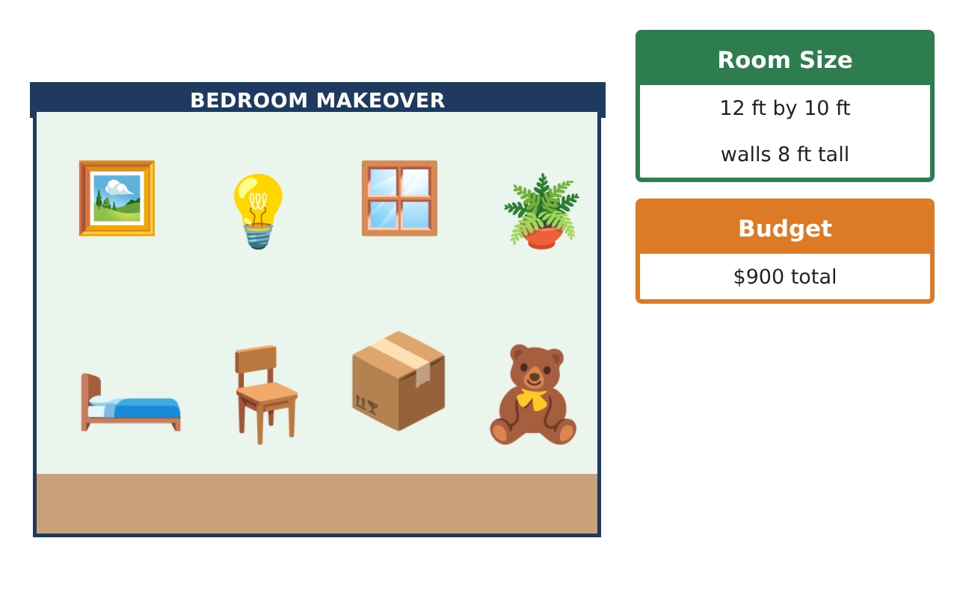
Learning Goals
- I can find areas of composite and polygonal regions in context.
- I can apply surface area to minimize materials.
- I can use volume with fractional edges and compare designs.
Project Timeline
When | What you will do
Day 1 | Floor & Rug Design
Day 2 | Paint & Box Design
Day 3 | Pitch the Makeover
Final | Makeover Design Board + reflection
Part 1: Floor & Rug Design
Day 1 · The room is 12 ft by 10 ft with a 4 ft by 3 ft closet.
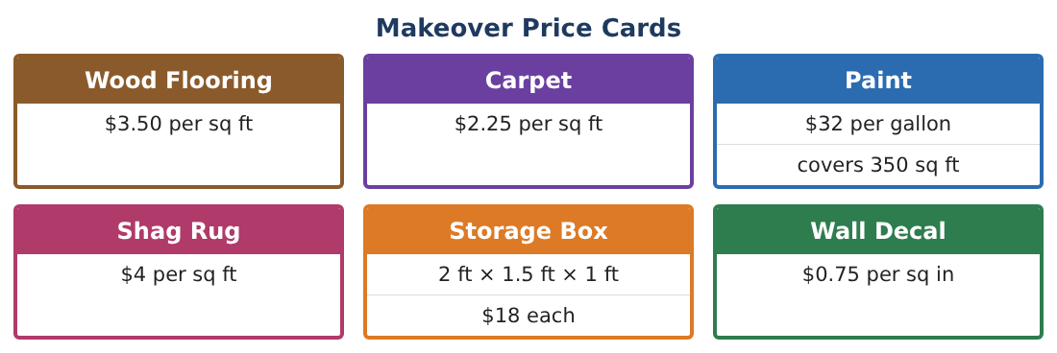
1. The floor will be wood except a square carpeted reading nook 5 ft on a side. Find the cost of the floor.

2. A hexagon rug is made of 6 congruent triangles, each with base 3 ft and height 2.6 ft. Find its area and cost.

3. Plot the rug corners on a grid: (2, 1), (8, 1), (10, 5), (2, 5) (1 unit = 1 ft). Find its area by decomposing.
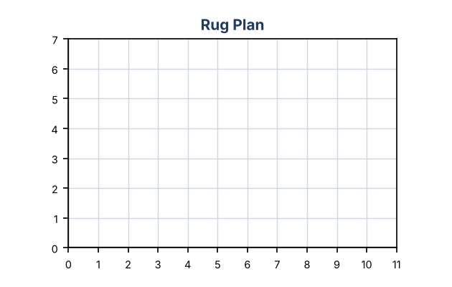

4. Which rug gives more area per dollar at $4 per sq ft: hexagon or the trapezoid-shaped rug from the grid? Explain.

Part 2: Paint & Box Design
Day 2 · Walls are 8 ft tall. One door (3 × 7 ft), two windows (4 × 3$\frac{1}{2}$ ft). Two coats.
5. Find the gallons and cost of paint for the walls AND the ceiling (12 × 10 ft) with two coats.

6. Two box designs hold 3 cubic ft: A is 2 × 1.5 × 1 ft, B is 1.5 × 1.5 × 1$\frac{1}{3}$ ft. Which uses less cardboard?

7. If cardboard costs $0.40 per sq ft, how much is saved making 20 boxes of design B instead of A?

8. Explain why a cube-like box uses less cardboard for the same volume.

Part 3: Pitch the Makeover
Day 3 · Budget: $900.
9. A bookcase is a rectangular prism 3 ft wide, 1 ft deep, 5$\frac{1}{2}$ ft tall with 4 equal shelves. What is the volume of each shelf space?

10. Choose the floor plan, rug, paint, boxes, and decals. Find the total cost and the percent of the budget used.

11. Write a recommendation for the TV show explaining one choice where you used geometry to save money.

Final Product: Makeover Design Board
Your final product must include:
- Coordinate floor plan with the rug
- Mixed flooring cost
- Paint for walls and ceiling with two coats
- Box design comparison with surface area
- Budget with percent used and a recommendation
Reflection
R1. How can two boxes have the same volume but different surface areas?

R2. When decomposing a polygon, how do you make sure you do not count area twice?

Scoring Rubric
Criteria | 4 – Exceeds | 3 – Meets | 2 – Approaching | 1 – Beginning
Mathematical Accuracy | All calculations and solutions are correct; answers include units and are checked. | Nearly all work is correct; minor errors do not change conclusions. | Several errors; some conclusions are affected. | Many errors or missing work.
Reasoning & Justification | Clear, complete explanations connect every answer to the situation; uses precise vocabulary. | Explanations are mostly clear and connected to the situation. | Explanations are brief or partly unclear. | Little or no explanation.
Application & Design | Areas, surface areas, and volumes are computed correctly and used to choose materials within the budget. Goes beyond the minimum with a creative, realistic choice. | Areas, surface areas, and volumes are computed correctly and used to choose materials within the budget. | Design is incomplete or only partly uses the math from the unit. | Design is missing or unrelated to the unit math.
Communication & Presentation | Design board shows the floor plan, calculations, materials list, and total cost. Polished, organized, and visually engaging. | Design board shows the floor plan, calculations, materials list, and total cost. Organized and easy to follow. | Product is missing required parts or is hard to follow. | Product is mostly missing.

