6TH GRADE MATH · UNIT 7: DATA DISPLAYS  Lunch Menu Survey  Survey classmates and use data displays to recommend a new lunch menu. | Honors  2–3 class periods

Name: ________________________________ Date: ______________ Period: ______
The Scenario
The cafeteria wants to add a new lunch and asked the student council for advice. Your team surveyed students about their favorite foods, how long the lunch line takes, and how many items they buy.
You will organize the data with displays, find the center and spread, and recommend a menu that the data supports.
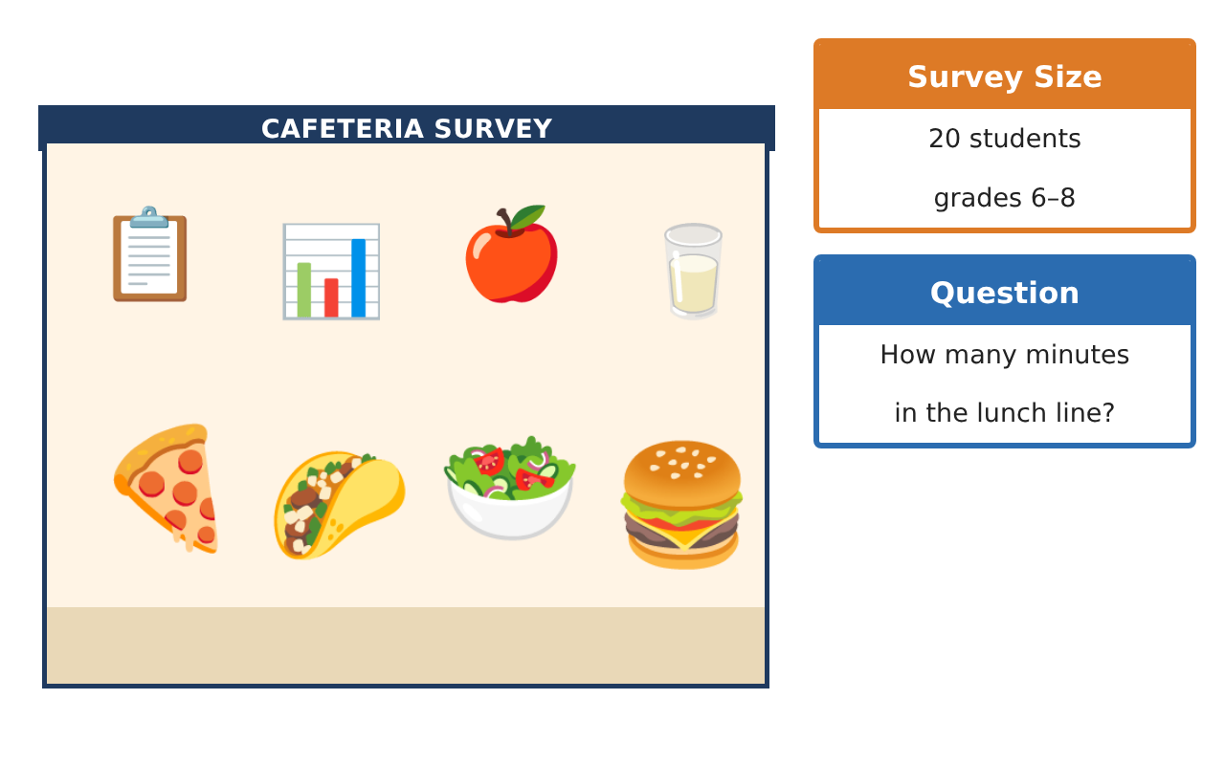
Learning Goals
- I can choose and justify data displays for a purpose.
- I can compare data sets using center, spread, and shape.
- I can design a survey and recommend action from data.
Project Timeline
When | What you will do
Day 1 | Choose the Display
Day 2 | Compare Lunch Lines
Day 3 | Survey Design & Recommendation
Final | Menu Recommendation Report + reflection
Part 1: Choose the Display
Day 1 · Use the Survey Data card.
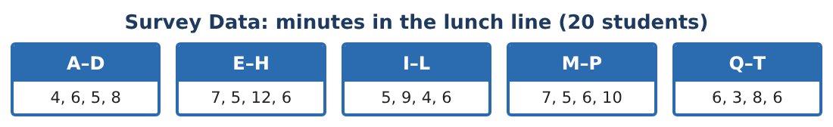
1. Make a box plot and a histogram (intervals of 2 minutes starting at 2). Which display shows the outlier better? Which shows the peak better?

2. Find the mean, median, MAD, and IQR.

3. If the 12 is removed, which statistics change and by how much?

4. A student says, "The mean is 6.4, so most students wait about 6 minutes." Evaluate this statement.

Part 2: Compare Lunch Lines
Day 2 · Line A (old): the Survey Data. Line B (new register): 3, 4, 4, 5, 5, 5, 4, 6, 3, 4, 5, 5, 4, 6, 5, 4, 3, 5, 4, 6.
5. Find the mean, median, and MAD of Line B.

6. Draw both box plots on one scale. Describe the overlap.

7. How many MADs apart are the two means (use the larger MAD)? Is the difference meaningful?

8. Predict the total minutes saved per day for 300 students if the new register is used. Show your reasoning.

Part 3: Survey Design & Recommendation
Day 3 · You may add one new lunch option.
9. Write a survey question to choose between tacos and burgers. Describe how to make the sample fair.

10. The favorite-food survey (pizza 7, tacos 5, salad 3, burgers 4, other 1) came only from 6th graders. Explain why this might be biased.

11. Write a one-page recommendation with at least two displays and three statistics, including a limitation of the data.

Final Product: Menu Recommendation Report
Your final product must include:
- Two displays with an explanation of why each was chosen
- Full statistics before and after the outlier is removed
- Comparison of two lunch lines with MAD reasoning
- A fair survey design
- Recommendation with a limitation
Reflection
R1. How does the purpose of a report affect the display you choose?

R2. Why should conclusions mention the sample and its limits?

Scoring Rubric
Criteria | 4 – Exceeds | 3 – Meets | 2 – Approaching | 1 – Beginning
Mathematical Accuracy | All calculations and solutions are correct; answers include units and are checked. | Nearly all work is correct; minor errors do not change conclusions. | Several errors; some conclusions are affected. | Many errors or missing work.
Reasoning & Justification | Clear, complete explanations connect every answer to the situation; uses precise vocabulary. | Explanations are mostly clear and connected to the situation. | Explanations are brief or partly unclear. | Little or no explanation.
Application & Design | Displays and statistics are correct and are used to support the lunch recommendation. Goes beyond the minimum with a creative, realistic choice. | Displays and statistics are correct and are used to support the lunch recommendation. | Design is incomplete or only partly uses the math from the unit. | Design is missing or unrelated to the unit math.
Communication & Presentation | Report includes displays, statistics, comparison, and a clear recommendation. Polished, organized, and visually engaging. | Report includes displays, statistics, comparison, and a clear recommendation. Organized and easy to follow. | Product is missing required parts or is hard to follow. | Product is mostly missing.

