6TH GRADE MATH · UNIT 2: OPERATIONS OF FRACTIONS AND DECIMALS  Quilt Shop Makers  Measure, cut, and price fabric to sew a class quilt. | CP2  2–3 class periods

Name: ________________________________ Date: ______________ Period: ______
The Scenario
The art club is sewing a quilt to sell at the school auction. Fabric is sold by the yard in fractions of a yard, squares must be cut to exact sizes, and every material has a price in dollars and cents.
You will use fraction and decimal operations to plan the cutting, figure out how much fabric to buy, and find the total cost of your quilt.
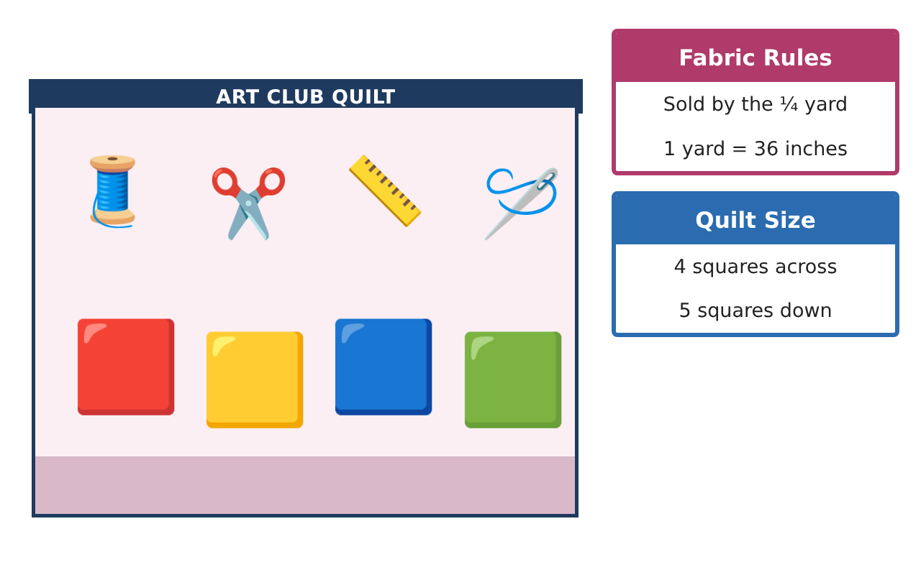
Learning Goals
- I can add and subtract fractions and mixed numbers to measure fabric.
- I can multiply and divide fractions to cut pieces.
- I can multiply and add decimals to find costs.
Project Timeline
When | What you will do
Day 1 | Measure the Fabric
Day 2 | Cut the Squares
Day 3 | Price the Quilt
Final | Quilt Plan & Price Sheet + reflection
Part 1: Measure the Fabric
Day 1 · Each quilt square is cut from strips of fabric.
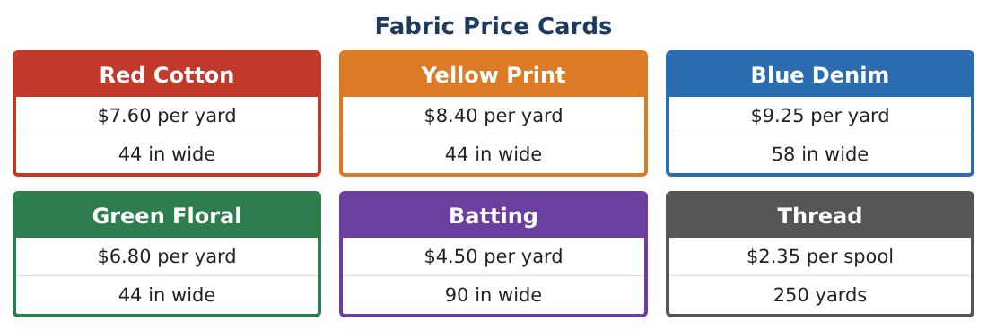
1. A strip is $\frac{3}{4}$ yard long. You cut off $\frac{1}{4}$ yard. How much is left?
Starter: $\frac{3}{4}$ − $\frac{1}{4}$ = ___

2. You have 1$\frac{1}{2}$ yards of red and $\frac{3}{4}$ yard of yellow. How many yards is that in all?

3. Blue fabric comes in a 2$\frac{1}{3}$ yard piece. You use 1$\frac{2}{3}$ yards. How much is left?

4. Which is longer, $\frac{5}{8}$ yard or $\frac{2}{3}$ yard? Explain how you know.

Part 2: Cut the Squares
Day 2 · Each square needs $\frac{1}{8}$ yard of fabric.
5. How many squares can you cut from $\frac{3}{4}$ yard of fabric?
Starter: $\frac{3}{4}$ ÷ $\frac{1}{8}$ = $\frac{3}{4}$ × ___ = ___

6. The quilt has 20 squares. How many yards of fabric do you need?

7. You want $\frac{1}{2}$ of the squares to be red. How many yards of red fabric is that?

8. A border strip is 2$\frac{1}{2}$ yards long. You cut it into pieces that are $\frac{1}{2}$ yard long. How many pieces?

Part 3: Price the Quilt
Day 3 · Use the Fabric Price Cards.
9. Find the cost of 1.25 yards of red cotton.

10. Find the cost of 2.5 yards of batting and 2 spools of thread. Add to find the total.

11. Choose two more fabrics for your quilt and decide how many yards of each to buy. Find the total cost of everything.

Final Product: Quilt Plan & Price Sheet
Your final product must include:
- A drawing of your 4 × 5 quilt with colors
- How much of each fabric you need (in yards)
- How many squares each color makes
- A price sheet with the total cost
- One sentence about your favorite part of the design
Reflection
R1. Why does dividing by $\frac{1}{8}$ give a bigger number?

R2. Where do you line up decimals when you multiply money?

Scoring Rubric
Criteria | 4 – Exceeds | 3 – Meets | 2 – Approaching | 1 – Beginning
Mathematical Accuracy | All calculations and solutions are correct; answers include units and are checked. | Nearly all work is correct; minor errors do not change conclusions. | Several errors; some conclusions are affected. | Many errors or missing work.
Reasoning & Justification | Clear, complete explanations connect every answer to the situation; uses precise vocabulary. | Explanations are mostly clear and connected to the situation. | Explanations are brief or partly unclear. | Little or no explanation.
Application & Design | Fabric amounts, cuts, and costs are computed with correct fraction and decimal operations and match the quilt design. Goes beyond the minimum with a creative, realistic choice. | Fabric amounts, cuts, and costs are computed with correct fraction and decimal operations and match the quilt design. | Design is incomplete or only partly uses the math from the unit. | Design is missing or unrelated to the unit math.
Communication & Presentation | Quilt plan shows the diagram, fabric amounts, cutting plan, and price sheet. Polished, organized, and visually engaging. | Quilt plan shows the diagram, fabric amounts, cutting plan, and price sheet. Organized and easy to follow. | Product is missing required parts or is hard to follow. | Product is mostly missing.

