6TH GRADE MATH · UNIT 5: INEQUALITIES  Theme Park Rules  Use inequalities to check ride rules, budgets, and wait times at a theme park. | CP1  2–3 class periods

Name: ________________________________ Date: ______________ Period: ______
The Scenario
Your class is visiting Thunder Valley Theme Park. Every ride has a rule: you must be at least a certain height, some rides have weight or age limits, and your group has a budget for food and games.
You will write, solve, and graph inequalities to decide who can ride what and to plan the best day possible.
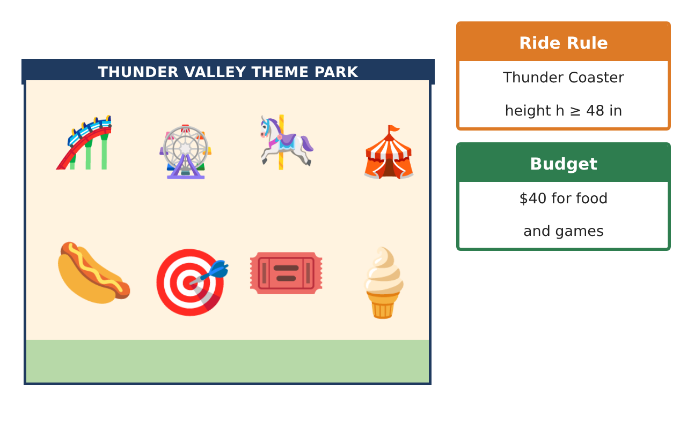
Learning Goals
- I can write and graph inequalities for real rules.
- I can solve one-step inequalities and interpret the solutions.
- I can use more than one inequality to make a decision.
Project Timeline
When | What you will do
Day 1 | Who Can Ride?
Day 2 | Money & Time
Day 3 | Design a Ride
Final | Theme Park Day Plan + reflection
Part 1: Who Can Ride?
Day 1 · Use the Ride Rule Cards. Heights: Ava 45 in, Ben 51 in, Cruz 41 in, Dev 48 in.
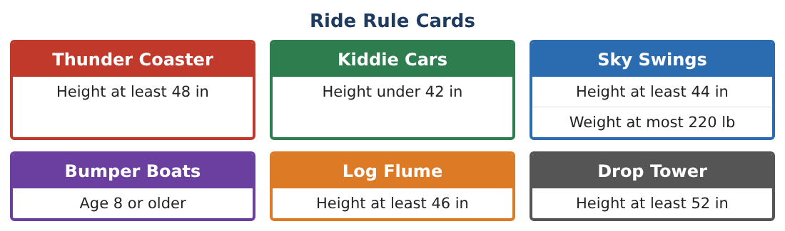
1. Write each ride rule as an inequality (h for height, w for weight, a for age).

2. Make a table showing which rides each friend can go on.

3. Graph the heights that can ride the Sky Swings but NOT the Log Flume.
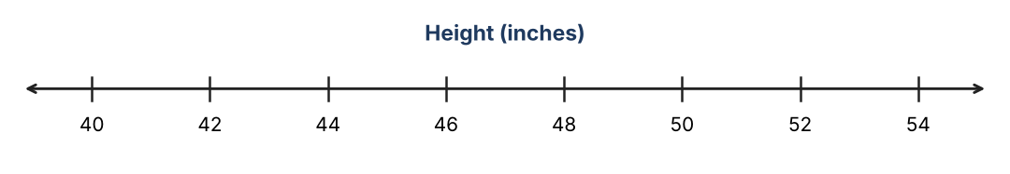

4. Ben grows $\frac{1}{2}$ inch per month. How many more months until he can ride the Drop Tower?

Part 2: Money & Time
Day 2 · Each student has $40.
5. Lunch costs $11.50. Game tickets cost $2.50. Write and solve an inequality for the number of tickets t you can buy.

6. You have 2 hours left at the park. Each coaster ride takes 40 minutes including the wait. Write and solve an inequality for the number of rides r.

7. The park says a group needs at least 12 people for a discount. Your group has 7. Write and solve an inequality for how many more people p you need.

8. Explain why t = 11.4 is not a sensible answer for game tickets.

Part 3: Design a Ride
Day 3 · Design a new ride for Thunder Valley.
9. Write a height rule for your ride with a minimum AND a maximum (two inequalities). Graph it.

10. Using the four friends above, who can ride your ride?

11. Each ride car holds at most 450 pounds. If each rider weighs 90 pounds, how many riders can share a car? Write and solve an inequality.

Final Product: Theme Park Day Plan
Your final product must include:
- Inequalities and graphs for every ride rule
- Rider table for the four friends
- Budget and time inequalities with solutions
- Your new ride with its rule and graph
- A day plan that satisfies every constraint
Reflection
R1. How do you decide whether to round a solution up or down?

R2. How is the solution of an inequality different from the solution of an equation?

Scoring Rubric
Criteria | 4 – Exceeds | 3 – Meets | 2 – Approaching | 1 – Beginning
Mathematical Accuracy | All calculations and solutions are correct; answers include units and are checked. | Nearly all work is correct; minor errors do not change conclusions. | Several errors; some conclusions are affected. | Many errors or missing work.
Reasoning & Justification | Clear, complete explanations connect every answer to the situation; uses precise vocabulary. | Explanations are mostly clear and connected to the situation. | Explanations are brief or partly unclear. | Little or no explanation.
Application & Design | Ride rules, budgets, and times are written, solved, and graphed as inequalities and used to make decisions. Goes beyond the minimum with a creative, realistic choice. | Ride rules, budgets, and times are written, solved, and graphed as inequalities and used to make decisions. | Design is incomplete or only partly uses the math from the unit. | Design is missing or unrelated to the unit math.
Communication & Presentation | Day plan includes rules, graphs, solved inequalities, and a schedule. Polished, organized, and visually engaging. | Day plan includes rules, graphs, solved inequalities, and a schedule. Organized and easy to follow. | Product is missing required parts or is hard to follow. | Product is mostly missing.

