6TH GRADE MATH · UNIT 5: INEQUALITIES  Theme Park Rules  Use inequalities to check ride rules, budgets, and wait times at a theme park. | Honors  2–3 class periods

Name: ________________________________ Date: ______________ Period: ______
The Scenario
Your class is visiting Thunder Valley Theme Park. Every ride has a rule: you must be at least a certain height, some rides have weight or age limits, and your group has a budget for food and games.
You will write, solve, and graph inequalities to decide who can ride what and to plan the best day possible.
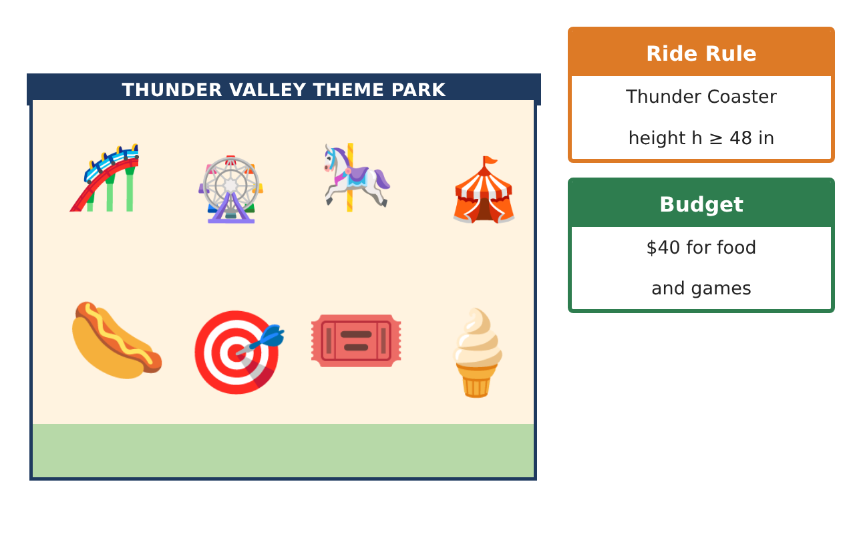
Learning Goals
- I can write and graph compound conditions using inequalities.
- I can solve inequalities in context and interpret boundary values.
- I can design rules that meet several constraints.
Project Timeline
When | What you will do
Day 1 | Ride Logic
Day 2 | Constraints
Day 3 | Engineer a Ride
Final | Theme Park Day Plan + reflection
Part 1: Ride Logic
Day 1 · Use the Ride Rule Cards.
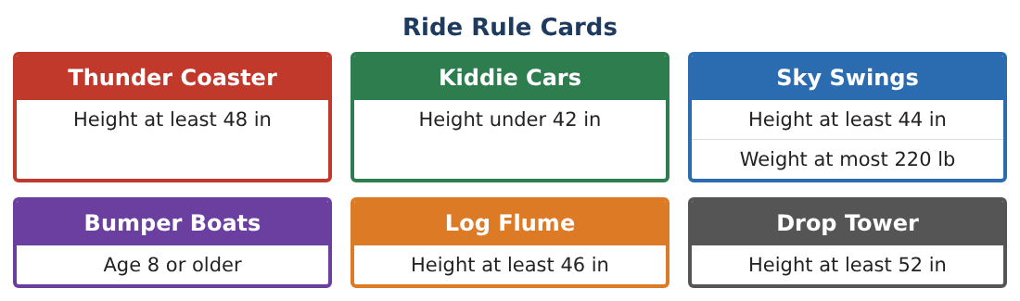
1. Write the heights that can ride the Log Flume but not the Drop Tower. Graph the set.
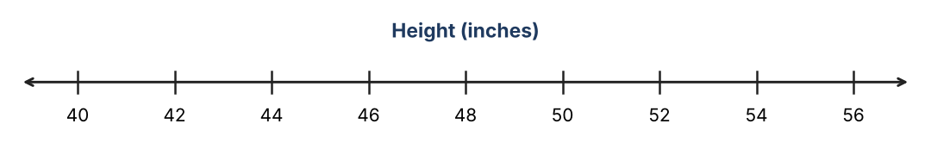

2. Write the heights that can ride neither the Kiddie Cars nor the Sky Swings.

3. Is there a height that can ride every ride? Explain using inequalities.

4. A rider is 4 feet 1 inch tall and weighs 105 pounds. List every ride they can ride.

Part 2: Constraints
Day 2 · Each student has $50.
5. Entry is $28. Snacks cost $3.75. You want to keep at least $5 for the bus. Write and solve an inequality for snacks s.

6. A group discount gives $4 off each ticket for groups of at least 15. Your class of 23 needs at least how many more friends to form two discount groups?

7. Wait time grows by 6 minutes every half hour after 10:00 a.m., starting at 10 minutes. You want to wait at most 40 minutes. Up to how many half hours after 10:00 can you get in line?

8. Explain why the boundary point of a "≤" solution is included but a "<" boundary is not, using one of the problems above.

Part 3: Engineer a Ride
Day 3 · A new ride must be safe and fair.
9. A ride car can hold at most 600 lb. The car and harness weigh 150 lb. Riders average 95 lb. Write and solve an inequality for the number of riders.

10. Write a height rule (minimum and maximum) so that at least three of the four friends (45, 51, 41, 48 in) can ride but the Drop Tower rule is still stricter.

11. Without a Fast Pass, 3 rides cost $5 each and each ride has a 35-minute wait. A Fast Pass for 3 rides skips the waits. Write an inequality for a Fast Pass price p that costs more than paying for the 3 rides but less than $20. Explain the trade-off.

Final Product: Theme Park Day Plan
Your final product must include:
- Compound conditions written and graphed
- Budget, group, and time inequalities solved and interpreted
- Your engineered ride rules
- Fast Pass pricing rule with justification
- A day plan that meets every constraint
Reflection
R1. How can two simple inequalities describe a range? Give an example.

R2. Why is it impossible to satisfy some pairs of inequalities at the same time?

Scoring Rubric
Criteria | 4 – Exceeds | 3 – Meets | 2 – Approaching | 1 – Beginning
Mathematical Accuracy | All calculations and solutions are correct; answers include units and are checked. | Nearly all work is correct; minor errors do not change conclusions. | Several errors; some conclusions are affected. | Many errors or missing work.
Reasoning & Justification | Clear, complete explanations connect every answer to the situation; uses precise vocabulary. | Explanations are mostly clear and connected to the situation. | Explanations are brief or partly unclear. | Little or no explanation.
Application & Design | Ride rules, budgets, and times are written, solved, and graphed as inequalities and used to make decisions. Goes beyond the minimum with a creative, realistic choice. | Ride rules, budgets, and times are written, solved, and graphed as inequalities and used to make decisions. | Design is incomplete or only partly uses the math from the unit. | Design is missing or unrelated to the unit math.
Communication & Presentation | Day plan includes rules, graphs, solved inequalities, and a schedule. Polished, organized, and visually engaging. | Day plan includes rules, graphs, solved inequalities, and a schedule. Organized and easy to follow. | Product is missing required parts or is hard to follow. | Product is mostly missing.

