6TH GRADE MATH · UNIT 3: RATIONAL NUMBERS  Weather Station Watch  Track below-zero temperatures, elevations, and locations with rational numbers. | Honors  2–3 class periods

Name: ________________________________ Date: ______________ Period: ______
The Scenario
Your class runs the school weather station for the winter. Temperatures drop below zero, nearby stations sit above and below sea level, and the storm tracker shows every station on a coordinate map.
You will use positive and negative numbers, absolute value, and the coordinate plane to report the weather to the school.
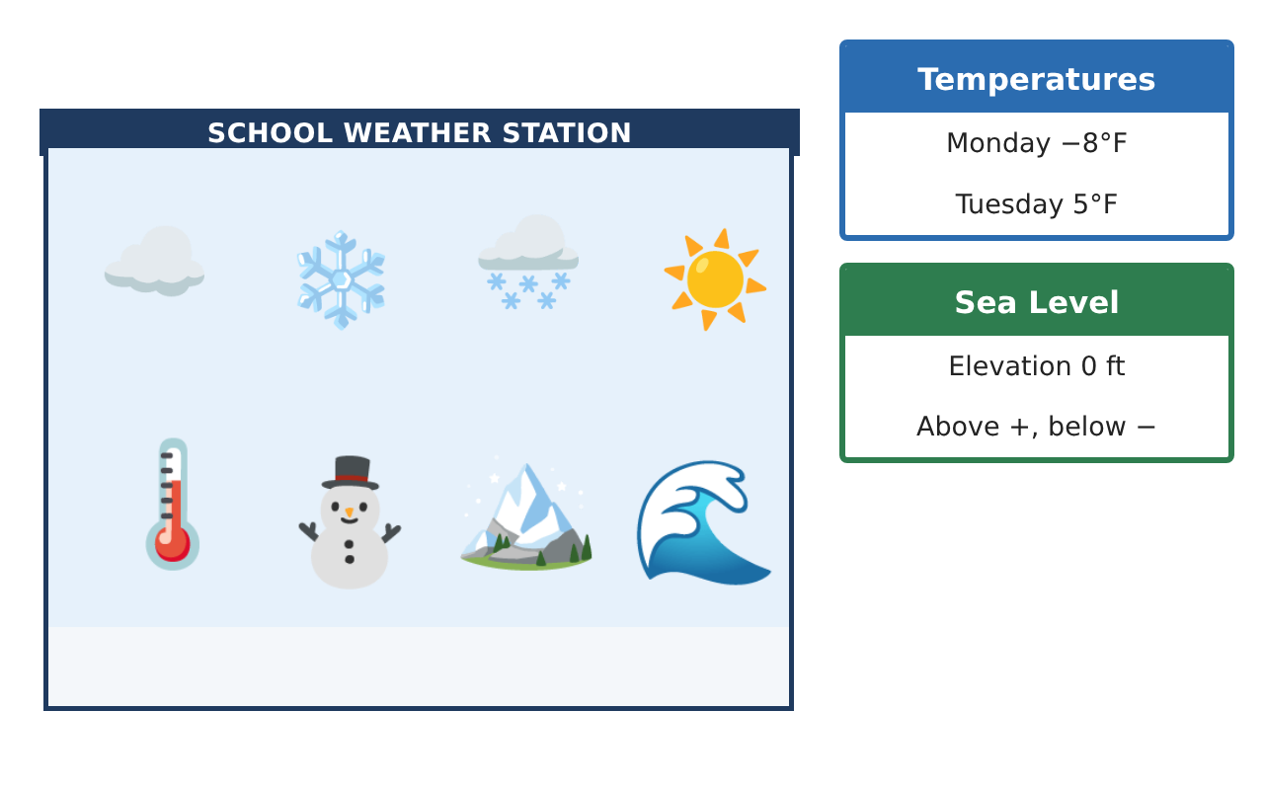
Learning Goals
- I can reason about rational numbers, opposites, and absolute value in context.
- I can find distances and areas on the coordinate plane using absolute value.
- I can use reflections to describe locations and paths.
Project Timeline
When | What you will do
Day 1 | Data Detective
Day 2 | Elevation Profile
Day 3 | Coordinate Coverage
Final | Weather Station Report + reflection
Part 1: Data Detective
Day 1 · Five readings: −4$\frac{1}{3}$, −4.3, −$\frac{17}{4}$, −4.35, −4$\frac{1}{6}$ degrees Fahrenheit.
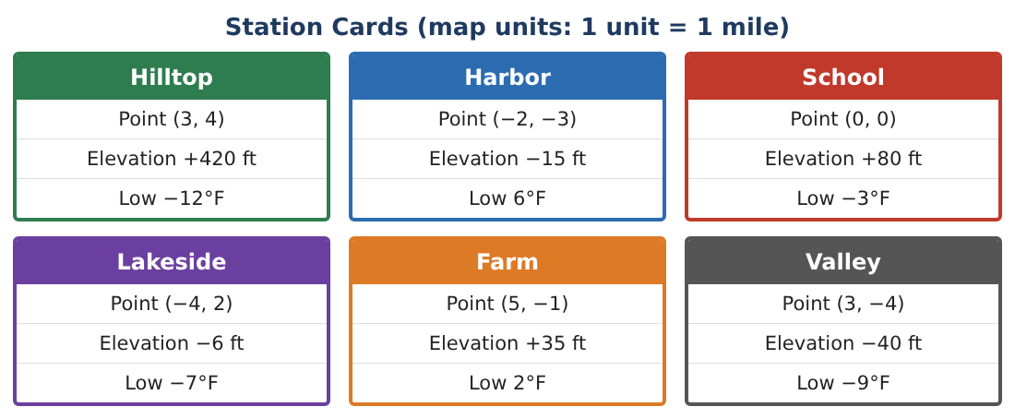
1. Order the readings from coldest to warmest. Show how you compared them.

2. Find the mean of 6, −12, −3, −7, 2, and −9 (the station lows). Interpret the sign.

3. Is it possible for |a| < |b| but a > b? Give an example from the readings or explain why not.

4. The temperature fell 1.5°F every hour from 6°F. After how many hours was it −4.5°F?

Part 2: Elevation Profile
Day 2 · Use the Station Cards.
5. A hiker walks from Valley to Hilltop. Find the total change in elevation and the absolute change.

6. Find the mean elevation of all six stations. Which stations are within 50 ft of the mean?

7. Write two different stations whose elevations have a sum of 0 if one of them moved. Explain using opposites.

8. Explain why |a − b| gives the distance between two elevations no matter which is higher.

Part 3: Coordinate Coverage
Day 3 · The weather radar covers a rectangle. 1 unit = 1 mile.
9. The radar rectangle has corners at Lakeside (−4, 2), (5, 2), (5, −4), and (−4, −4). Find its perimeter and area.
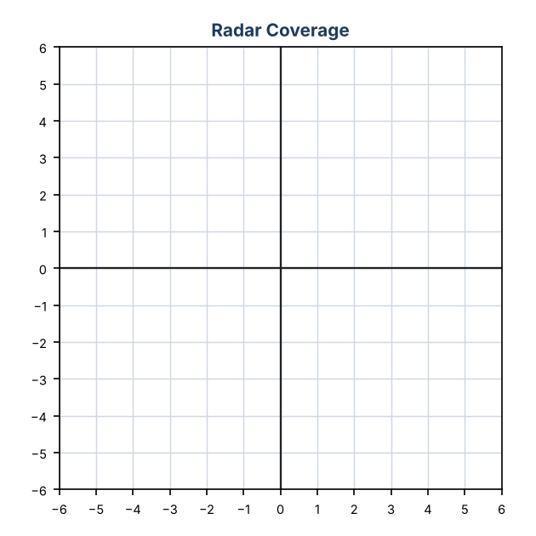

10. Which stations are outside the radar rectangle?

11. Design a new rectangular radar zone that covers all six stations with the least area. Give the corners and the area.

Final Product: Weather Station Report
Your final product must include:
- Ordered data with a number line
- Elevation profile with changes and means
- Radar rectangle calculations and a redesign
- Answer to the |a| < |b| question with examples
- A polished weather station report
Reflection
R1. Summarize how the sign and the absolute value of a number each give information.

R2. How did you find side lengths on the coordinate plane without a ruler?

Scoring Rubric
Criteria | 4 – Exceeds | 3 – Meets | 2 – Approaching | 1 – Beginning
Mathematical Accuracy | All calculations and solutions are correct; answers include units and are checked. | Nearly all work is correct; minor errors do not change conclusions. | Several errors; some conclusions are affected. | Many errors or missing work.
Reasoning & Justification | Clear, complete explanations connect every answer to the situation; uses precise vocabulary. | Explanations are mostly clear and connected to the situation. | Explanations are brief or partly unclear. | Little or no explanation.
Application & Design | Temperatures, elevations, and stations are ordered, compared, and mapped correctly with absolute value used for distances. Goes beyond the minimum with a creative, realistic choice. | Temperatures, elevations, and stations are ordered, compared, and mapped correctly with absolute value used for distances. | Design is incomplete or only partly uses the math from the unit. | Design is missing or unrelated to the unit math.
Communication & Presentation | Report includes the station map, ordered data, distance calculations, and a forecast. Polished, organized, and visually engaging. | Report includes the station map, ordered data, distance calculations, and a forecast. Organized and easy to follow. | Product is missing required parts or is hard to follow. | Product is mostly missing.

