PRE-ALGEBRA (7TH) · UNIT 10: AREA AND VOLUME  Backyard Pool Makeover  Use area, surface area, and volume to design a backyard with a pool and patio. | CP1  2–3 class periods

Name: ________________________________ Date: ______________ Period: ______
The Scenario
A family hired your design team to redo their backyard. They want a pool, a stone patio, a garden, and a fire pit, and they have a budget.
You will use area, surface area, and volume to choose shapes, calculate materials, and present your design.
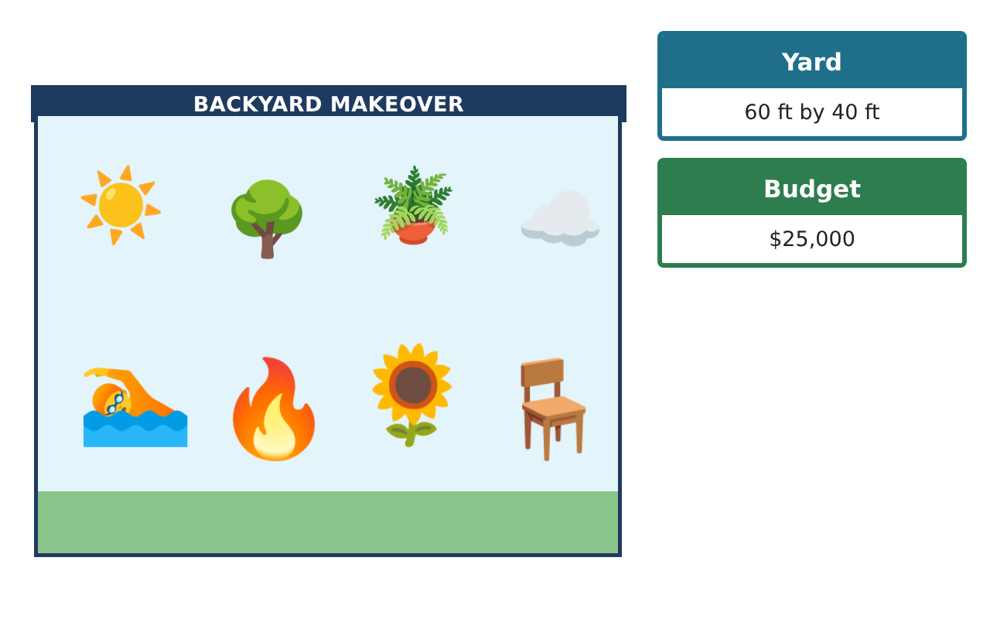
Learning Goals
- I can find areas of composite figures and circles.
- I can find surface area and volume of prisms and cylinders.
- I can use area and volume to price a project within a budget.
Project Timeline
When | What you will do
Day 1 | Hardscape
Day 2 | Pools
Day 3 | Budget Proposal
Final | Backyard Design Proposal + reflection
Part 1: Hardscape
Day 1 · Use π ≈ 3.14. The yard is 60 ft by 40 ft.
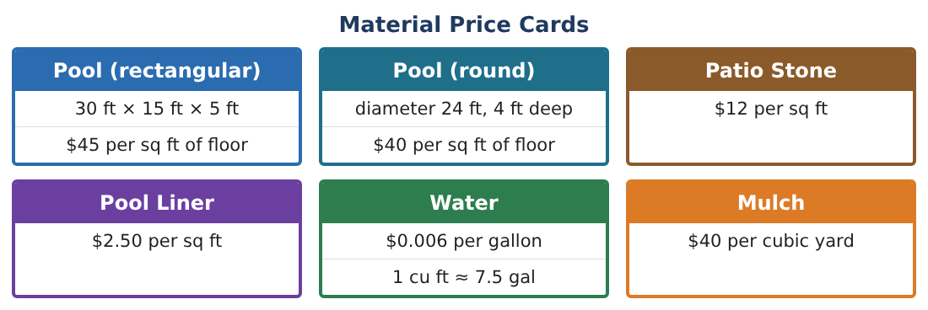
1. The patio is a trapezoid with parallel sides 26 ft and 18 ft and height 14 ft. Find its area and cost.

2. A circular fire pit (r = 2 ft) sits in the patio and is not paved. Find the paved area and the new cost.

3. Mulch 3 inches deep covers a 10 ft by 8 ft triangle garden. How many cubic yards? (27 cu ft = 1 cu yd)

4. What percent of the yard is the patio?

Part 2: Pools
Day 2 · Compare the two pools.
5. Find the volume in cubic feet and gallons of each pool.

6. Find the liner area for each pool (floor + walls).

7. Find the liner cost and the cost to fill each pool with water.

8. Which pool holds more water per square foot of yard it covers?

Part 3: Budget Proposal
Day 3 · Budget $25,000. Pool floor prices are on the cards.
9. Find the total cost for each pool option (floor, liner, water) plus the patio.

10. Which option fits the budget? How much is left for mulch and the garden?

11. Write your proposal with a labeled yard drawing and a cost table.

Final Product: Backyard Design Proposal
Your final product must include:
- Scaled yard drawing
- Area and cost of the patio and garden
- Volume, gallons, and liner area of both pools
- Total cost comparison
- Proposal with a recommendation
Reflection
R1. Why is the liner area different from the floor area?

R2. How did changing the shape of the pool change the cost?

Scoring Rubric
Criteria | 4 – Exceeds | 3 – Meets | 2 – Approaching | 1 – Beginning
Mathematical Accuracy | All calculations and solutions are correct; answers include units and are checked. | Nearly all work is correct; minor errors do not change conclusions. | Several errors; some conclusions are affected. | Many errors or missing work.
Reasoning & Justification | Clear, complete explanations connect every answer to the situation; uses precise vocabulary. | Explanations are mostly clear and connected to the situation. | Explanations are brief or partly unclear. | Little or no explanation.
Application & Design | Areas, surface areas, and volumes are computed correctly and used to price and compare designs. Goes beyond the minimum with a creative, realistic choice. | Areas, surface areas, and volumes are computed correctly and used to price and compare designs. | Design is incomplete or only partly uses the math from the unit. | Design is missing or unrelated to the unit math.
Communication & Presentation | Proposal includes a labeled drawing, calculations, a cost table, and a recommendation. Polished, organized, and visually engaging. | Proposal includes a labeled drawing, calculations, a cost table, and a recommendation. Organized and easy to follow. | Product is missing required parts or is hard to follow. | Product is mostly missing.

