PRE-ALGEBRA (7TH) · UNIT 10: AREA AND VOLUME  Backyard Pool Makeover  Use area, surface area, and volume to design a backyard with a pool and patio. | CP2  2–3 class periods

Name: ________________________________ Date: ______________ Period: ______
The Scenario
A family hired your design team to redo their backyard. They want a pool, a stone patio, a garden, and a fire pit, and they have a budget.
You will use area, surface area, and volume to choose shapes, calculate materials, and present your design.
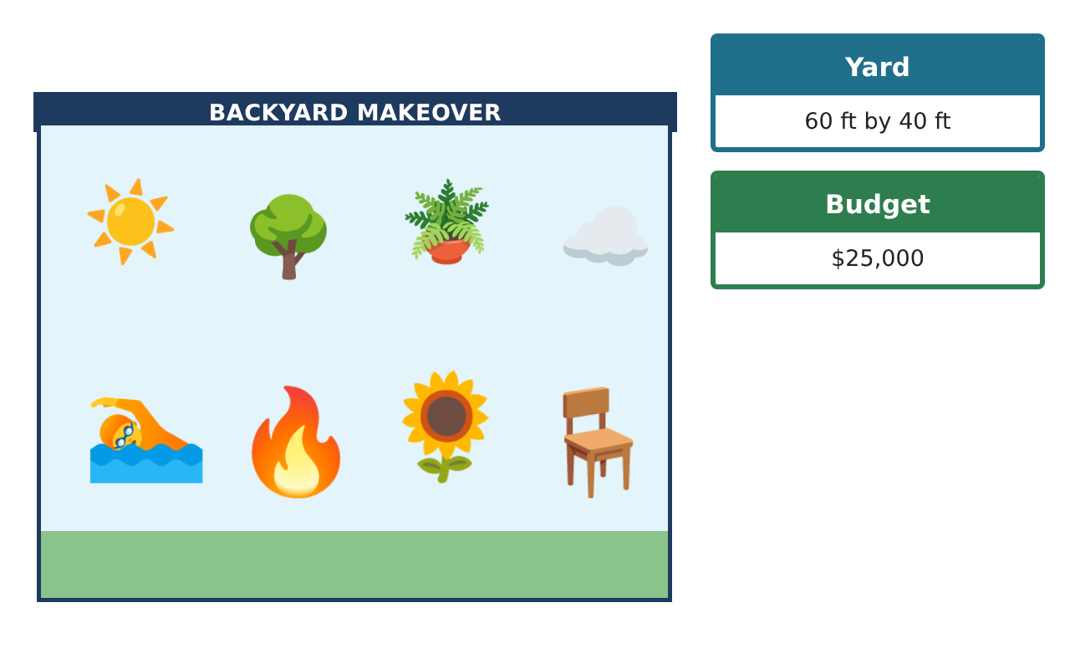
Learning Goals
- I can find the area of parallelograms, triangles, trapezoids, and circles.
- I can find the volume of prisms and cylinders.
- I can use measurements to find costs.
Project Timeline
When | What you will do
Day 1 | Patio & Garden
Day 2 | The Pool
Day 3 | Fire Pit & Cost
Final | Backyard Design Proposal + reflection
Part 1: Patio & Garden
Day 1 · Use the Material Price Cards. Use π ≈ 3.14.
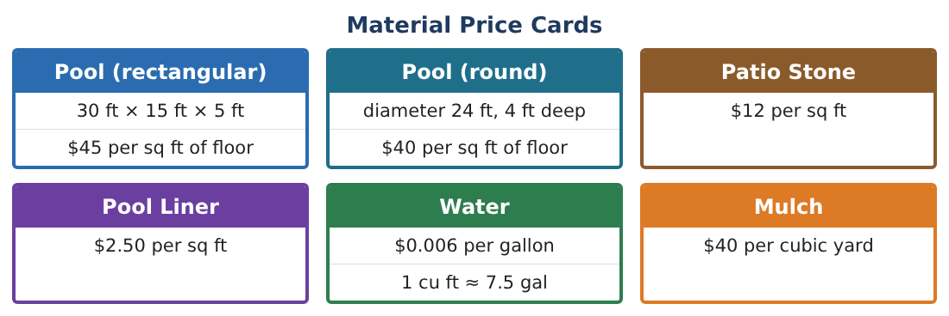
1. The patio is a parallelogram with base 20 ft and height 12 ft. Find its area.
Starter: A = bh = ___ × ___

2. Find the cost of patio stone for the patio.

3. A triangle garden has base 10 ft and height 8 ft. Find its area.

4. A trapezoid flower bed has bases 6 ft and 10 ft and height 4 ft. Find its area.

Part 2: The Pool
Day 2 · Compare the two pool shapes.
5. Find the floor area of the rectangular pool (30 ft × 15 ft).

6. Find the floor area of the round pool (diameter 24 ft).

7. Find the volume of water in the rectangular pool (5 ft deep).

8. Find the volume of the round pool (4 ft deep).

Part 3: Fire Pit & Cost
Day 3 · The fire pit is a circle with radius 2 ft.
9. Find the area of the fire pit.

10. How many gallons of water fill the rectangular pool? (1 cu ft ≈ 7.5 gal)

11. Choose a pool and find the cost of its floor. Add the patio. Is it under $25,000?

Final Product: Backyard Design Proposal
Your final product must include:
- A yard drawing with every shape labeled
- Areas of the patio, garden, bed, and fire pit
- Pool volume and gallons
- Cost table
- Your recommendation
Reflection
R1. Why is pool size measured with volume but the patio with area?

R2. How did you use the radius in the circle formulas?

Scoring Rubric
Criteria | 4 – Exceeds | 3 – Meets | 2 – Approaching | 1 – Beginning
Mathematical Accuracy | All calculations and solutions are correct; answers include units and are checked. | Nearly all work is correct; minor errors do not change conclusions. | Several errors; some conclusions are affected. | Many errors or missing work.
Reasoning & Justification | Clear, complete explanations connect every answer to the situation; uses precise vocabulary. | Explanations are mostly clear and connected to the situation. | Explanations are brief or partly unclear. | Little or no explanation.
Application & Design | Areas, surface areas, and volumes are computed correctly and used to price and compare designs. Goes beyond the minimum with a creative, realistic choice. | Areas, surface areas, and volumes are computed correctly and used to price and compare designs. | Design is incomplete or only partly uses the math from the unit. | Design is missing or unrelated to the unit math.
Communication & Presentation | Proposal includes a labeled drawing, calculations, a cost table, and a recommendation. Polished, organized, and visually engaging. | Proposal includes a labeled drawing, calculations, a cost table, and a recommendation. Organized and easy to follow. | Product is missing required parts or is hard to follow. | Product is mostly missing.

