PRE-ALGEBRA (7TH) · UNIT 8: LINEAR FUNCTIONS AND GRAPHING  Bike Share Showdown  Graph linear functions to choose the best bike or scooter rental. | CP1  2–3 class periods

Name: ________________________________ Date: ______________ Period: ______
The Scenario
Your city just launched three ways to get around downtown: a bike share, an electric scooter company, and a monthly pass. Each has a different starting fee and price per minute.
You will graph each option as a linear function, compare them, and write a guide that helps riders choose.
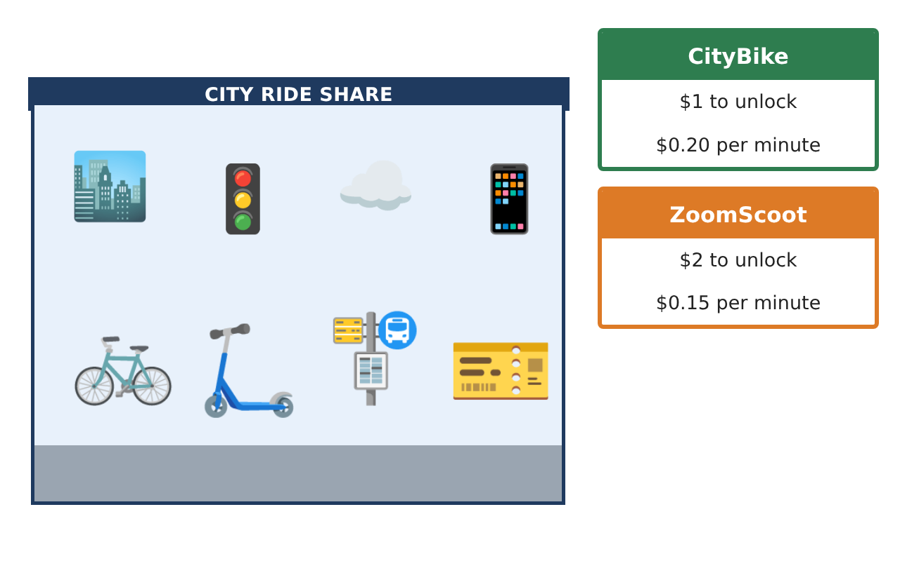
Learning Goals
- I can identify functions and represent them with tables, rules, and graphs.
- I can interpret slope and intercepts and fit a trend line.
- I can solve systems by graphing and graph linear inequalities.
Project Timeline
When | What you will do
Day 1 | Functions & Data
Day 2 | Three Options
Day 3 | Budget
Final | Rental Comparison Guide + reflection
Part 1: Functions & Data
Day 1 · Use the Ride Data card.
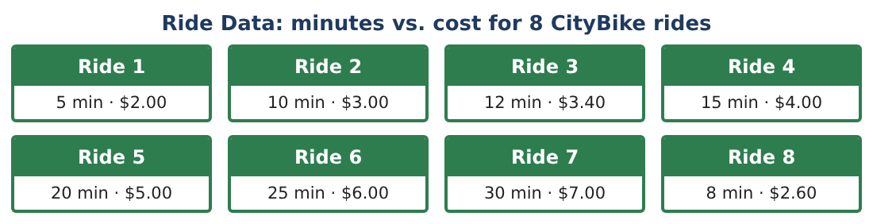
1. Is the set of (minutes, cost) pairs a function? Could a different set of rides make it not a function? Explain.

2. Make a scatter plot of the ride data. Describe the correlation.

3. Find the slope using two rides and write the equation of the line.

4. Predict the cost of a 45-minute ride.

Part 2: Three Options
Day 2 · ZoomScoot: $2 + $0.15 per minute. MonthPass: $30 per month, rides free.
5. Write rules for ZoomScoot and MonthPass for x total minutes in a month.

6. Graph CityBike, ZoomScoot, and MonthPass (for one long ride per month) on the same axes. Where do CityBike and ZoomScoot cross?

7. A rider takes 20 rides of 15 minutes each in a month. Find the monthly cost of each option.

8. Solve the system y = 0.20x + 1 and y = 0.15x + 2 algebraically to check your graph.

Part 3: Budget
Day 3 · You have at most $12 per week for CityBike rides.
9. Let r be the number of rides and m the minutes per ride (same each time). Write the cost of r 10-minute rides and an inequality for the budget.

10. Graph y ≤ 0.20x + 1 for one ride. Which side is shaded and what does a point in the shaded region mean?

11. Write your Rider Guide: which option is best for (a) one short trip, (b) one long trip, (c) daily commuting? Use your graphs.

Final Product: Rental Comparison Guide
Your final product must include:
- Scatter plot with trend line
- Rules and graphs for three options
- System solved by graphing and algebra
- Budget inequality
- Rider Guide with recommendations
Reflection
R1. How do slope and y-intercept help you compare plans without graphing?

R2. Why is the intersection of two lines important here?

Scoring Rubric
Criteria | 4 – Exceeds | 3 – Meets | 2 – Approaching | 1 – Beginning
Mathematical Accuracy | All calculations and solutions are correct; answers include units and are checked. | Nearly all work is correct; minor errors do not change conclusions. | Several errors; some conclusions are affected. | Many errors or missing work.
Reasoning & Justification | Clear, complete explanations connect every answer to the situation; uses precise vocabulary. | Explanations are mostly clear and connected to the situation. | Explanations are brief or partly unclear. | Little or no explanation.
Application & Design | Linear functions, slopes, intercepts, systems, and inequalities are modeled and used correctly to compare options. Goes beyond the minimum with a creative, realistic choice. | Linear functions, slopes, intercepts, systems, and inequalities are modeled and used correctly to compare options. | Design is incomplete or only partly uses the math from the unit. | Design is missing or unrelated to the unit math.
Communication & Presentation | Rider Guide includes graphs, rules, intersection points, and a clear decision chart. Polished, organized, and visually engaging. | Rider Guide includes graphs, rules, intersection points, and a clear decision chart. Organized and easy to follow. | Product is missing required parts or is hard to follow. | Product is mostly missing.

