PRE-ALGEBRA (7TH) · UNIT 5: OPERATIONS WITH FRACTIONS  Birdhouse Builders  Measure, cut, and assemble birdhouses using fraction and mixed-number operations. | Honors  2–3 class periods

Name: ________________________________ Date: ______________ Period: ______
The Scenario
The science club is putting birdhouses around the school garden. Each birdhouse is cut from wooden boards measured in feet and inches, and the measurements use fractions of an inch.
You will use fraction operations to plan every cut, avoid wasting wood, and design your own birdhouse.
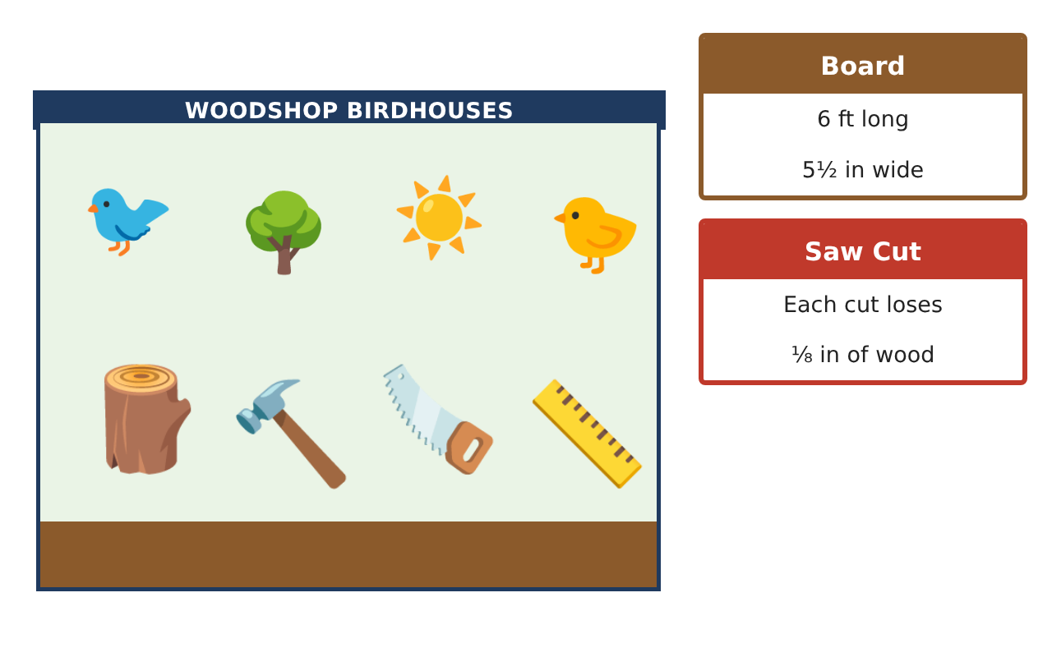
Learning Goals
- I can solve multi-step problems with rational numbers and customary units.
- I can optimize cuts to reduce waste.
- I can use powers of fractions and fraction equations in design.
Project Timeline
When | What you will do
Day 1 | Efficient Cutting
Day 2 | Rational Numbers in the Shop
Day 3 | Design Challenge
Final | Birdhouse Build Plan + reflection
Part 1: Efficient Cutting
Day 1 · Boards are 6 ft (72 in). Each cut removes $\frac{1}{8}$ in.
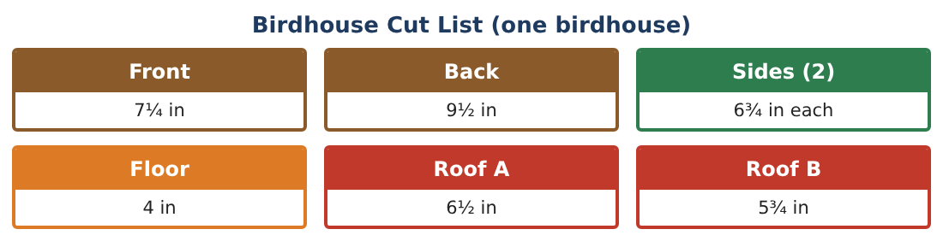
1. Find the length used by one birdhouse with 7 cuts and the leftover from one board.

2. Can two leftovers (24$\frac{5}{8}$ in each) make the pieces of a third birdhouse if pieces cannot be joined? Show a cutting plan.

3. Using that plan, how many boards are needed for 12 birdhouses?

4. What fraction of the wood is wasted with the 8-board plan?

Part 2: Rational Numbers in the Shop
Day 2 · Measurements can be fractions or decimals.
5. A digital caliper reads 0.3125 in. Write it as a fraction in simplest form. Is it closer to $\frac{1}{4}$ or $\frac{3}{8}$?

6. The entrance hole has diameter 1$\frac{1}{4}$ in. Find its area using π ≈ $\frac{22}{7}$.

7. Evaluate ($\frac{3}{2}$)³ and explain what it means for a birdhouse scaled by 1$\frac{1}{2}$ in every direction.

8. Order −$\frac{3}{8}$, −0.4, −$\frac{5}{16}$, and −$\frac{1}{3}$ (these are errors in inches from four cuts). Which cut was most accurate?

Part 3: Design Challenge
Day 3 · Design a birdhouse for a larger bird.
9. A bluebird needs a floor with area at least 16 sq in. If the floor is square, what side length (to the nearest $\frac{1}{8}$ in) is needed?

10. A flicker needs a floor of 7$\frac{1}{4}$ in by 7$\frac{1}{4}$ in. By what factor must you scale the original 4 in floor? Solve 4k = 7$\frac{1}{4}$.

11. Write a full cut list for your scaled design and determine how many boards are needed for 6 birdhouses with the least waste.

Final Product: Birdhouse Build Plan
Your final product must include:
- Optimized cutting plan with leftovers
- Board count and waste fraction
- Rational number analysis (decimals, π, powers)
- Scaled design with equations
- Build plan with a materials list
Reflection
R1. How did planning leftovers reduce the number of boards?

R2. Why does scaling every length by k scale area by k² and volume by k³?

Scoring Rubric
Criteria | 4 – Exceeds | 3 – Meets | 2 – Approaching | 1 – Beginning
Mathematical Accuracy | All calculations and solutions are correct; answers include units and are checked. | Nearly all work is correct; minor errors do not change conclusions. | Several errors; some conclusions are affected. | Many errors or missing work.
Reasoning & Justification | Clear, complete explanations connect every answer to the situation; uses precise vocabulary. | Explanations are mostly clear and connected to the situation. | Explanations are brief or partly unclear. | Little or no explanation.
Application & Design | Cut plans, scaling, and equations use fraction operations correctly and produce a buildable birdhouse. Goes beyond the minimum with a creative, realistic choice. | Cut plans, scaling, and equations use fraction operations correctly and produce a buildable birdhouse. | Design is incomplete or only partly uses the math from the unit. | Design is missing or unrelated to the unit math.
Communication & Presentation | Build plan includes the drawing, cut list, board plan, and materials. Polished, organized, and visually engaging. | Build plan includes the drawing, cut list, board plan, and materials. Organized and easy to follow. | Product is missing required parts or is hard to follow. | Product is mostly missing.

