PRE-ALGEBRA (7TH) · UNIT 12: DATA ANALYSIS AND PROBABILITY  Board Game Inventor  Use probability, counting, and data to invent and test a fair board game. | CP2  2–3 class periods

Name: ________________________________ Date: ______________ Period: ______
The Scenario
A game company is holding a contest for the best new family board game. Your game must use dice, a spinner, and a deck of cards, and it must be fair and fun.
You will use probability and data to design the rules, test the game, and prove it is fair.
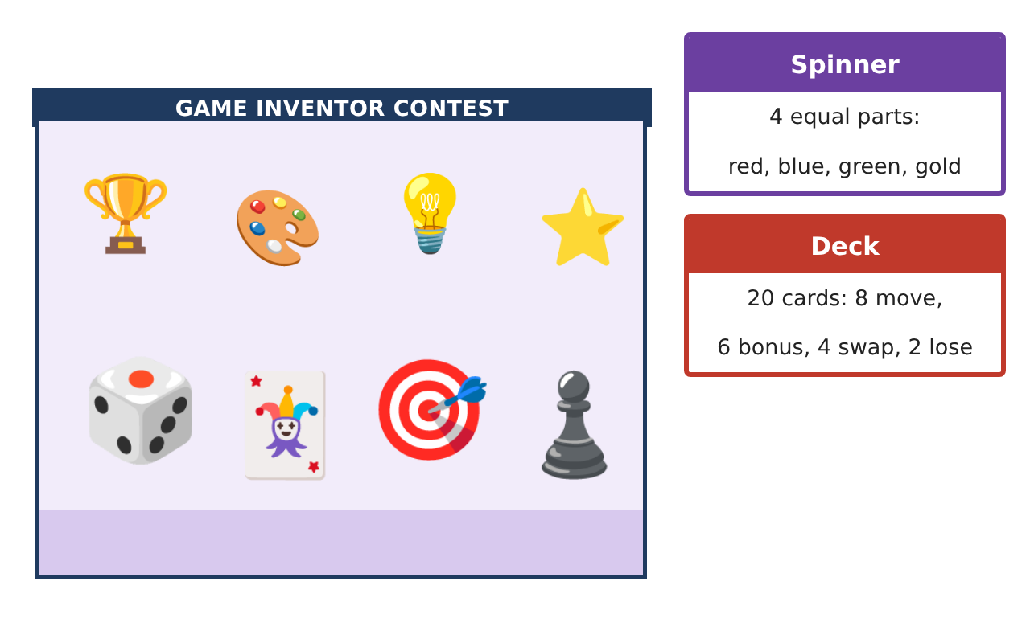
Learning Goals
- I can find theoretical and experimental probability.
- I can count outcomes with a tree diagram or the counting principle.
- I can display data to test a game.
Project Timeline
When | What you will do
Day 1 | Chance Basics
Day 2 | Counting Outcomes
Day 3 | Invent the Game
Final | Game Box & Rule Book + reflection
Part 1: Chance Basics
Day 1 · Use the spinner and deck shown on the first page.
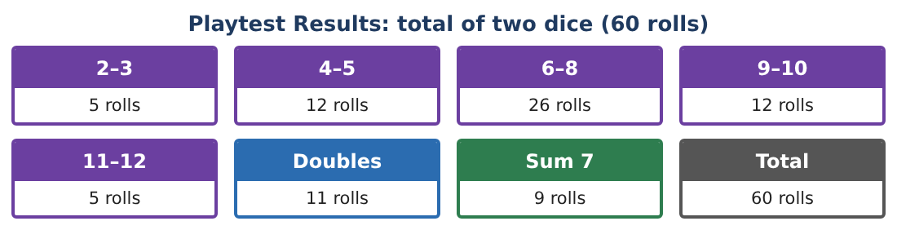
1. What is the probability the spinner lands on gold?

2. What is the probability of drawing a bonus card?

3. What is the probability of NOT drawing a lose card?

4. Roll one die. What is the probability of rolling an even number?

Part 2: Counting Outcomes
Day 2 · Make a tree diagram or use multiplication.
5. How many outcomes are there for one spin and one die roll?
Starter: spinner outcomes × die outcomes = ___ × ___

6. What is the probability of spinning red and rolling a 6?

7. How many outcomes are there for two dice? What is the probability of a sum of 7?

8. Compare: in the playtest, a sum of 7 came up 9 times in 60 rolls. What is the experimental probability?

Part 3: Invent the Game
Day 3 · Write your rules.
9. Make a bar graph of the playtest results.

10. Write a rule that uses the spinner and the deck. Find the probability that your rule happens on a turn.

11. Draw your game board and write three rules.

Final Product: Game Box & Rule Book
Your final product must include:
- Probability of each spinner color and card type
- Tree diagram or counting principle work
- Bar graph of the playtest
- Rules with probabilities
- Your game board
Reflection
R1. Why might experimental probability be different from theoretical probability?

R2. What makes a game fair?

Scoring Rubric
Criteria | 4 – Exceeds | 3 – Meets | 2 – Approaching | 1 – Beginning
Mathematical Accuracy | All calculations and solutions are correct; answers include units and are checked. | Nearly all work is correct; minor errors do not change conclusions. | Several errors; some conclusions are affected. | Many errors or missing work.
Reasoning & Justification | Clear, complete explanations connect every answer to the situation; uses precise vocabulary. | Explanations are mostly clear and connected to the situation. | Explanations are brief or partly unclear. | Little or no explanation.
Application & Design | Probabilities, counts, and playtest analysis are correct and used to make the game fair. Goes beyond the minimum with a creative, realistic choice. | Probabilities, counts, and playtest analysis are correct and used to make the game fair. | Design is incomplete or only partly uses the math from the unit. | Design is missing or unrelated to the unit math.
Communication & Presentation | Rule book includes probabilities, the board, playtest displays, and a fairness argument. Polished, organized, and visually engaging. | Rule book includes probabilities, the board, playtest displays, and a fairness argument. Organized and easy to follow. | Product is missing required parts or is hard to follow. | Product is mostly missing.

