PRE-ALGEBRA (7TH) · UNIT 12: DATA ANALYSIS AND PROBABILITY  Board Game Inventor  Use probability, counting, and data to invent and test a fair board game. | Honors  2–3 class periods

Name: ________________________________ Date: ______________ Period: ______
The Scenario
A game company is holding a contest for the best new family board game. Your game must use dice, a spinner, and a deck of cards, and it must be fair and fun.
You will use probability and data to design the rules, test the game, and prove it is fair.
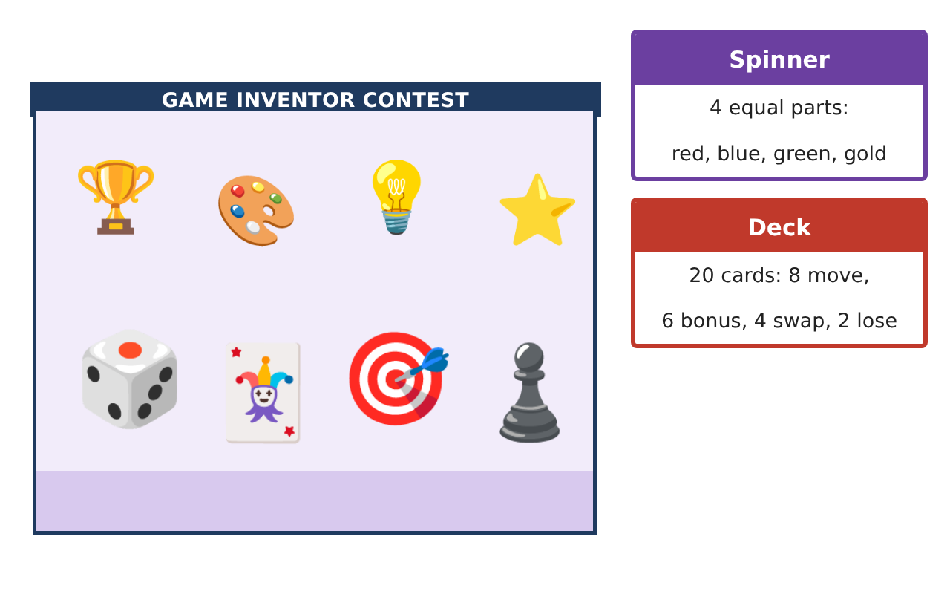
Learning Goals
- I can analyze compound probabilities, including dependent events.
- I can use counting methods to compute probabilities.
- I can use expected value and data to make a game fair.
Project Timeline
When | What you will do
Day 1 | Probability Engine
Day 2 | Counting & Probability
Day 3 | Expected Value & Fairness
Final | Game Box & Rule Book + reflection
Part 1: Probability Engine
Day 1 · Spinner (4 equal colors), deck of 20 cards (8 move, 6 bonus, 4 swap, 2 lose), two dice.
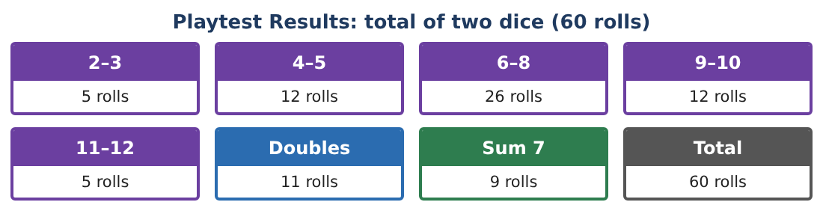
1. Find P(at least one 6 when rolling two dice).

2. Draw three cards without replacement. Find P(no lose cards).

3. Find P(exactly one bonus card in two draws without replacement).

4. Is "spin gold" independent of "roll a sum of 7"? Show that P(both) = P(gold) × P(7).

Part 2: Counting & Probability
Day 2 · Use permutations and combinations.
5. A hand is 4 cards from the 20-card deck. How many hands are possible?

6. How many hands contain both lose cards?

7. Find the probability that a hand contains both lose cards.

8. Five finish positions are awarded to 5 players. What is the probability that the youngest player finishes first and the oldest finishes last?

Part 3: Expected Value & Fairness
Day 3 · Card points: move +2, bonus +5, swap 0, lose −8.
9. Find the expected points per card drawn.

10. Player 1 earns 3 points for doubles and Player 2 earns 1 point for any sum of 6–8. Find the expected points per roll for each. Is it fair?

11. Change one rule so the expected points are equal, and use the playtest data to support your choice.

Final Product: Game Box & Rule Book
Your final product must include:
- Compound probability calculations
- Counting-based probabilities
- Expected value of cards and rules
- Fairness adjustment with data
- Complete rule book and board
Reflection
R1. How does expected value help design a fair game?

R2. When should you use the complement to find a probability?

Scoring Rubric
Criteria | 4 – Exceeds | 3 – Meets | 2 – Approaching | 1 – Beginning
Mathematical Accuracy | All calculations and solutions are correct; answers include units and are checked. | Nearly all work is correct; minor errors do not change conclusions. | Several errors; some conclusions are affected. | Many errors or missing work.
Reasoning & Justification | Clear, complete explanations connect every answer to the situation; uses precise vocabulary. | Explanations are mostly clear and connected to the situation. | Explanations are brief or partly unclear. | Little or no explanation.
Application & Design | Probabilities, counts, and playtest analysis are correct and used to make the game fair. Goes beyond the minimum with a creative, realistic choice. | Probabilities, counts, and playtest analysis are correct and used to make the game fair. | Design is incomplete or only partly uses the math from the unit. | Design is missing or unrelated to the unit math.
Communication & Presentation | Rule book includes probabilities, the board, playtest displays, and a fairness argument. Polished, organized, and visually engaging. | Rule book includes probabilities, the board, playtest displays, and a fairness argument. Organized and easy to follow. | Product is missing required parts or is hard to follow. | Product is mostly missing.

