PRE-ALGEBRA (7TH) · UNIT 1: ALGEBRAIC EXPRESSIONS AND INTEGERS  Deep Sea Expedition  Use integers and expressions to guide a submarine to the ocean floor and back. | CP1  2–3 class periods

Name: ________________________________ Date: ______________ Period: ______
The Scenario
Your team is piloting the research submarine Nautilus II. Sea level is 0 feet, every depth below it is negative, and the ocean gets colder as you dive.
You will use integers and expressions to plan dives, track temperature changes, and map the creatures you discover.
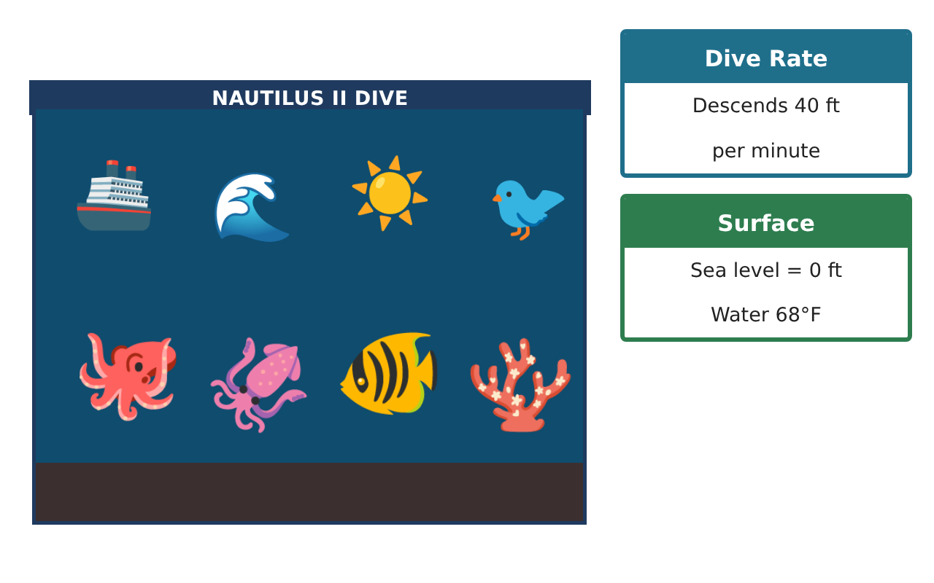
Learning Goals
- I can compute with integers in context.
- I can write and evaluate algebraic expressions for rates and changes.
- I can use the order of operations, patterns, and the coordinate plane to plan an expedition.
Project Timeline
When | What you will do
Day 1 | Dive Data
Day 2 | Expressions & Operations
Day 3 | Plan the Route
Final | Expedition Log + reflection
Part 1: Dive Data
Day 1 · Use the Discovery Cards.
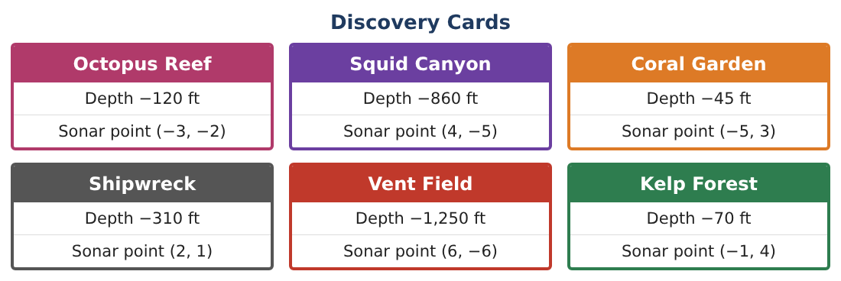
1. Find the change in depth from Coral Garden to Vent Field and from Vent Field back to the surface.

2. The average depth of the six discoveries: show the expression and evaluate it.

3. The temperature at −860 ft is 41°F and at the surface it is 68°F. Find the average change per 100 ft (to the nearest tenth).

4. Write an inequality comparing −310 and −120 and explain it in context.

Part 2: Expressions & Operations
Day 2 · The sub descends 40 ft per minute and rises 60 ft per minute.
5. Write an expression for the depth after descending d minutes and then rising r minutes.

6. Evaluate your expression for d = 25, r = 10. Is the sub above or below Squid Canyon?

7. Oxygen: the tank holds 900 units and the crew uses 12 units per minute. Write an expression for the oxygen left after t minutes and find how much is left after 45 minutes.

8. Evaluate the sonar reading −3[4 − (−2)]² ÷ 9 + 7.

Part 3: Plan the Route
Day 3 · Plot the sonar points. 1 unit = 100 ft horizontally.
9. Plot the points. Which two discoveries are in the same quadrant? Which discovery is closest to the origin (the dock)?
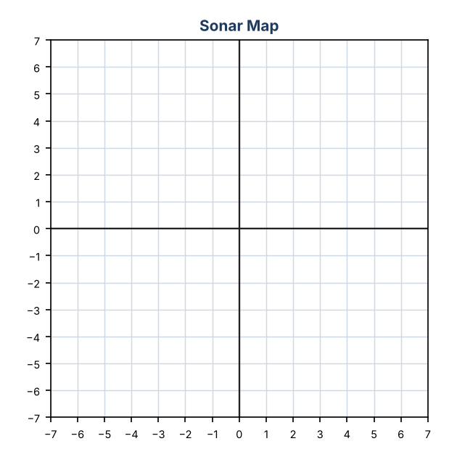

10. The sub visits Kelp Forest, then Coral Garden, then Octopus Reef. Find the total change in depth for the trip.

11. Design a 4-stop dive route. Give each depth change as an integer and show that the sub returns to the surface (total change 0 from the start).

Final Product: Expedition Log
Your final product must include:
- Dive data with integer calculations
- Depth and oxygen expressions with evaluations
- Sonar map and route
- Order-of-operations sonar reading
- Expedition log summarizing the dive
Reflection
R1. Why does a rise add a positive number and a dive add a negative number?

R2. How does writing an expression help you plan before you dive?

Scoring Rubric
Criteria | 4 – Exceeds | 3 – Meets | 2 – Approaching | 1 – Beginning
Mathematical Accuracy | All calculations and solutions are correct; answers include units and are checked. | Nearly all work is correct; minor errors do not change conclusions. | Several errors; some conclusions are affected. | Many errors or missing work.
Reasoning & Justification | Clear, complete explanations connect every answer to the situation; uses precise vocabulary. | Explanations are mostly clear and connected to the situation. | Explanations are brief or partly unclear. | Little or no explanation.
Application & Design | Integer calculations, expressions, and the sonar map correctly model the dive and support the route plan. Goes beyond the minimum with a creative, realistic choice. | Integer calculations, expressions, and the sonar map correctly model the dive and support the route plan. | Design is incomplete or only partly uses the math from the unit. | Design is missing or unrelated to the unit math.
Communication & Presentation | Expedition log includes depths, expressions, the sonar map, and a clear summary. Polished, organized, and visually engaging. | Expedition log includes depths, expressions, the sonar map, and a clear summary. Organized and easy to follow. | Product is missing required parts or is hard to follow. | Product is mostly missing.

