PRE-ALGEBRA (7TH) · UNIT 2: SOLVING ONE-STEP EQUATIONS AND INEQUALITIES  Movie Night Fundraiser  Simplify expressions and solve one-step equations and inequalities to run a school movie night. | CP1  2–3 class periods

Name: ________________________________ Date: ______________ Period: ______
The Scenario
The student council is hosting a movie night in the gym to raise money for new sports equipment. You will sell tickets and snacks, rent a projector, and follow the gym rules.
You will use properties, equations, and inequalities to figure out how many tickets and snacks to sell and whether you will reach the goal.

Learning Goals
- I can use properties and the distributive property to write equivalent expressions.
- I can solve one-step equations with integers and decimals.
- I can solve and graph one-step inequalities, including dividing by a negative.
Project Timeline
When | What you will do
Day 1 | Profit Expressions
Day 2 | Equations
Day 3 | Inequalities & Plan
Final | Fundraiser Plan + reflection
Part 1: Profit Expressions
Day 1 · Use the Price Board. t = tickets, p = popcorn, d = drinks.
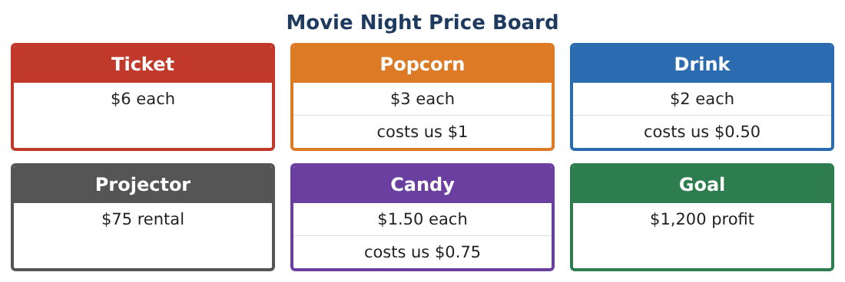
1. Write an expression for the profit on p popcorns and d drinks (price minus our cost).

2. Write and simplify an expression for total profit including tickets and the projector.

3. A "combo" is 1 ticket, 1 popcorn, and 1 drink for $10. Simplify the profit on c combos.

4. Simplify −3(2x − 5) + 4x and name the properties you used.

Part 2: Equations
Day 2 · Write and solve one-step equations.
5. The combo profit was $595. How many combos were sold?

6. Drink profit was $93. How many drinks were sold?

7. The temperature in the gym fell 6 degrees to 64°F. What was it before?

8. The council split the profit equally among 4 teams; each got $287.50. What was the total profit?

Part 3: Inequalities & Plan
Day 3 · The goal is $1,200 profit.
9. The council already has $650 profit. How much more profit p is needed? Solve and graph.

10. The air conditioner lowers the gym temperature 2 degrees per hour, and the total change must be no lower than −8 degrees. Solve −2h ≥ −8 and explain what the answer means.

11. Make a plan for selling tickets, combos, and snacks that reaches the $1,200 goal without going over 240 people. Show your calculations.

Final Product: Fundraiser Plan
Your final product must include:
- Profit expressions and simplifications
- Four solved equations with checks
- Inequalities with graphs
- A sales plan that meets the goal and the gym rule
- Presentation for the student council
Reflection
R1. Why do you reverse the inequality symbol when you divide by a negative?

R2. How did simplifying expressions make the plan easier?

Scoring Rubric
Criteria | 4 – Exceeds | 3 – Meets | 2 – Approaching | 1 – Beginning
Mathematical Accuracy | All calculations and solutions are correct; answers include units and are checked. | Nearly all work is correct; minor errors do not change conclusions. | Several errors; some conclusions are affected. | Many errors or missing work.
Reasoning & Justification | Clear, complete explanations connect every answer to the situation; uses precise vocabulary. | Explanations are mostly clear and connected to the situation. | Explanations are brief or partly unclear. | Little or no explanation.
Application & Design | Expressions, equations, and inequalities model sales and limits correctly and are used to reach the goal. Goes beyond the minimum with a creative, realistic choice. | Expressions, equations, and inequalities model sales and limits correctly and are used to reach the goal. | Design is incomplete or only partly uses the math from the unit. | Design is missing or unrelated to the unit math.
Communication & Presentation | Fundraiser plan includes expressions, solved equations, graphed inequalities, and a recommendation. Polished, organized, and visually engaging. | Fundraiser plan includes expressions, solved equations, graphed inequalities, and a recommendation. Organized and easy to follow. | Product is missing required parts or is hard to follow. | Product is mostly missing.

