PRE-ALGEBRA (7TH) · UNIT 2: SOLVING ONE-STEP EQUATIONS AND INEQUALITIES  Movie Night Fundraiser  Simplify expressions and solve one-step equations and inequalities to run a school movie night. | Honors  2–3 class periods

Name: ________________________________ Date: ______________ Period: ______
The Scenario
The student council is hosting a movie night in the gym to raise money for new sports equipment. You will sell tickets and snacks, rent a projector, and follow the gym rules.
You will use properties, equations, and inequalities to figure out how many tickets and snacks to sell and whether you will reach the goal.
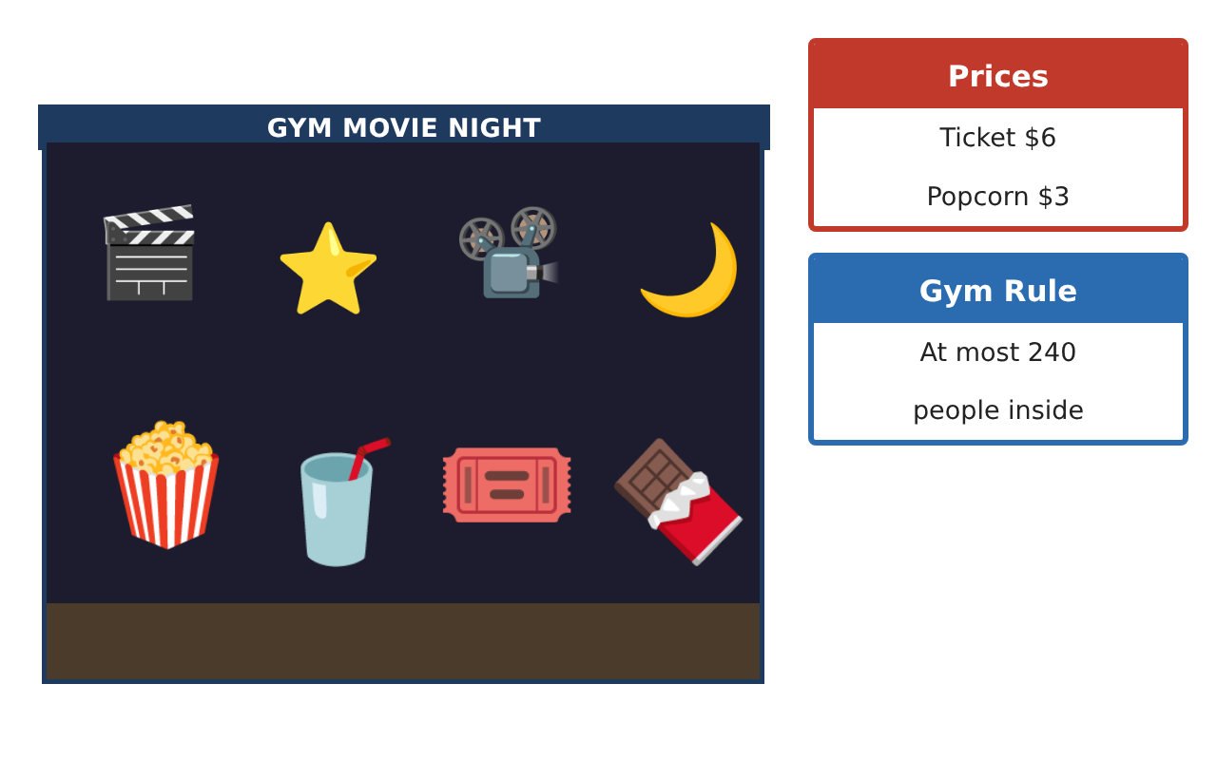
Learning Goals
- I can write equivalent expressions and justify each step with a property.
- I can solve one-step equations and inequalities with rational coefficients.
- I can optimize a plan under constraints.
Project Timeline
When | What you will do
Day 1 | Expression Analysis
Day 2 | Equations with Rational Numbers
Day 3 | Constraints & Optimization
Final | Fundraiser Plan + reflection
Part 1: Expression Analysis
Day 1 · Use the Price Board.
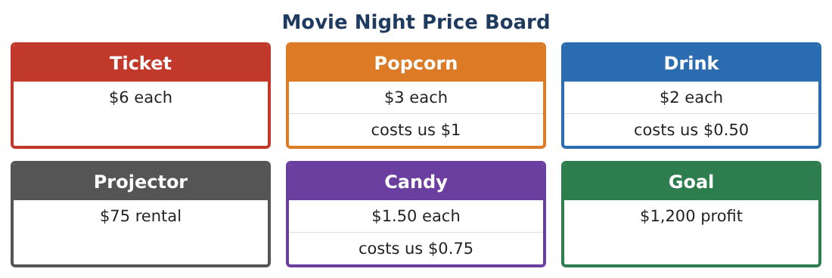
1. A family pack is 4 tickets, 3 popcorns, and 4 drinks for $38. Write the profit per pack and simplify. Is the pack a better deal for the council than selling the items separately?

2. Prove 6(t + 2) − 2(3t − 1) is the same for every t. What is its value?

3. Simplify $\frac{3}{4}$(8x − 12) − $\frac{1}{2}$(4x + 6).

4. Write two different expressions that equal 12n − 18 and explain the property used.

Part 2: Equations with Rational Numbers
Day 2 · Solve each one-step equation and interpret.
5. Candy profit is $0.75 per piece. Profit was $67.50. How many pieces sold?

6. $\frac{2}{3}$ of the seats were filled with 160 people. How many seats are there?

7. After a −$18.25 refund, the balance was $1,043.75. What was it before?

8. −$\frac{5}{4}$x = 35. Solve and write a movie-night story that this equation could describe.

Part 3: Constraints & Optimization
Day 3 · Goal: at least $1,200 profit. At most 240 people. Projector $75.
9. Each person buys one ticket and spends on average $3.50 on snacks with average profit $2.10. Write and solve an inequality for the number of people needed to reach the goal.

10. Graph the possible numbers of people on a number line (use both the goal and the gym rule).
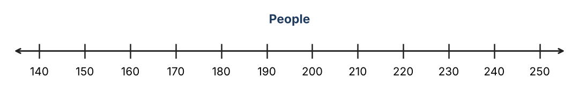

11. Recommend a ticket price change that would reach the goal with only 130 people. Justify with an inequality.

Final Product: Fundraiser Plan
Your final product must include:
- Expression proofs with properties
- Equations with fractions and decimals
- Inequality model for attendance
- Graph showing goal and gym constraints
- Recommendation memo with a ticket price
Reflection
R1. When does a "deal" earn less profit for the seller? Use your family pack result.

R2. How do two inequalities together describe the possible attendance?

Scoring Rubric
Criteria | 4 – Exceeds | 3 – Meets | 2 – Approaching | 1 – Beginning
Mathematical Accuracy | All calculations and solutions are correct; answers include units and are checked. | Nearly all work is correct; minor errors do not change conclusions. | Several errors; some conclusions are affected. | Many errors or missing work.
Reasoning & Justification | Clear, complete explanations connect every answer to the situation; uses precise vocabulary. | Explanations are mostly clear and connected to the situation. | Explanations are brief or partly unclear. | Little or no explanation.
Application & Design | Expressions, equations, and inequalities model sales and limits correctly and are used to reach the goal. Goes beyond the minimum with a creative, realistic choice. | Expressions, equations, and inequalities model sales and limits correctly and are used to reach the goal. | Design is incomplete or only partly uses the math from the unit. | Design is missing or unrelated to the unit math.
Communication & Presentation | Fundraiser plan includes expressions, solved equations, graphed inequalities, and a recommendation. Polished, organized, and visually engaging. | Fundraiser plan includes expressions, solved equations, graphed inequalities, and a recommendation. Organized and easy to follow. | Product is missing required parts or is hard to follow. | Product is mostly missing.

