PRE-ALGEBRA (7TH) · UNIT 3: DECIMALS AND EQUATIONS  Road Trip Planner  Use decimals, formulas, and equations to plan a family road trip. | CP1  2–3 class periods

Name: ________________________________ Date: ______________ Period: ______
The Scenario
Your family is driving from Boston to Montreal and back with stops along the way. Gas prices are in dollars and cents, speeds and times vary, and in Canada distances are in kilometers and gas is sold by the liter.
You will use decimals, formulas, and equations to plan the route, the budget, and the schedule.
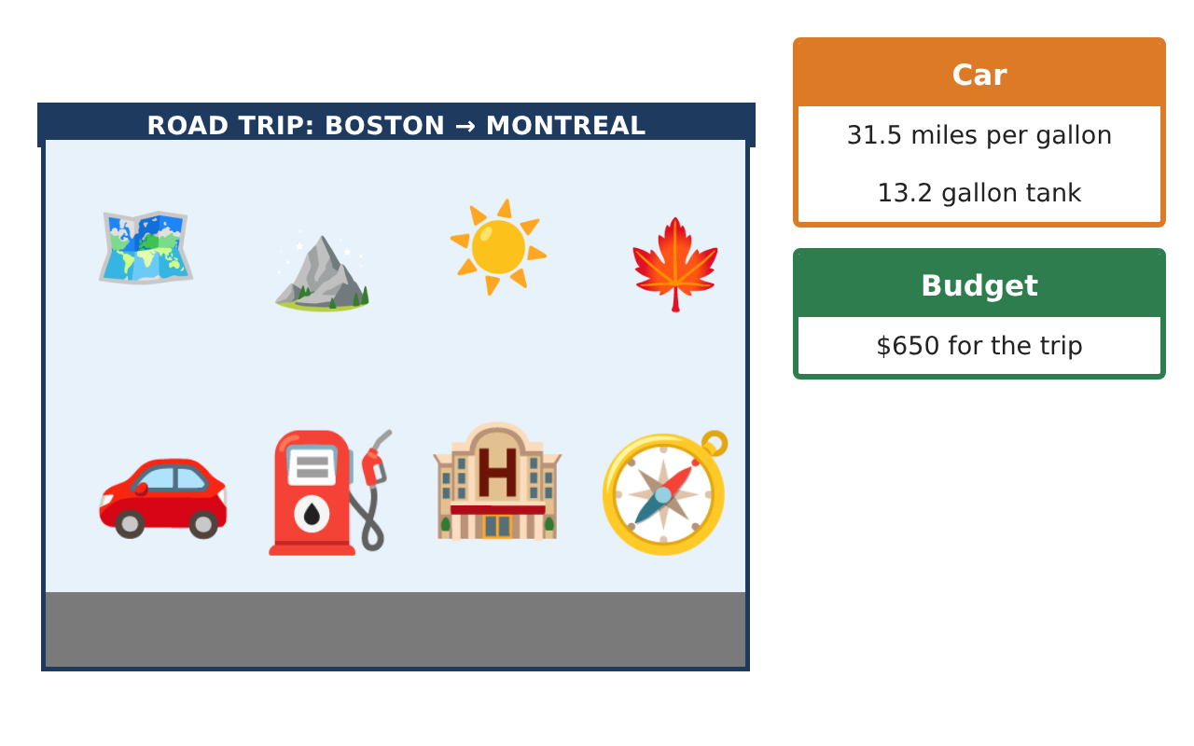
Learning Goals
- I can estimate and compute with decimals in multi-step problems.
- I can use formulas and solve one-step decimal equations.
- I can convert metric and customary units.
Project Timeline
When | What you will do
Day 1 | Trip Data
Day 2 | Money Equations
Day 3 | Metric Canada
Final | Road Trip Itinerary + reflection
Part 1: Trip Data
Day 1 · Use the Trip Leg Cards.
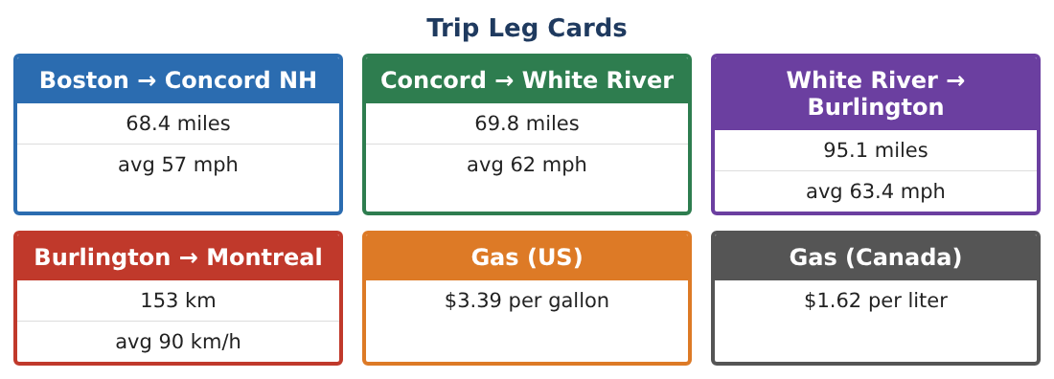
1. Find the time for each US leg (nearest hundredth of an hour) and the total US driving time in hours and minutes.

2. Find the mean and median of the four leg times (Montreal leg = 153 ÷ 90 = 1.70 h).

3. Estimate the total gas for the round trip (US legs twice plus the Canada leg twice, about 95 miles each way) at 31.5 mpg.

4. Is one full tank (13.2 gallons) enough to reach Montreal from Boston? Explain.

Part 2: Money Equations
Day 2 · Write and solve a one-step equation for each.
5. Two nights in a hotel cost $289.80. What is the price per night?

6. After buying gas, you have $472.35 left from $650. How much did you spend?

7. A toll is 1.25 times the regular car price of $3.60. What is the toll?

8. A snack stop costs $\frac{s}{4}$ per person, and each person paid $6.85. What was the total s?

Part 3: Metric Canada
Day 3 · 1 km ≈ 0.621 mi; 1 gal ≈ 3.785 L; US $1 ≈ CA $1.36.
9. Convert the Burlington → Montreal leg to miles and find the time at 90 km/h in hours and minutes.

10. Gas in Canada is CA $1.62 per liter. Find the price per gallon in US dollars and compare with $3.39.

11. Build the full itinerary with leave and arrive times, distances, gas stops, and a budget that stays under $650.

Final Product: Road Trip Itinerary
Your final product must include:
- Leg table with times
- Mean and median trip times
- Gas plan and cost
- Money equations solved
- Itinerary with metric conversions and the budget
Reflection
R1. Why might the median leg time be a better summary than the mean?

R2. Why must you convert units before comparing gas prices?

Scoring Rubric
Criteria | 4 – Exceeds | 3 – Meets | 2 – Approaching | 1 – Beginning
Mathematical Accuracy | All calculations and solutions are correct; answers include units and are checked. | Nearly all work is correct; minor errors do not change conclusions. | Several errors; some conclusions are affected. | Many errors or missing work.
Reasoning & Justification | Clear, complete explanations connect every answer to the situation; uses precise vocabulary. | Explanations are mostly clear and connected to the situation. | Explanations are brief or partly unclear. | Little or no explanation.
Application & Design | Distances, times, costs, and conversions are computed correctly and used to build a realistic itinerary. Goes beyond the minimum with a creative, realistic choice. | Distances, times, costs, and conversions are computed correctly and used to build a realistic itinerary. | Design is incomplete or only partly uses the math from the unit. | Design is missing or unrelated to the unit math.
Communication & Presentation | Itinerary includes a leg table, times, fuel and money plans, and conversions. Polished, organized, and visually engaging. | Itinerary includes a leg table, times, fuel and money plans, and conversions. Organized and easy to follow. | Product is missing required parts or is hard to follow. | Product is mostly missing.

