PRE-ALGEBRA (7TH) · UNIT 3: DECIMALS AND EQUATIONS  Road Trip Planner  Use decimals, formulas, and equations to plan a family road trip. | CP2  2–3 class periods

Name: ________________________________ Date: ______________ Period: ______
The Scenario
Your family is driving from Boston to Montreal and back with stops along the way. Gas prices are in dollars and cents, speeds and times vary, and in Canada distances are in kilometers and gas is sold by the liter.
You will use decimals, formulas, and equations to plan the route, the budget, and the schedule.
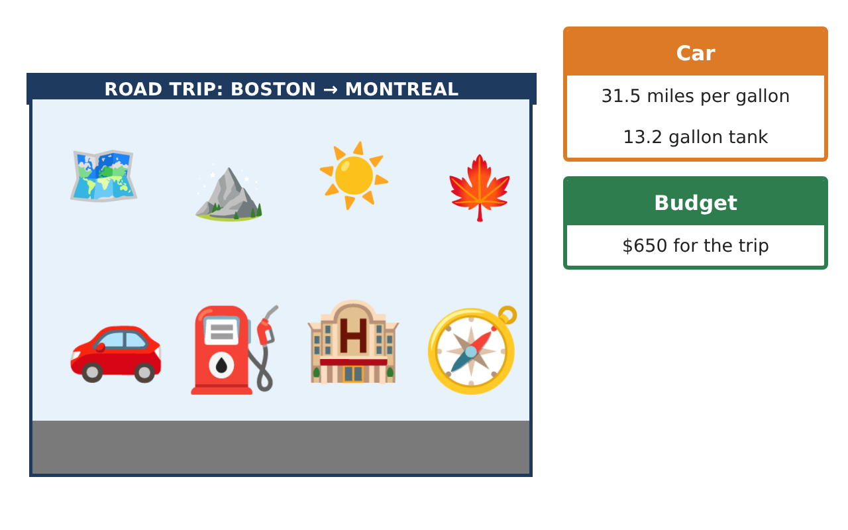
Learning Goals
- I can round and estimate with decimals.
- I can use the formula d = rt.
- I can solve one-step equations with decimals.
Project Timeline
When | What you will do
Day 1 | Estimate the Trip
Day 2 | Distance, Rate, Time
Day 3 | Canada Stop
Final | Road Trip Itinerary + reflection
Part 1: Estimate the Trip
Day 1 · Use the Trip Leg Cards.
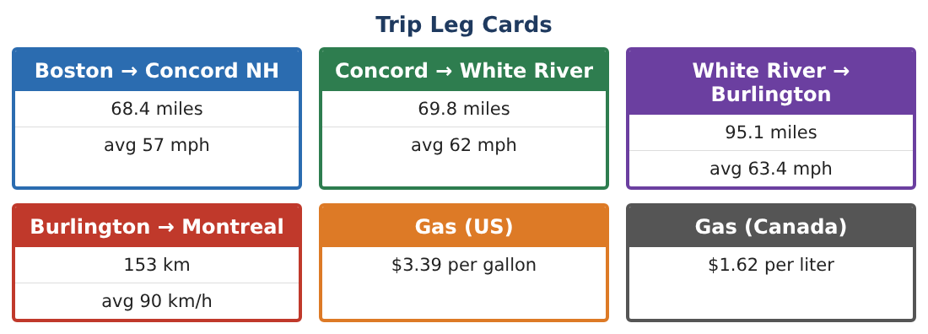
1. Round each US leg to the nearest mile. Estimate the total US distance.

2. Find the exact total of the three US legs.

3. Gas costs $3.39 per gallon. Estimate the cost of 10 gallons, then find it exactly.

4. Find the mean of the average speeds 57, 62, and 63.4 mph.

Part 2: Distance, Rate, Time
Day 2 · Use d = rt.
5. How far do you drive in 1.5 hours at 62 mph?
Starter: d = r × t = 62 × ___

6. How long does the Boston → Concord leg take at 57 mph? Round to the nearest tenth of an hour.

7. Solve 31.5g = 233.3 to find the gallons of gas for the US legs. Round to the nearest tenth.

8. How much does that gas cost at $3.39 per gallon?

Part 3: Canada Stop
Day 3 · 1 kilometer is about 0.62 mile. 1 gallon is about 3.79 liters.
9. Convert 153 km to miles.

10. Gas in Canada costs $1.62 per liter. About how much is that per gallon?

11. Make a table of each leg with distance (miles) and time. Find the total driving time.

Final Product: Road Trip Itinerary
Your final product must include:
- A map or list of the route
- Estimated and exact distances
- Times found with d = rt
- Gas needed and cost
- Your trip itinerary with stops
Reflection
R1. When is an estimate good enough, and when do you need the exact answer?

R2. How do you choose whether to multiply or divide with d = rt?

Scoring Rubric
Criteria | 4 – Exceeds | 3 – Meets | 2 – Approaching | 1 – Beginning
Mathematical Accuracy | All calculations and solutions are correct; answers include units and are checked. | Nearly all work is correct; minor errors do not change conclusions. | Several errors; some conclusions are affected. | Many errors or missing work.
Reasoning & Justification | Clear, complete explanations connect every answer to the situation; uses precise vocabulary. | Explanations are mostly clear and connected to the situation. | Explanations are brief or partly unclear. | Little or no explanation.
Application & Design | Distances, times, costs, and conversions are computed correctly and used to build a realistic itinerary. Goes beyond the minimum with a creative, realistic choice. | Distances, times, costs, and conversions are computed correctly and used to build a realistic itinerary. | Design is incomplete or only partly uses the math from the unit. | Design is missing or unrelated to the unit math.
Communication & Presentation | Itinerary includes a leg table, times, fuel and money plans, and conversions. Polished, organized, and visually engaging. | Itinerary includes a leg table, times, fuel and money plans, and conversions. Organized and easy to follow. | Product is missing required parts or is hard to follow. | Product is mostly missing.

