PRE-ALGEBRA (7TH) · UNIT 3: DECIMALS AND EQUATIONS  Road Trip Planner  Use decimals, formulas, and equations to plan a family road trip. | Honors  2–3 class periods

Name: ________________________________ Date: ______________ Period: ______
The Scenario
Your family is driving from Boston to Montreal and back with stops along the way. Gas prices are in dollars and cents, speeds and times vary, and in Canada distances are in kilometers and gas is sold by the liter.
You will use decimals, formulas, and equations to plan the route, the budget, and the schedule.
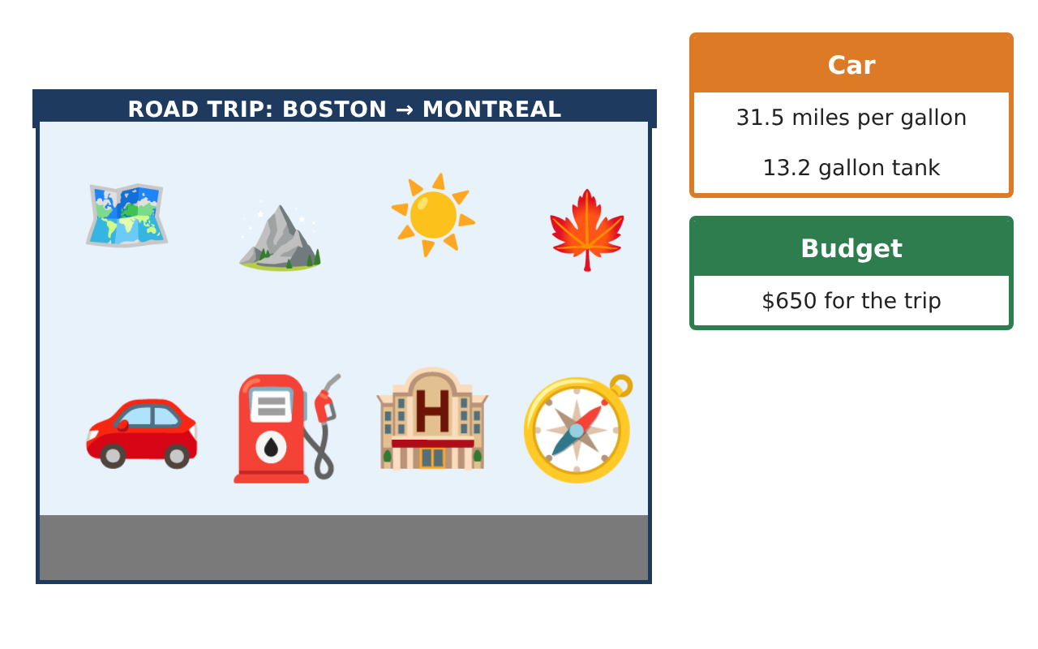
Learning Goals
- I can use formulas and decimal equations to make planning decisions.
- I can analyze trip data with measures of center.
- I can perform multi-step unit conversions with rates.
Project Timeline
When | What you will do
Day 1 | Speed & Time Analysis
Day 2 | Budget Equations
Day 3 | Metric Itinerary
Final | Road Trip Itinerary + reflection
Part 1: Speed & Time Analysis
Day 1 · Use the Trip Leg Cards.
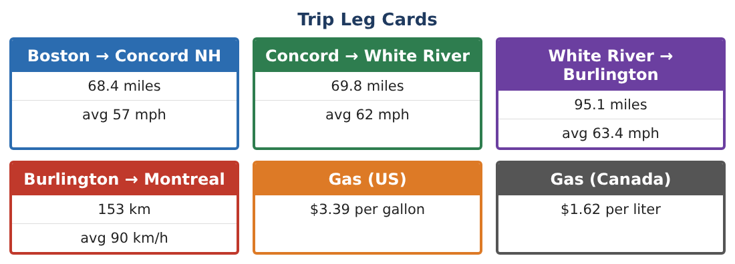
1. Find the average speed for the whole US part of the trip (total distance ÷ total time). Why is it not the mean of the three speeds?

2. Solve d = rt for t, then find how much time is saved on the White River → Burlington leg by driving 65 mph instead of 63.4 mph (in minutes).

3. Is speeding worth it? Use your answer and a $150 speeding ticket to argue.

4. The car gets 31.5 mpg at 60 mph but 27.8 mpg at 70 mph. How much more gas does the 233.3-mile US trip use at 70 mph?

Part 2: Budget Equations
Day 2 · Budget $650.
5. Hotel tax is 0.0975 of the room price. With tax, one night is $158.43. Solve 1.0975p = 158.43 for the price.

6. Find the round-trip gas cost if US gas is $3.39 per gallon for 466.6 miles and Canadian gas is US $4.51 per gallon for 190 miles.

7. With 2 hotel nights at $158.43 and the gas, how much is left for food and tolls? Write and solve an equation.

8. Should the family fill up in Vermont before crossing the border? Use numbers.

Part 3: Metric Itinerary
Day 3 · 1 km ≈ 0.621 mi, 1 gal ≈ 3.785 L, US $1 ≈ CA $1.36.
9. A Canadian sign says the speed limit is 100 km/h. Convert to mph.

10. Find the car’s fuel efficiency in km per liter.

11. Create a complete itinerary (times, distances in both units, fuel stops, and costs) and justify every decision with a calculation.

Final Product: Road Trip Itinerary
Your final product must include:
- Speed and time analysis with formulas
- Budget equations including tax and conversion
- Fuel plan comparing US and Canadian gas
- Metric conversions (km/h, km/L)
- Full itinerary with justification
Reflection
R1. Explain why average speed for a trip is not the mean of the leg speeds.

R2. How did writing equations help you check the budget?

Scoring Rubric
Criteria | 4 – Exceeds | 3 – Meets | 2 – Approaching | 1 – Beginning
Mathematical Accuracy | All calculations and solutions are correct; answers include units and are checked. | Nearly all work is correct; minor errors do not change conclusions. | Several errors; some conclusions are affected. | Many errors or missing work.
Reasoning & Justification | Clear, complete explanations connect every answer to the situation; uses precise vocabulary. | Explanations are mostly clear and connected to the situation. | Explanations are brief or partly unclear. | Little or no explanation.
Application & Design | Distances, times, costs, and conversions are computed correctly and used to build a realistic itinerary. Goes beyond the minimum with a creative, realistic choice. | Distances, times, costs, and conversions are computed correctly and used to build a realistic itinerary. | Design is incomplete or only partly uses the math from the unit. | Design is missing or unrelated to the unit math.
Communication & Presentation | Itinerary includes a leg table, times, fuel and money plans, and conversions. Polished, organized, and visually engaging. | Itinerary includes a leg table, times, fuel and money plans, and conversions. Organized and easy to follow. | Product is missing required parts or is hard to follow. | Product is mostly missing.

