PRE-ALGEBRA (7TH) · UNIT 9: SPATIAL THINKING  Skate Park Designer  Use angles, polygons, circles, and transformations to design a town skate park. | CP1  2–3 class periods

Name: ________________________________ Date: ______________ Period: ______
The Scenario
The town council approved a new skate park and wants students to design it. The ramps need exact angles, the rails run parallel, the deck is a polygon, and the bowl is a circle.
You will use angle relationships, polygons, circles, and transformations to create a blueprint and a logo for the park.
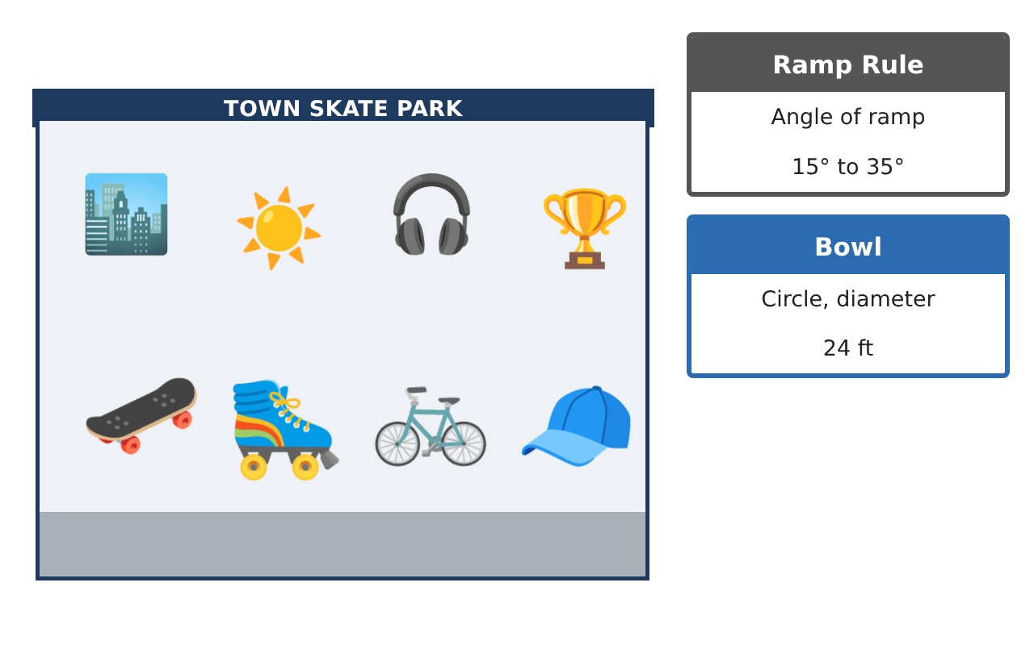
Learning Goals
- I can use angle pair relationships to find unknown angles.
- I can use parallel lines, polygon angle sums, and congruence in design.
- I can apply circle formulas and transformations.
Project Timeline
When | What you will do
Day 1 | Ramp Geometry
Day 2 | Layout
Day 3 | Bowl & Logo
Final | Skate Park Blueprint + reflection
Part 1: Ramp Geometry
Day 1 · Use the Feature Cards.
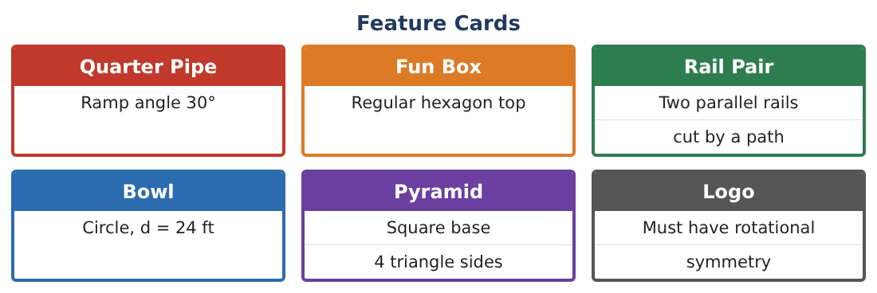
1. A ramp and its support form a right triangle with the ground. If the ramp angle is (2x + 4)° and the angle at the top is (3x + 1)°, find x and both angles.

2. Does the 38° ramp meet the rule (15° to 35°)? What angle would you change it to?

3. Two crossing rails form angles (4y − 10)° and (2y + 50)° that are vertical. Find y and the angle.

4. Explain why vertical angles are always equal.

Part 2: Layout
Day 2 · Two parallel rails are crossed by a path.
5. An alternate interior angle is (5x − 20)° and its partner is (3x + 30)°. Find x and the angle.

6. The fun box top is a regular hexagon and the pyramid base is a square. Find each interior angle and the sum of the exterior angles of each.

7. Two ramp triangles have matching sides 6 ft, 8 ft, 10 ft. Are they congruent? Which rule?

8. What polygon has an interior angle sum of 1,080°? Could it be the deck?

Part 3: Bowl & Logo
Day 3 · Use π ≈ 3.14.
9. Find the circumference and area of the 24-ft bowl. A coping rail goes around the edge at $12 per foot. Find its cost.

10. The logo is a triangle with vertices (1, 1), (4, 1), (1, 3). Rotate it 90° counterclockwise about the origin. Give the new vertices.
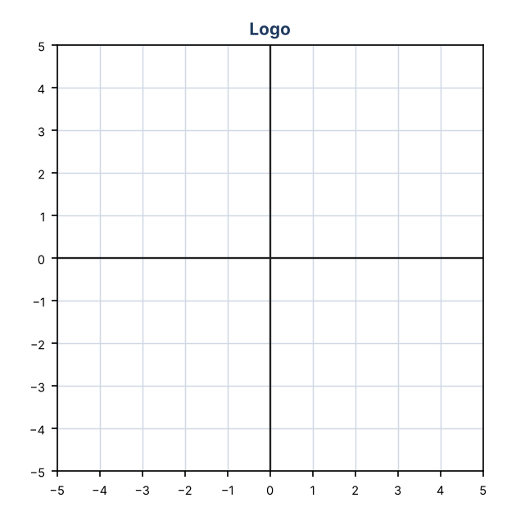

11. Design a logo with rotational symmetry of order 3 or more. Give its angle of rotation.

Final Product: Skate Park Blueprint
Your final product must include:
- Blueprint with every angle labeled and justified
- Equations for unknown angles
- Polygon angle calculations
- Bowl measurements and coping cost
- Logo with a rotation and its symmetry
Reflection
R1. How did writing equations help you find angles?

R2. How is a rotation different from a translation?

Scoring Rubric
Criteria | 4 – Exceeds | 3 – Meets | 2 – Approaching | 1 – Beginning
Mathematical Accuracy | All calculations and solutions are correct; answers include units and are checked. | Nearly all work is correct; minor errors do not change conclusions. | Several errors; some conclusions are affected. | Many errors or missing work.
Reasoning & Justification | Clear, complete explanations connect every answer to the situation; uses precise vocabulary. | Explanations are mostly clear and connected to the situation. | Explanations are brief or partly unclear. | Little or no explanation.
Application & Design | Angles, polygons, circle measures, and transformations are correct and produce a buildable design. Goes beyond the minimum with a creative, realistic choice. | Angles, polygons, circle measures, and transformations are correct and produce a buildable design. | Design is incomplete or only partly uses the math from the unit. | Design is missing or unrelated to the unit math.
Communication & Presentation | Blueprint is labeled with angles and measurements and includes the logo and calculations. Polished, organized, and visually engaging. | Blueprint is labeled with angles and measurements and includes the logo and calculations. Organized and easy to follow. | Product is missing required parts or is hard to follow. | Product is mostly missing.

