PRE-ALGEBRA (7TH) · UNIT 9: SPATIAL THINKING  Skate Park Designer  Use angles, polygons, circles, and transformations to design a town skate park. | CP2  2–3 class periods

Name: ________________________________ Date: ______________ Period: ______
The Scenario
The town council approved a new skate park and wants students to design it. The ramps need exact angles, the rails run parallel, the deck is a polygon, and the bowl is a circle.
You will use angle relationships, polygons, circles, and transformations to create a blueprint and a logo for the park.
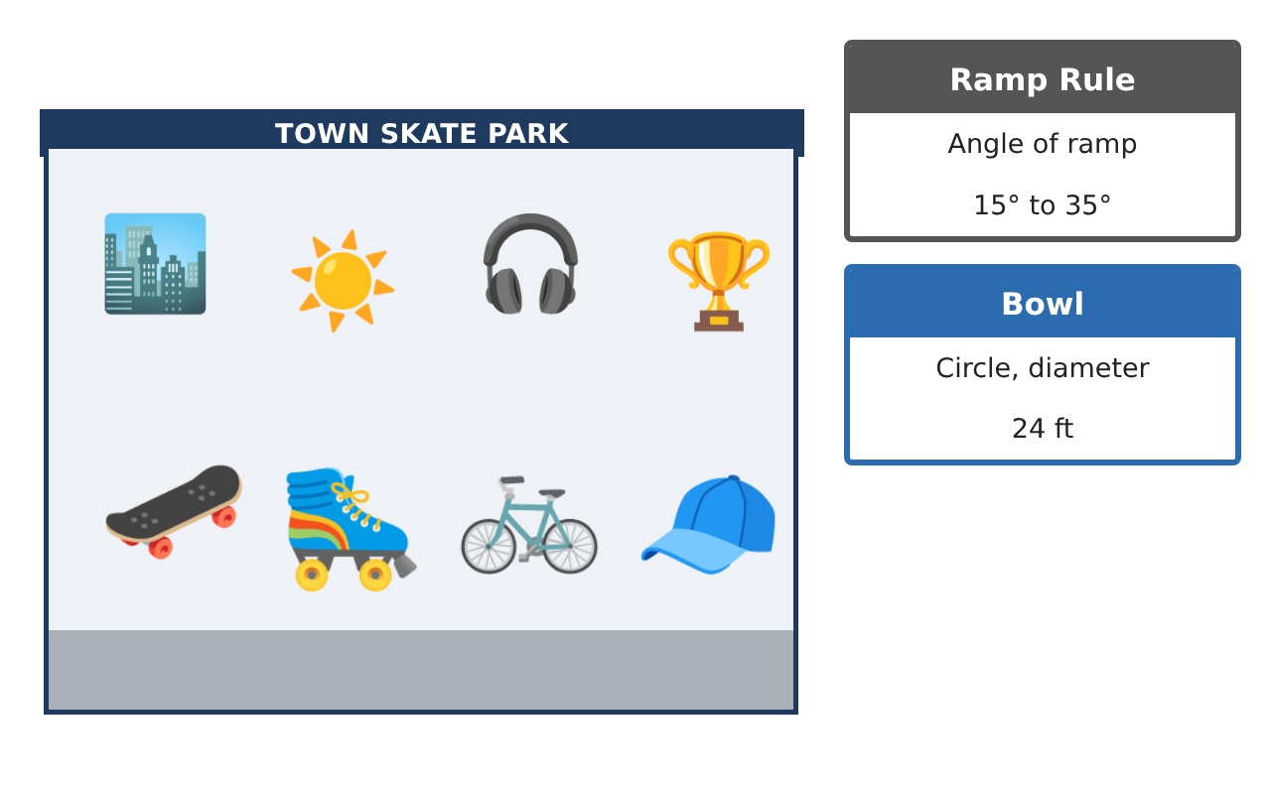
Learning Goals
- I can identify complementary, supplementary, and vertical angles.
- I can find angle measures with parallel lines.
- I can use the circumference formula and transformations.
Project Timeline
When | What you will do
Day 1 | Ramp Angles
Day 2 | Rails & Deck
Day 3 | Bowl & Logo
Final | Skate Park Blueprint + reflection
Part 1: Ramp Angles
Day 1 · A ramp meets the ground. The angle under the ramp and the angle on top of the ground line form a straight line.
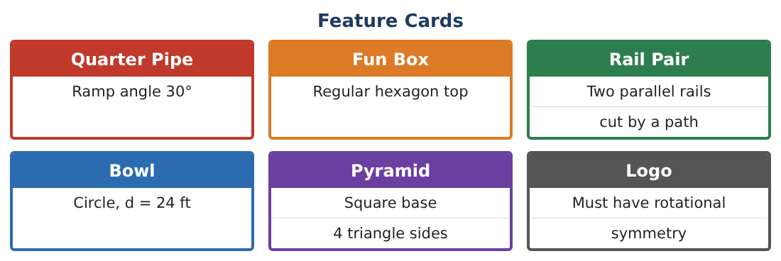
1. The quarter pipe ramp angle is 30°. What is the supplementary angle on the other side?
Starter: 30 + x = 180

2. A support post makes a right angle with the ground. The ramp makes 30° with the ground. What angle does the ramp make with the post?

3. Two rails cross and make a 70° angle. What are the other three angles?

4. Name one pair of complementary and one pair of supplementary angles you found.

Part 2: Rails & Deck
Day 2 · The two rails are parallel. A path crosses them.
5. The path makes a 65° angle with the first rail. What is the corresponding angle at the second rail?

6. What is the same-side interior angle to the 65° angle?

7. The fun box top is a regular hexagon. Find the sum of its angles.

8. Find the measure of each angle of the regular hexagon.

Part 3: Bowl & Logo
Day 3 · Use π ≈ 3.14.
9. The bowl is a circle with diameter 24 ft. Find its circumference.

10. Translate the point (2, 3) on the logo 4 units right and 1 unit down.

11. Draw a logo with at least one line of symmetry. Show the line.

Final Product: Skate Park Blueprint
Your final product must include:
- Blueprint with the ramp, rails, fun box, and bowl
- All angle measures labeled
- Hexagon angle sum
- Bowl circumference
- Your logo with symmetry
Reflection
R1. How do parallel rails help you find angles without measuring?

R2. Why does a regular hexagon have 120° angles?

Scoring Rubric
Criteria | 4 – Exceeds | 3 – Meets | 2 – Approaching | 1 – Beginning
Mathematical Accuracy | All calculations and solutions are correct; answers include units and are checked. | Nearly all work is correct; minor errors do not change conclusions. | Several errors; some conclusions are affected. | Many errors or missing work.
Reasoning & Justification | Clear, complete explanations connect every answer to the situation; uses precise vocabulary. | Explanations are mostly clear and connected to the situation. | Explanations are brief or partly unclear. | Little or no explanation.
Application & Design | Angles, polygons, circle measures, and transformations are correct and produce a buildable design. Goes beyond the minimum with a creative, realistic choice. | Angles, polygons, circle measures, and transformations are correct and produce a buildable design. | Design is incomplete or only partly uses the math from the unit. | Design is missing or unrelated to the unit math.
Communication & Presentation | Blueprint is labeled with angles and measurements and includes the logo and calculations. Polished, organized, and visually engaging. | Blueprint is labeled with angles and measurements and includes the logo and calculations. Organized and easy to follow. | Product is missing required parts or is hard to follow. | Product is mostly missing.

