PRE-ALGEBRA (7TH) · UNIT 9: SPATIAL THINKING  Skate Park Designer  Use angles, polygons, circles, and transformations to design a town skate park. | Honors  2–3 class periods

Name: ________________________________ Date: ______________ Period: ______
The Scenario
The town council approved a new skate park and wants students to design it. The ramps need exact angles, the rails run parallel, the deck is a polygon, and the bowl is a circle.
You will use angle relationships, polygons, circles, and transformations to create a blueprint and a logo for the park.
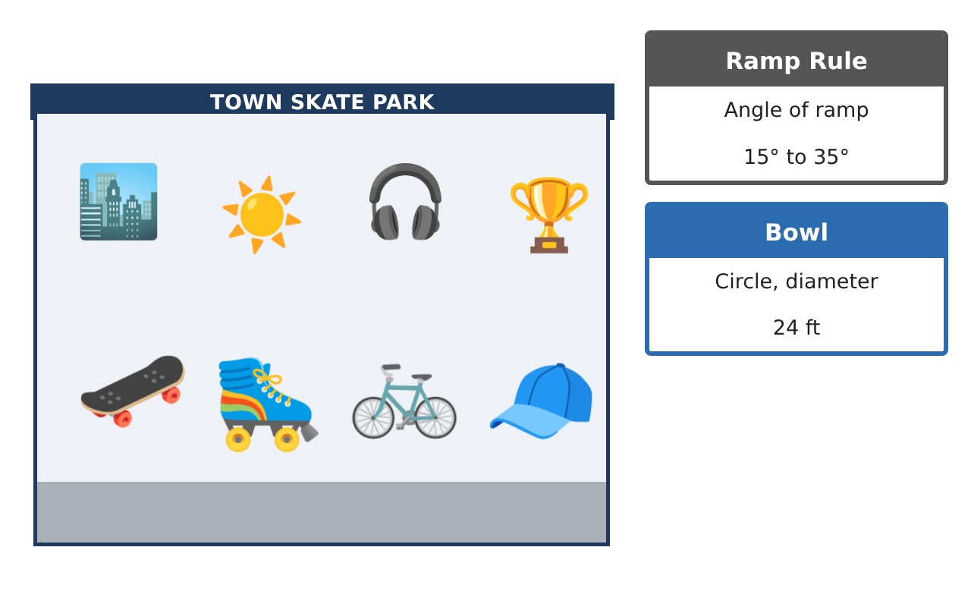
Learning Goals
- I can justify angle relationships with algebra and reasoning.
- I can use polygon properties to design tiling and decks.
- I can apply circles and compositions of transformations.
Project Timeline
When | What you will do
Day 1 | Angle Proofs
Day 2 | Deck Design
Day 3 | Bowl & Logo
Final | Skate Park Blueprint + reflection
Part 1: Angle Proofs
Day 1 · Rails are parallel; ramps meet the 15°–35° rule.
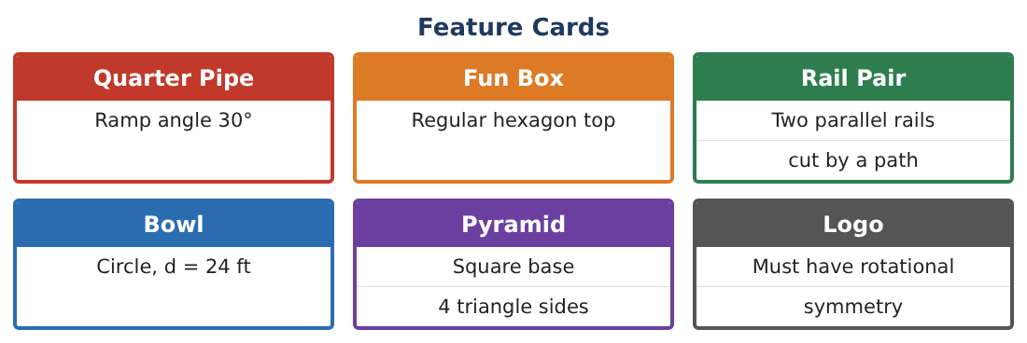
1. A path crosses two parallel rails. One angle is (x² − 10)° and its corresponding angle is (3x + 30)° with x > 0. Find x and the angle.

2. Prove that same-side interior angles are supplementary using a corresponding angle and a linear pair.

3. A ramp rises 4 ft for each 10 ft forward. Use a protractor drawing to estimate the angle. Does it meet the rule?

4. The angles of a triangular kicker are in the ratio 1 : 2 : 6. Find them. Does the smallest meet the ramp rule?

Part 2: Deck Design
Day 2 · The deck is tiled with polygons.
5. Which regular polygons tile a flat deck by themselves? Use interior angles to explain.

6. Can regular octagons and squares tile together? Show the angle sum at a vertex.

7. A regular polygon deck has interior angles of 150°. How many sides? What is its angle sum?

8. Explain why every regular polygon has exterior angles that add to 360°.

Part 3: Bowl & Logo
Day 3 · Use π.
9. The bowl is a circle with diameter 24 ft. A safety zone 4 ft wide surrounds it. Find the area of the safety zone in terms of π and to the nearest square foot.

10. Reflect the logo triangle (1, 1), (4, 1), (1, 3) across the y-axis, then rotate the image 180° about the origin. What single transformation does the same thing?
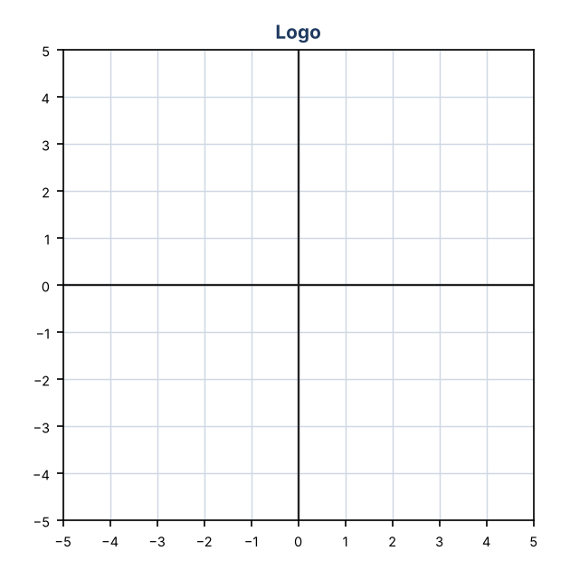

11. Design a logo with exactly 4 lines of symmetry and rotational symmetry of order 4. Explain how you know.

Final Product: Skate Park Blueprint
Your final product must include:
- Blueprint with angle proofs
- Deck tiling plan with angle sums
- Bowl and safety zone areas
- Composite transformation of the logo
- Presentation to the town council
Reflection
R1. Why do only some regular polygons tile a plane?

R2. How can two transformations combine to equal a single transformation?

Scoring Rubric
Criteria | 4 – Exceeds | 3 – Meets | 2 – Approaching | 1 – Beginning
Mathematical Accuracy | All calculations and solutions are correct; answers include units and are checked. | Nearly all work is correct; minor errors do not change conclusions. | Several errors; some conclusions are affected. | Many errors or missing work.
Reasoning & Justification | Clear, complete explanations connect every answer to the situation; uses precise vocabulary. | Explanations are mostly clear and connected to the situation. | Explanations are brief or partly unclear. | Little or no explanation.
Application & Design | Angles, polygons, circle measures, and transformations are correct and produce a buildable design. Goes beyond the minimum with a creative, realistic choice. | Angles, polygons, circle measures, and transformations are correct and produce a buildable design. | Design is incomplete or only partly uses the math from the unit. | Design is missing or unrelated to the unit math.
Communication & Presentation | Blueprint is labeled with angles and measurements and includes the logo and calculations. Polished, organized, and visually engaging. | Blueprint is labeled with angles and measurements and includes the logo and calculations. Organized and easy to follow. | Product is missing required parts or is hard to follow. | Product is mostly missing.

