PRE-ALGEBRA (7TH) · UNIT 6: RATIOS, PROPORTIONS, AND PERCENTAGES  Sneaker Store Manager  Use rates, proportions, and percents to run a sneaker store for a week. | CP2  2–3 class periods

Name: ________________________________ Date: ______________ Period: ______
The Scenario
You just became the manager of Fresh Kicks Sneaker Store. You have to order shoes from suppliers, lay out the new store, run a grand-opening raffle, and set prices that bring customers in and still make a profit.
You will use ratios, proportions, and percents to make every decision.
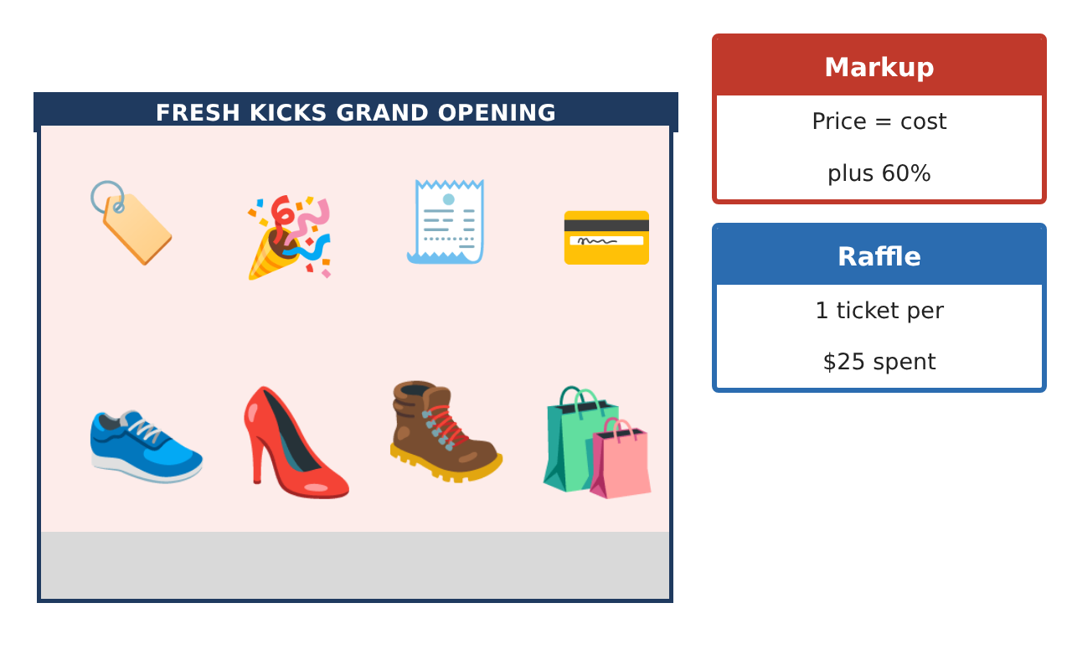
Learning Goals
- I can find unit rates and compare them.
- I can solve proportions.
- I can find percents, discounts, and simple probability.
Project Timeline
When | What you will do
Day 1 | Best Supplier
Day 2 | Scale Drawing
Day 3 | Prices & Raffle
Final | Store Manager Report + reflection
Part 1: Best Supplier
Day 1 · Use the Supplier Cards.
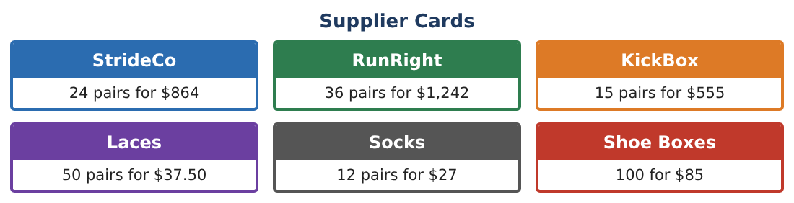
1. Find the price per pair for StrideCo.
Starter: $864 ÷ 24 = ___

2. Find the price per pair for RunRight and KickBox. Which supplier is cheapest?

3. Socks cost $27 for 12 pairs. How much do 30 pairs cost?

4. Laces cost $37.50 for 50. What is the cost per pair of laces?

Part 2: Scale Drawing
Day 2 · On the store plan, 1 inch = 4 feet.
5. The store is 12 inches long on the plan. How long is it really?

6. The checkout counter is 3$\frac{1}{2}$ in on the plan. How long is it?

7. A wall shelf is 20 ft long. How long should it be on the plan?

8. Draw a simple plan of the store with three labeled items and their real lengths.

Part 3: Prices & Raffle
Day 3 · The store adds 60% to the cost to set the price.
9. A pair costs the store $35. What is the price after a 60% markup?

10. The pair goes on sale for 25% off $56. What is the sale price?

11. The raffle has 200 tickets and 4 winning tickets. What is the probability of winning with 1 ticket? Write it as a fraction and a percent.

Final Product: Store Manager Report
Your final product must include:
- Unit price comparison
- Store scale drawing
- One markup and one discount
- Raffle probability
- Your manager report
Reflection
R1. Why does a unit rate make comparing suppliers easier?

R2. Is 25% off and then 25% more the same price? Explain.

Scoring Rubric
Criteria | 4 – Exceeds | 3 – Meets | 2 – Approaching | 1 – Beginning
Mathematical Accuracy | All calculations and solutions are correct; answers include units and are checked. | Nearly all work is correct; minor errors do not change conclusions. | Several errors; some conclusions are affected. | Many errors or missing work.
Reasoning & Justification | Clear, complete explanations connect every answer to the situation; uses precise vocabulary. | Explanations are mostly clear and connected to the situation. | Explanations are brief or partly unclear. | Little or no explanation.
Application & Design | Unit rates, proportions, scale, percents, and probability are used correctly to make store decisions. Goes beyond the minimum with a creative, realistic choice. | Unit rates, proportions, scale, percents, and probability are used correctly to make store decisions. | Design is incomplete or only partly uses the math from the unit. | Design is missing or unrelated to the unit math.
Communication & Presentation | Manager report includes the supplier choice, layout, pricing table, raffle analysis, and recommendations. Polished, organized, and visually engaging. | Manager report includes the supplier choice, layout, pricing table, raffle analysis, and recommendations. Organized and easy to follow. | Product is missing required parts or is hard to follow. | Product is mostly missing.

