PRE-ALGEBRA (7TH) · UNIT 4: FACTORS, FRACTIONS, AND EXPONENTS  Space Mission Packer  Use factors, fractions, exponents, and scientific notation to pack a mission to Mars. | CP1  2–3 class periods

Name: ________________________________ Date: ______________ Period: ______
The Scenario
Mission control has chosen your team to pack the cargo bay for a crewed mission to Mars. Supplies must be split into identical kits, cargo space is measured in fractions of the bay, and distances in space are huge.
You will use factors, fractions, exponents, and scientific notation to pack the ship and plan the journey.
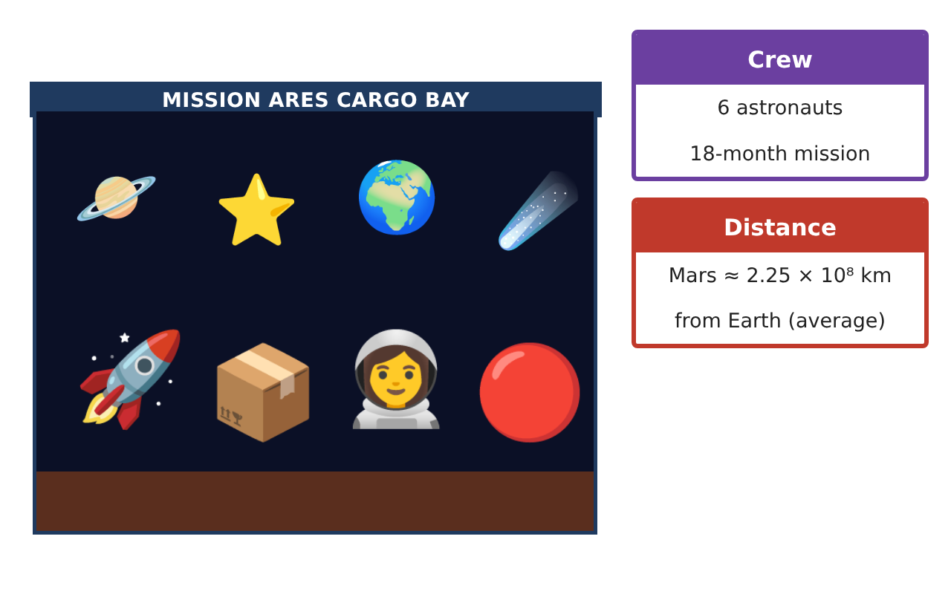
Learning Goals
- I can use prime factorization and the GCF to solve packing problems.
- I can simplify and compare fractions and identify rational numbers.
- I can use exponent rules and scientific notation.
Project Timeline
When | What you will do
Day 1 | Supply Kits
Day 2 | Cargo Fractions
Day 3 | Exponents in Space
Final | Mission Packing Manifest + reflection
Part 1: Supply Kits
Day 1 · Use the Supply Cards.
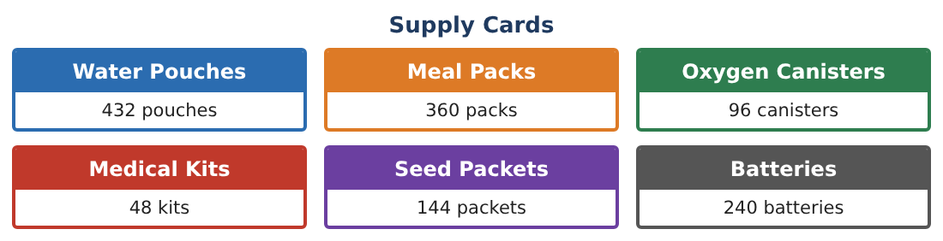
1. Write the prime factorization of 432, 360, and 144 using exponents.

2. Find the GCF of 432, 360, and 144. How many identical kits can be made with water, meals, and seeds? What is in each kit?

3. Can all six supplies go into the same identical kits? Find the GCF of all six amounts.

4. List what goes in each of the 24 kits.

Part 2: Cargo Fractions
Day 2 · The 24-section cargo bay holds the kits.
5. Each kit fills $\frac{1}{3}$ of a section. How many sections do 24 kits fill? What fraction of the bay is that?

6. Science equipment fills $\frac{5}{12}$ of the bay and spare parts fill $\frac{1}{6}$. Write the fraction of the bay that is still empty.

7. Classify each as rational or irrational: $\frac{5}{12}$, 0.333…, √2, π, √16.

8. Order $\frac{5}{12}$, 0.4, $\frac{3}{8}$, and $\frac{4}{9}$ from least to greatest.

Part 3: Exponents in Space
Day 3 · Use exponent rules and scientific notation.
9. Simplify 10⁸ × 10³ and $\frac{10⁸}{10⁵}$. Explain the rules.

10. Light travels about 3 × 10⁵ km per second. About how many seconds does a radio message take to reach Mars at 2.25 × 10⁸ km?

11. Mars has a diameter of 6.8 × 10³ km and Earth 1.27 × 10⁴ km. About how many times wider is Earth?

Final Product: Mission Packing Manifest
Your final product must include:
- Prime factorizations and GCF kit plan
- Contents of each kit
- Cargo bay fractions
- Exponent and scientific notation calculations
- Packing manifest and mission fact sheet
Reflection
R1. How does prime factorization make finding the GCF faster?

R2. Explain why $\frac{10⁸}{10⁵}$ = 10³ using repeated multiplication.

Scoring Rubric
Criteria | 4 – Exceeds | 3 – Meets | 2 – Approaching | 1 – Beginning
Mathematical Accuracy | All calculations and solutions are correct; answers include units and are checked. | Nearly all work is correct; minor errors do not change conclusions. | Several errors; some conclusions are affected. | Many errors or missing work.
Reasoning & Justification | Clear, complete explanations connect every answer to the situation; uses precise vocabulary. | Explanations are mostly clear and connected to the situation. | Explanations are brief or partly unclear. | Little or no explanation.
Application & Design | Kits, cargo fractions, and space calculations use factors, fractions, and exponents correctly. Goes beyond the minimum with a creative, realistic choice. | Kits, cargo fractions, and space calculations use factors, fractions, and exponents correctly. | Design is incomplete or only partly uses the math from the unit. | Design is missing or unrelated to the unit math.
Communication & Presentation | Manifest includes kit contents, cargo fractions, calculations, and a mission fact sheet. Polished, organized, and visually engaging. | Manifest includes kit contents, cargo fractions, calculations, and a mission fact sheet. Organized and easy to follow. | Product is missing required parts or is hard to follow. | Product is mostly missing.

