PRE-ALGEBRA (7TH) · UNIT 4: FACTORS, FRACTIONS, AND EXPONENTS  Space Mission Packer  Use factors, fractions, exponents, and scientific notation to pack a mission to Mars. | Honors  2–3 class periods

Name: ________________________________ Date: ______________ Period: ______
The Scenario
Mission control has chosen your team to pack the cargo bay for a crewed mission to Mars. Supplies must be split into identical kits, cargo space is measured in fractions of the bay, and distances in space are huge.
You will use factors, fractions, exponents, and scientific notation to pack the ship and plan the journey.
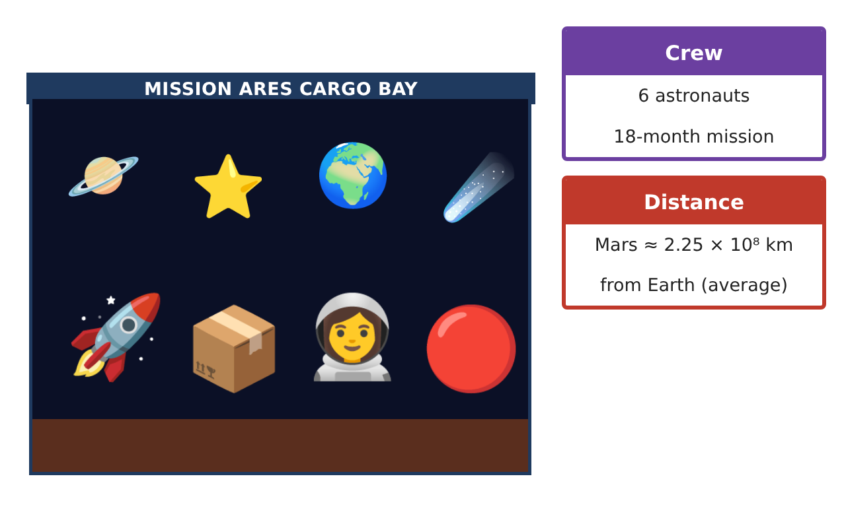
Learning Goals
- I can use prime factorization, GCF, and LCM to plan schedules and kits.
- I can compute with fractions and classify real numbers.
- I can use exponent rules, including zero and negative exponents, and scientific notation.
Project Timeline
When | What you will do
Day 1 | Kits & Schedules
Day 2 | Cargo & Real Numbers
Day 3 | Powers of Space
Final | Mission Packing Manifest + reflection
Part 1: Kits & Schedules
Day 1 · Use the Supply Cards.
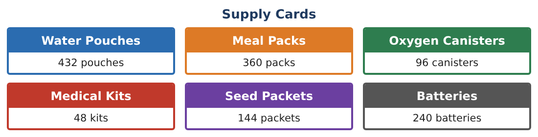
1. Find the GCF of all six supply amounts using prime factorization and list one kit.

2. Oxygen is checked every 6 days, batteries every 8 days, and seeds every 15 days. All three are checked on day 0. When are they next checked on the same day?

3. If the mission lasts 540 days, how many times are all three checked on the same day (including day 0)?

4. A second ship carries 504 water pouches. Can it use the same kits (with 18 water each)? Explain with factors.

Part 2: Cargo & Real Numbers
Day 2 · The cargo bay holds 24 sections.
5. Kits fill $\frac{1}{3}$, science $\frac{5}{12}$, and spare parts $\frac{1}{6}$ of the bay. The crew wants to add a rover that fills $\frac{3}{16}$ of the bay. Will it fit? Show your work.

6. How much would the science equipment need to shrink (as a fraction of the bay) so the rover fits?

7. Between which two whole numbers is √50? Is it rational? Use this to estimate the side of a square panel with area 50 m².

8. The radiation shield is $\frac{4}{9}$ lead. Is the decimal terminating or repeating? Explain using the prime factors of the denominator.

Part 3: Powers of Space
Day 3 · Use exponent rules and scientific notation.
9. Simplify and evaluate: $\frac{(2³)² × 2⁻⁴}{2⁰}$.

10. At the closest approach Mars is 5.46 × 10⁷ km away; at the farthest it is 4.01 × 10⁸ km. How many times farther is the farthest distance? How long does a radio signal take for each (light travels 3 × 10⁵ km/s)?

11. A dust particle has a mass of 5 × 10⁻⁷ kg. How many particles make 1 kg? Write your answer in scientific notation.

Final Product: Mission Packing Manifest
Your final product must include:
- Kit plan using prime factorization and GCF
- Check-in schedule using the LCM
- Cargo analysis with fractions and real numbers
- Exponent and scientific notation calculations
- Mission manifest with recommendations
Reflection
R1. When is the GCF the right tool and when is the LCM? Give mission examples.

R2. Why is a⁰ = 1 for any nonzero a? Use the quotient rule.

Scoring Rubric
Criteria | 4 – Exceeds | 3 – Meets | 2 – Approaching | 1 – Beginning
Mathematical Accuracy | All calculations and solutions are correct; answers include units and are checked. | Nearly all work is correct; minor errors do not change conclusions. | Several errors; some conclusions are affected. | Many errors or missing work.
Reasoning & Justification | Clear, complete explanations connect every answer to the situation; uses precise vocabulary. | Explanations are mostly clear and connected to the situation. | Explanations are brief or partly unclear. | Little or no explanation.
Application & Design | Kits, cargo fractions, and space calculations use factors, fractions, and exponents correctly. Goes beyond the minimum with a creative, realistic choice. | Kits, cargo fractions, and space calculations use factors, fractions, and exponents correctly. | Design is incomplete or only partly uses the math from the unit. | Design is missing or unrelated to the unit math.
Communication & Presentation | Manifest includes kit contents, cargo fractions, calculations, and a mission fact sheet. Polished, organized, and visually engaging. | Manifest includes kit contents, cargo fractions, calculations, and a mission fact sheet. Organized and easy to follow. | Product is missing required parts or is hard to follow. | Product is mostly missing.

