PRE-ALGEBRA (7TH) · UNIT 7: SOLVING EQUATIONS AND INEQUALITIES  Summer Job Savings  Compare summer jobs and savings plans with multi-step equations, inequalities, and interest. | CP2  2–3 class periods

Name: ________________________________ Date: ______________ Period: ______
The Scenario
You want to buy a $650 laptop by the end of the summer. You can mow lawns, babysit, or work at the snack stand at the town pool, and you can put your money in a savings account that earns interest.
You will write and solve equations and inequalities to compare jobs, reach your goal, and plan your savings.

Learning Goals
- I can write and solve two-step equations.
- I can solve two-step inequalities.
- I can use the simple interest formula.
Project Timeline
When | What you will do
Day 1 | Earn the Money
Day 2 | Reach the Goal
Day 3 | Save with Interest
Final | Summer Savings Plan + reflection
Part 1: Earn the Money
Day 1 · Use the Job Offer Cards. You have $85 saved.
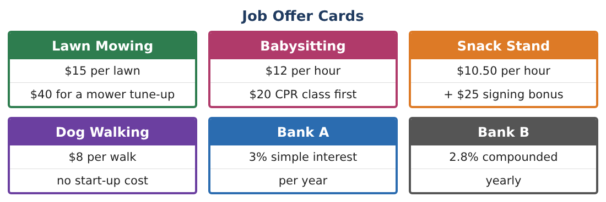
1. Mowing: write an expression for the money earned from m lawns after paying for the $40 tune-up.
Starter: 15 × ___ − 40

2. How many lawns must you mow to earn $200 after the tune-up? Solve 15m − 40 = 200.

3. Babysitting: solve 12h − 20 = 172 to find the hours needed.

4. Check your mowing answer by substituting.

Part 2: Reach the Goal
Day 2 · You need $650 and have $85.
5. Write and solve an inequality for the number of dog walks w you need: 85 + 8w ≥ 650.

6. Snack stand: 85 + 25 + 10.50h ≥ 650. Solve for h.

7. If you work 12 hours a week at the snack stand, how many weeks is that?

8. Graph the solution of w ≥ 71 on a number line.
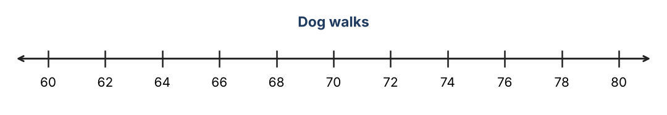

Part 3: Save with Interest
Day 3 · Simple interest: I = Prt.
9. You put $300 in Bank A at 3% for 1 year. How much interest do you earn?

10. How much is in the account after 2 years with simple interest?

11. Choose a job and write your full summer plan with an equation or inequality.

Final Product: Summer Savings Plan
Your final product must include:
- Your job choice and earnings equation
- An inequality for reaching $650
- A graph of the solution
- Interest calculation
- Savings calendar for the summer
Reflection
R1. Why do you undo addition or subtraction first when solving a two-step equation?

R2. Why do you round 70.6 walks up to 71?

Scoring Rubric
Criteria | 4 – Exceeds | 3 – Meets | 2 – Approaching | 1 – Beginning
Mathematical Accuracy | All calculations and solutions are correct; answers include units and are checked. | Nearly all work is correct; minor errors do not change conclusions. | Several errors; some conclusions are affected. | Many errors or missing work.
Reasoning & Justification | Clear, complete explanations connect every answer to the situation; uses precise vocabulary. | Explanations are mostly clear and connected to the situation. | Explanations are brief or partly unclear. | Little or no explanation.
Application & Design | Equations and inequalities model each job and goal correctly and support a realistic savings plan. Goes beyond the minimum with a creative, realistic choice. | Equations and inequalities model each job and goal correctly and support a realistic savings plan. | Design is incomplete or only partly uses the math from the unit. | Design is missing or unrelated to the unit math.
Communication & Presentation | Plan includes the job choice, solved equations and inequalities, interest comparison, and a calendar. Polished, organized, and visually engaging. | Plan includes the job choice, solved equations and inequalities, interest comparison, and a calendar. Organized and easy to follow. | Product is missing required parts or is hard to follow. | Product is mostly missing.

