PRE-ALGEBRA (7TH) · UNIT 7: SOLVING EQUATIONS AND INEQUALITIES  Summer Job Savings  Compare summer jobs and savings plans with multi-step equations, inequalities, and interest. | Honors  2–3 class periods

Name: ________________________________ Date: ______________ Period: ______
The Scenario
You want to buy a $650 laptop by the end of the summer. You can mow lawns, babysit, or work at the snack stand at the town pool, and you can put your money in a savings account that earns interest.
You will write and solve equations and inequalities to compare jobs, reach your goal, and plan your savings.

Learning Goals
- I can model and compare plans with multi-step equations and inequalities.
- I can transform formulas to answer questions.
- I can analyze simple and compound interest over time.
Project Timeline
When | What you will do
Day 1 | Job Modeling
Day 2 | Constraints
Day 3 | Growing the Money
Final | Summer Savings Plan + reflection
Part 1: Job Modeling
Day 1 · Use the Job Offer Cards.
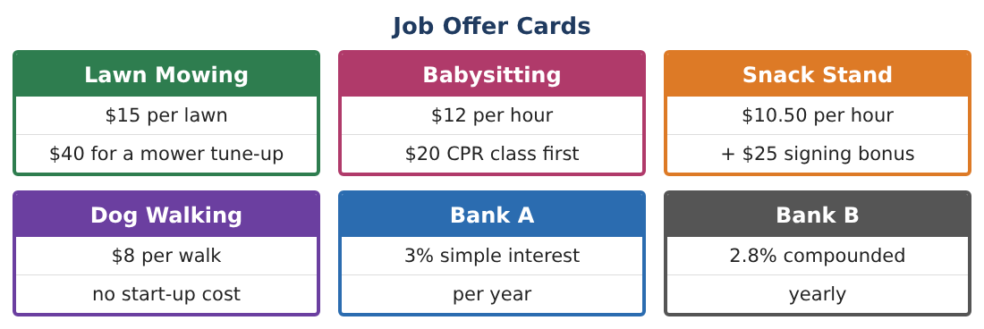
1. Write total-earnings expressions for all four jobs after start-up costs, with h hours (snack, babysitting), l lawns, or w walks. Assume one lawn takes 1.25 h and one walk takes 0.5 h. Rewrite each in terms of hours.

2. Rank the jobs by total earnings for 40 hours.

3. When does mowing earn the same as the snack stand? Solve and interpret.

4. Dog walking has the best rate, but only 20 walks per week are available. Write the most you can earn from dogs in 6 weeks and the hours used.

Part 2: Constraints
Day 2 · Goal $650, saved $85, at most 15 hours of work per week, 8 weeks of summer.
5. If you only walk dogs (max 20 walks/week), write and solve an inequality for the weeks needed.

6. You want to save $650 AND keep at least $150 spending money. Write a two-step inequality for babysitting hours and solve.

7. Is 62 hours possible within the 15-hour weekly limit over 8 weeks? How much of the limit is used?

8. Design a mixed plan (two jobs) that reaches $800 within 8 weeks and 15 h/week. Show the equation for your total.

Part 3: Growing the Money
Day 3 · A = P(1 + r)ᵗ and I = Prt.
9. Solve A = P(1 + rt) for t. How long until $650 grows to $750 at 3% simple interest?

10. Make a table for $650 in Bank A and Bank B for t = 1, 5, 10, 20 years. When does Bank B pull ahead?

11. Write a recommendation for a younger sibling about choosing a bank for long-term savings.

Final Product: Summer Savings Plan
Your final product must include:
- Job models in a common unit (hours)
- Break-even analysis
- Constraint inequalities with a mixed plan
- Interest formulas transformed and a growth table
- Summer and long-term savings recommendation
Reflection
R1. Why did rewriting every job in terms of hours make comparing them easier?

R2. Explain why the simple and compound accounts switch which is better.

Scoring Rubric
Criteria | 4 – Exceeds | 3 – Meets | 2 – Approaching | 1 – Beginning
Mathematical Accuracy | All calculations and solutions are correct; answers include units and are checked. | Nearly all work is correct; minor errors do not change conclusions. | Several errors; some conclusions are affected. | Many errors or missing work.
Reasoning & Justification | Clear, complete explanations connect every answer to the situation; uses precise vocabulary. | Explanations are mostly clear and connected to the situation. | Explanations are brief or partly unclear. | Little or no explanation.
Application & Design | Equations and inequalities model each job and goal correctly and support a realistic savings plan. Goes beyond the minimum with a creative, realistic choice. | Equations and inequalities model each job and goal correctly and support a realistic savings plan. | Design is incomplete or only partly uses the math from the unit. | Design is missing or unrelated to the unit math.
Communication & Presentation | Plan includes the job choice, solved equations and inequalities, interest comparison, and a calendar. Polished, organized, and visually engaging. | Plan includes the job choice, solved equations and inequalities, interest comparison, and a calendar. Organized and easy to follow. | Product is missing required parts or is hard to follow. | Product is mostly missing.

