PRE-ALGEBRA (7TH) · UNIT 11: RIGHT TRIANGLES IN ALGEBRA  Zip Line Engineer  Use the Pythagorean theorem, distance, and trig ratios to build a safe zip line. | CP1  2–3 class periods

Name: ________________________________ Date: ______________ Period: ______
The Scenario
Camp Pine Ridge wants a zip line from a hilltop tower to a landing platform by the lake. The cable must be long enough, the angle of descent must be safe, and the posts need support wires.
You will use right triangles to design the zip line and write a safety report for the camp director.
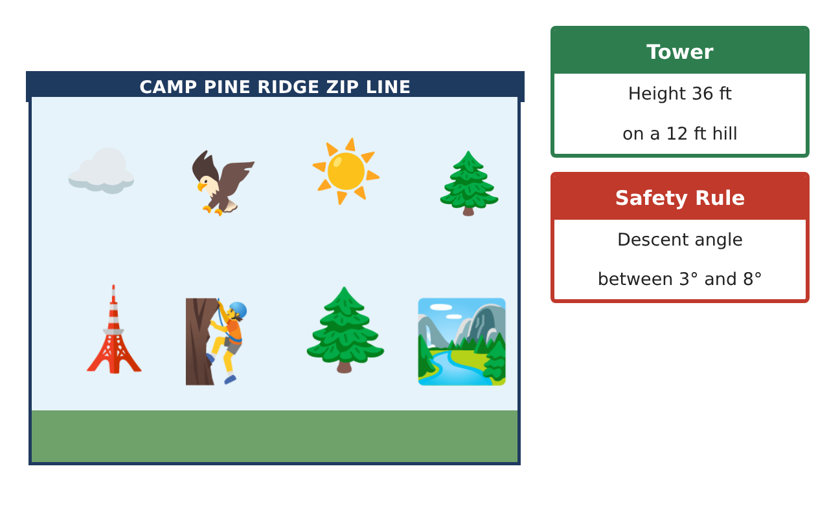
Learning Goals
- I can use the Pythagorean theorem and its converse.
- I can use the distance and midpoint formulas.
- I can use trig ratios and special right triangles to find sides and angles.
Project Timeline
When | What you will do
Day 1 | Cable Design
Day 2 | Site Map
Day 3 | Safe Angle
Final | Zip Line Engineering Report + reflection
Part 1: Cable Design
Day 1 · The tower top is 48 ft above the landing (36 ft tower on a 12 ft hill). The landing is 500 ft away horizontally.
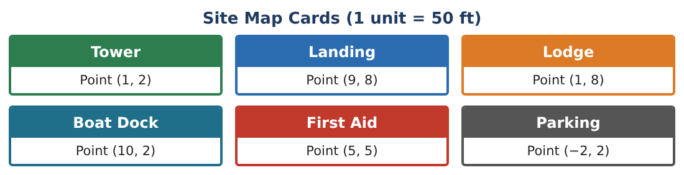
1. Find the length of the cable to the nearest foot.

2. Estimate √252,304 without a calculator using perfect squares.

3. The cable sags, so the camp buys 5% extra. How much cable should they buy?

4. A support wire makes a 45°-45°-90° triangle with a 20 ft post. How long is the wire?

Part 2: Site Map
Day 2 · Use the Site Map Cards. 1 unit = 50 ft.
5. Find the distance from Tower (1, 2) to Landing (9, 8) using the distance formula, in feet.

6. Find the midpoint of the zip line. Which station is closest to it?

7. Find the distance from Landing (9, 8) to Boat Dock (10, 2) in feet (nearest foot).

8. Is the triangle Tower–Landing–Lodge a right triangle? Use the converse.

Part 3: Safe Angle
Day 3 · Safe descent: 3° to 8°.
9. Use tangent to find the angle of descent for a 48 ft drop over 500 ft.

10. What is the greatest drop allowed over 500 ft for an 8° angle?

11. At 4 ft tall, a camper casts a 6 ft shadow while the tower casts a 54 ft shadow. Use similar triangles to find the tower height.

Final Product: Zip Line Engineering Report
Your final product must include:
- Cable length with estimation and extra
- Site map with distances and midpoint
- Special right triangle support wire
- Safe-angle calculations
- Engineering report
Reflection
R1. How does the converse of the Pythagorean theorem help engineers?

R2. Why use tangent to find the descent angle?

Scoring Rubric
Criteria | 4 – Exceeds | 3 – Meets | 2 – Approaching | 1 – Beginning
Mathematical Accuracy | All calculations and solutions are correct; answers include units and are checked. | Nearly all work is correct; minor errors do not change conclusions. | Several errors; some conclusions are affected. | Many errors or missing work.
Reasoning & Justification | Clear, complete explanations connect every answer to the situation; uses precise vocabulary. | Explanations are mostly clear and connected to the situation. | Explanations are brief or partly unclear. | Little or no explanation.
Application & Design | Lengths, distances, and angles are computed correctly and used to choose a safe design. Goes beyond the minimum with a creative, realistic choice. | Lengths, distances, and angles are computed correctly and used to choose a safe design. | Design is incomplete or only partly uses the math from the unit. | Design is missing or unrelated to the unit math.
Communication & Presentation | Engineering report includes the map, calculations, angle analysis, and a recommendation. Polished, organized, and visually engaging. | Engineering report includes the map, calculations, angle analysis, and a recommendation. Organized and easy to follow. | Product is missing required parts or is hard to follow. | Product is mostly missing.

