PRE-ALGEBRA (7TH) · UNIT 11: RIGHT TRIANGLES IN ALGEBRA  Zip Line Engineer  Use the Pythagorean theorem, distance, and trig ratios to build a safe zip line. | CP2  2–3 class periods

Name: ________________________________ Date: ______________ Period: ______
The Scenario
Camp Pine Ridge wants a zip line from a hilltop tower to a landing platform by the lake. The cable must be long enough, the angle of descent must be safe, and the posts need support wires.
You will use right triangles to design the zip line and write a safety report for the camp director.
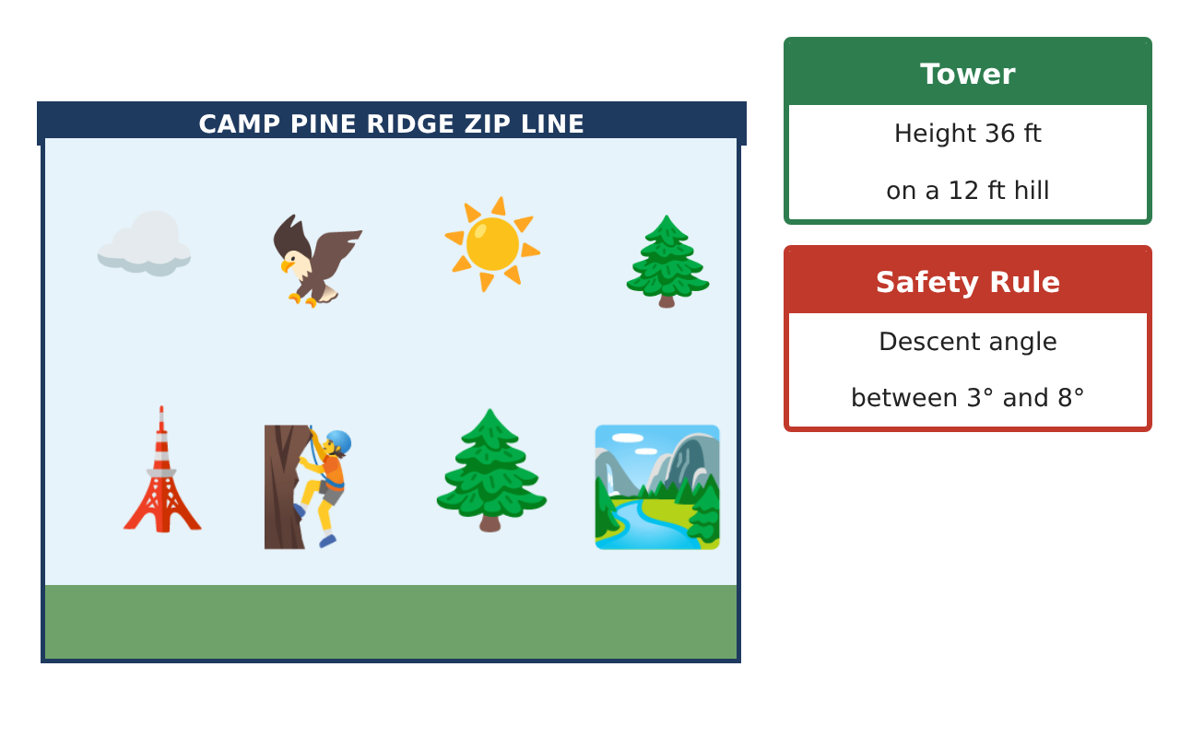
Learning Goals
- I can estimate and find square roots.
- I can use the Pythagorean theorem to find a missing side.
- I can find the distance between two points.
Project Timeline
When | What you will do
Day 1 | Square Roots
Day 2 | Cable Length
Day 3 | Site Map
Final | Zip Line Engineering Report + reflection
Part 1: Square Roots
Day 1 · Use perfect squares to estimate.
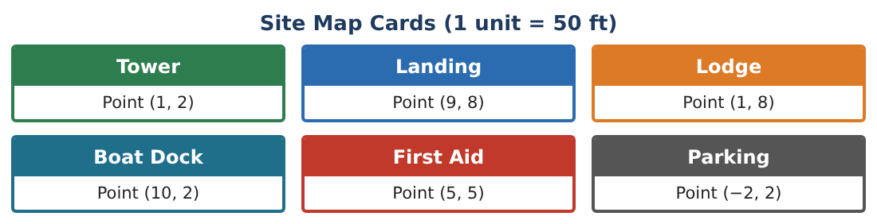
1. Find √144 and √81.

2. Between which two whole numbers is √50? Which is it closer to?

3. A square platform has area 64 sq ft. How long is each side?

4. Estimate √200 to the nearest whole number.

Part 2: Cable Length
Day 2 · The cable, the ground, and the height form a right triangle.
5. A practice zip line drops 30 ft over a ground distance of 40 ft. How long is the cable?
Starter: c² = 30² + 40² = ___

6. A support wire runs from the top of a 12 ft post to a stake 5 ft away. How long is the wire?

7. A 25 ft ladder reaches a tower 24 ft up. How far is the base of the ladder from the tower?

8. Is a triangle with sides 9, 12, and 15 a right triangle? Show your check.

Part 3: Site Map
Day 3 · Use the Site Map Cards. 1 unit = 50 ft.
9. Plot the Tower (1, 2) and Lodge (1, 8). How far apart are they in units and in feet?
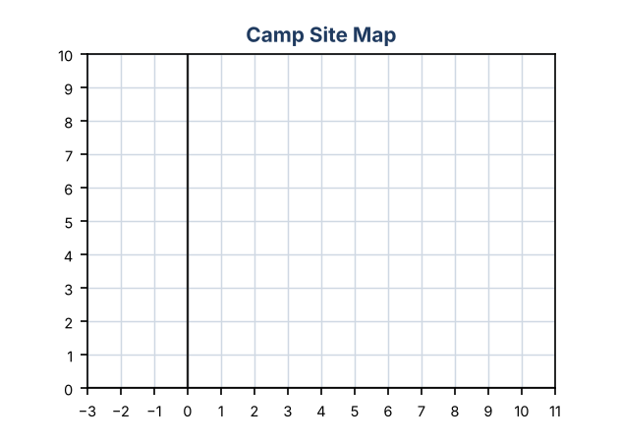

10. Use the Pythagorean theorem to find the distance from the Tower (1, 2) to the Landing (9, 8).

11. Draw your zip line on the map and write one safety rule for riders.

Final Product: Zip Line Engineering Report
Your final product must include:
- Square-root estimates
- Cable and support wire lengths
- Site map with distances
- Right-triangle check
- Safety poster
Reflection
R1. Why does the Pythagorean theorem only work for right triangles?

R2. How did the grid help you find a slanted distance?

Scoring Rubric
Criteria | 4 – Exceeds | 3 – Meets | 2 – Approaching | 1 – Beginning
Mathematical Accuracy | All calculations and solutions are correct; answers include units and are checked. | Nearly all work is correct; minor errors do not change conclusions. | Several errors; some conclusions are affected. | Many errors or missing work.
Reasoning & Justification | Clear, complete explanations connect every answer to the situation; uses precise vocabulary. | Explanations are mostly clear and connected to the situation. | Explanations are brief or partly unclear. | Little or no explanation.
Application & Design | Lengths, distances, and angles are computed correctly and used to choose a safe design. Goes beyond the minimum with a creative, realistic choice. | Lengths, distances, and angles are computed correctly and used to choose a safe design. | Design is incomplete or only partly uses the math from the unit. | Design is missing or unrelated to the unit math.
Communication & Presentation | Engineering report includes the map, calculations, angle analysis, and a recommendation. Polished, organized, and visually engaging. | Engineering report includes the map, calculations, angle analysis, and a recommendation. Organized and easy to follow. | Product is missing required parts or is hard to follow. | Product is mostly missing.

