PRE-ALGEBRA (7TH) · UNIT 11: RIGHT TRIANGLES IN ALGEBRA  Zip Line Engineer  Use the Pythagorean theorem, distance, and trig ratios to build a safe zip line. | Honors  2–3 class periods

Name: ________________________________ Date: ______________ Period: ______
The Scenario
Camp Pine Ridge wants a zip line from a hilltop tower to a landing platform by the lake. The cable must be long enough, the angle of descent must be safe, and the posts need support wires.
You will use right triangles to design the zip line and write a safety report for the camp director.
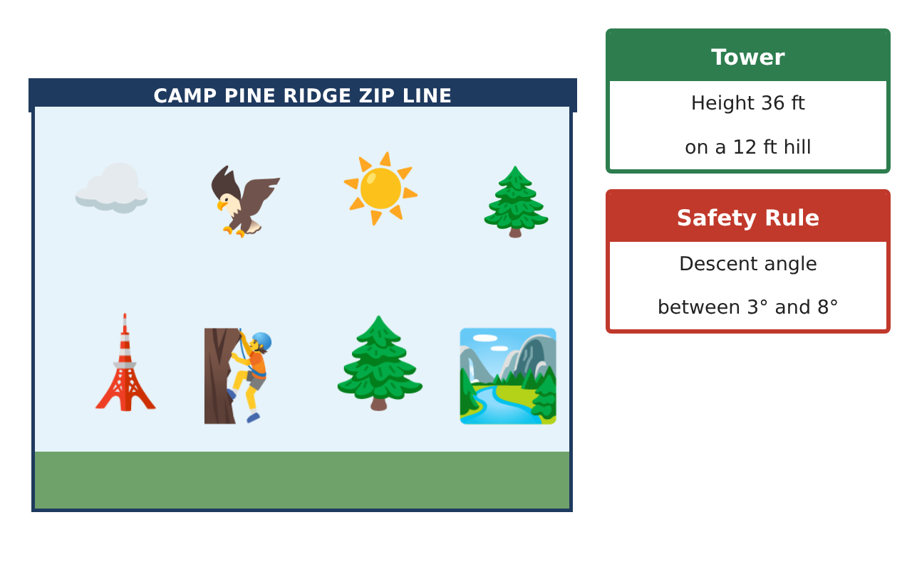
Learning Goals
- I can solve multi-step problems with the Pythagorean theorem and distance formula.
- I can use trig ratios and special right triangles to design within constraints.
- I can justify a design with mathematical reasoning.
Project Timeline
When | What you will do
Day 1 | Design Constraints
Day 2 | Support Structure
Day 3 | Map Analysis
Final | Zip Line Engineering Report + reflection
Part 1: Design Constraints
Day 1 · Safe descent 3° to 8°. Tower top is 48 ft above the landing.
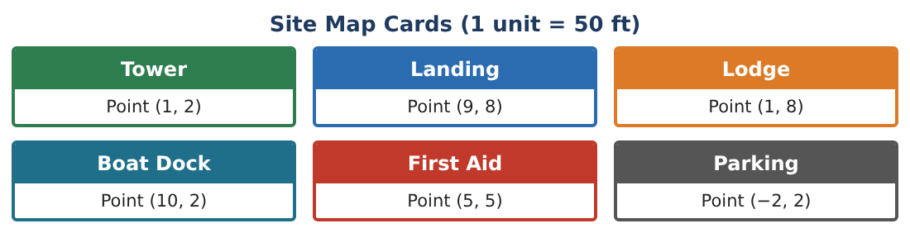
1. Find the range of horizontal distances that keep the angle safe.

2. Which possible landing points on the Site Map (1 unit = 50 ft) from the Tower (1, 2) are within that range?

3. For the Boat Dock landing, find the cable length and the descent angle.

4. Riders need at least 4 seconds of ride time at about 25 ft per second. Which landing meets this?

Part 2: Support Structure
Day 2 · Use special right triangles.
5. Two support wires run from the top of a 36 ft tower to the ground, one at 60° and one at 45° with the ground. Find each wire length and how far each stake is from the tower base.

6. What is the distance between the two stakes if they are on opposite sides of the tower?

7. A brace forms a 30°-60°-90° triangle with hypotenuse 10 ft. Find both legs exactly.

8. Prove the 45°-45°-90° ratio using the Pythagorean theorem.

Part 3: Map Analysis
Day 3 · Site Map Cards, 1 unit = 50 ft.
9. Find the perimeter of the triangle Tower–Landing–Boat Dock in feet.
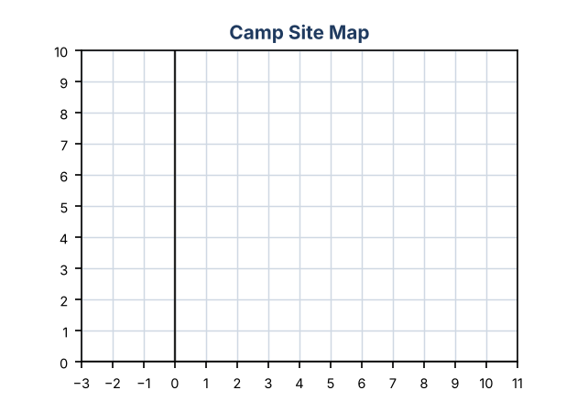

10. The first-aid station must be within 300 ft of the midpoint of any zip line built. For the Boat Dock zip line, check this.

11. Recommend Landing or Boat Dock and justify with angle, ride time, cost of cable ($8 per ft), and safety.

Final Product: Zip Line Engineering Report
Your final product must include:
- Safe distance range from tangent
- Comparison of two landing sites
- Support wires with special right triangles
- Map distances, perimeter, and midpoint
- Recommendation with justification
Reflection
R1. Why does a longer horizontal distance make a smaller descent angle?

R2. How did special right triangles let you find exact answers?

Scoring Rubric
Criteria | 4 – Exceeds | 3 – Meets | 2 – Approaching | 1 – Beginning
Mathematical Accuracy | All calculations and solutions are correct; answers include units and are checked. | Nearly all work is correct; minor errors do not change conclusions. | Several errors; some conclusions are affected. | Many errors or missing work.
Reasoning & Justification | Clear, complete explanations connect every answer to the situation; uses precise vocabulary. | Explanations are mostly clear and connected to the situation. | Explanations are brief or partly unclear. | Little or no explanation.
Application & Design | Lengths, distances, and angles are computed correctly and used to choose a safe design. Goes beyond the minimum with a creative, realistic choice. | Lengths, distances, and angles are computed correctly and used to choose a safe design. | Design is incomplete or only partly uses the math from the unit. | Design is missing or unrelated to the unit math.
Communication & Presentation | Engineering report includes the map, calculations, angle analysis, and a recommendation. Polished, organized, and visually engaging. | Engineering report includes the map, calculations, angle analysis, and a recommendation. Organized and easy to follow. | Product is missing required parts or is hard to follow. | Product is mostly missing.

