PRECALCULUS · UNIT 1: EQUATIONS AND INEQUALITIES  Concert Venue Planner  Use equations and inequalities to set ticket prices, tolerances, and capacity for a concert. | CP1  2–3 class periods

Name: ________________________________ Date: ______________ Period: ______
The Scenario
Your team is running a summer concert at Riverside Amphitheater. Ticket price affects how many people come, the sound system must stay within safe levels, and the venue has fixed costs no matter how many tickets are sold.
You will solve equations and inequalities to set the price, plan the budget, and keep the crowd safe.
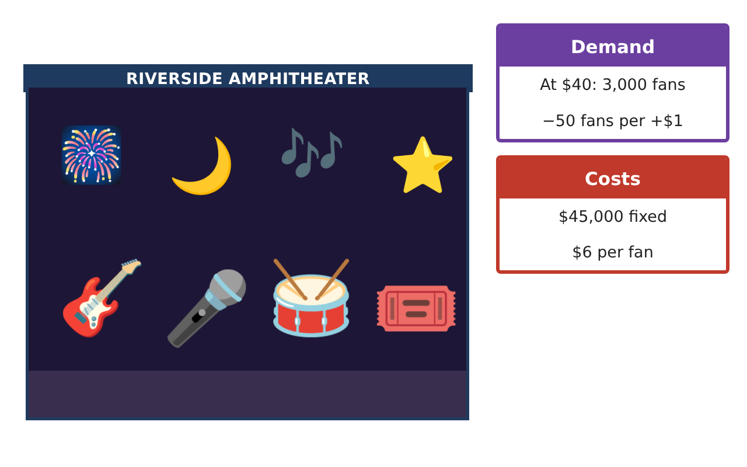
Learning Goals
- I can solve absolute value, quadratic, and polynomial equations and inequalities.
- I can solve rational inequalities and interpret restrictions.
- I can use equations to optimize a plan.
Project Timeline
When | What you will do
Day 1 | Revenue & Profit
Day 2 | Average Cost
Day 3 | Sound & Safety
Final | Venue Operations Plan + reflection
Part 1: Revenue & Profit
Day 1 · n = 5,000 − 50p and C = 45,000 + 6n.
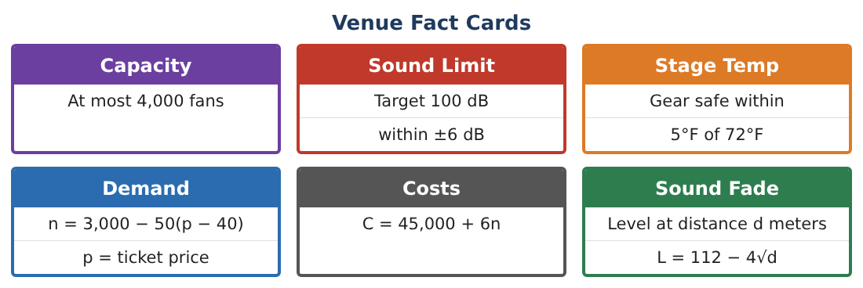
1. Write revenue R(p) and profit P(p) as polynomials.

2. Solve P(p) ≥ 0 to find the prices that make a profit.

3. Capacity is at most 4,000 fans. Write and solve the inequality for p.

4. Combine the conditions. What prices are allowed and profitable? What price maximizes profit?

Part 2: Average Cost
Day 2 · The average cost per fan is A(n) = $\frac{45,000 + 6n}{n}$.
5. Find A(1,000) and A(3,000).

6. Solve A(n) ≤ 20 to find how many fans keep the average cost at most $20.

7. Why must n > 0 in this inequality? What happens to A(n) as n gets large?

8. Solve |L − 100| ≤ 6 and |T − 72| < 5. Explain the difference in the endpoints.

Part 3: Sound & Safety
Day 3 · The sound level near a speaker: a fan at distance d meters hears L = 112 − 4√d (simplified model).
9. Solve 112 − 4√d = 100 to find where the level is 100 dB.

10. Solve 112 − 4√d ≤ 94 to find where it is quiet enough for families.

11. Write your venue plan: price, expected fans, profit, and the family seating distance.

Final Product: Venue Operations Plan
Your final product must include:
- Profit model and profitable price interval
- Capacity and optimal price
- Average-cost inequality
- Sound-distance radical equation
- Venue operations plan
Reflection
R1. Why must you check the solutions of a radical equation?

R2. How do rational inequalities differ from polynomial inequalities?

Scoring Rubric
Criteria | 4 – Exceeds | 3 – Meets | 2 – Approaching | 1 – Beginning
Mathematical Accuracy | All calculations and solutions are correct; answers include units and are checked. | Nearly all work is correct; minor errors do not change conclusions. | Several errors; some conclusions are affected. | Many errors or missing work.
Reasoning & Justification | Clear, complete explanations connect every answer to the situation; uses precise vocabulary. | Explanations are mostly clear and connected to the situation. | Explanations are brief or partly unclear. | Little or no explanation.
Application & Design | Equations and inequalities model price, cost, safety, and sound correctly and support the plan. Goes beyond the minimum with a creative, realistic choice. | Equations and inequalities model price, cost, safety, and sound correctly and support the plan. | Design is incomplete or only partly uses the math from the unit. | Design is missing or unrelated to the unit math.
Communication & Presentation | Plan includes models, solution sets, a recommended price, and seating zones. Polished, organized, and visually engaging. | Plan includes models, solution sets, a recommended price, and seating zones. Organized and easy to follow. | Product is missing required parts or is hard to follow. | Product is mostly missing.

