PRECALCULUS · UNIT 4: TRIGONOMETRIC FUNCTIONS  Daylight and Seasons  Model hours of daylight and temperatures with sinusoidal functions. | CP1  2–3 class periods

Name: ________________________________ Date: ______________ Period: ______
The Scenario
The parks department wants to schedule outdoor events when there is plenty of daylight and comfortable weather. Daylight and temperature rise and fall every year in a repeating pattern.
You will use the unit circle and sinusoidal functions to model the seasons and recommend event dates.
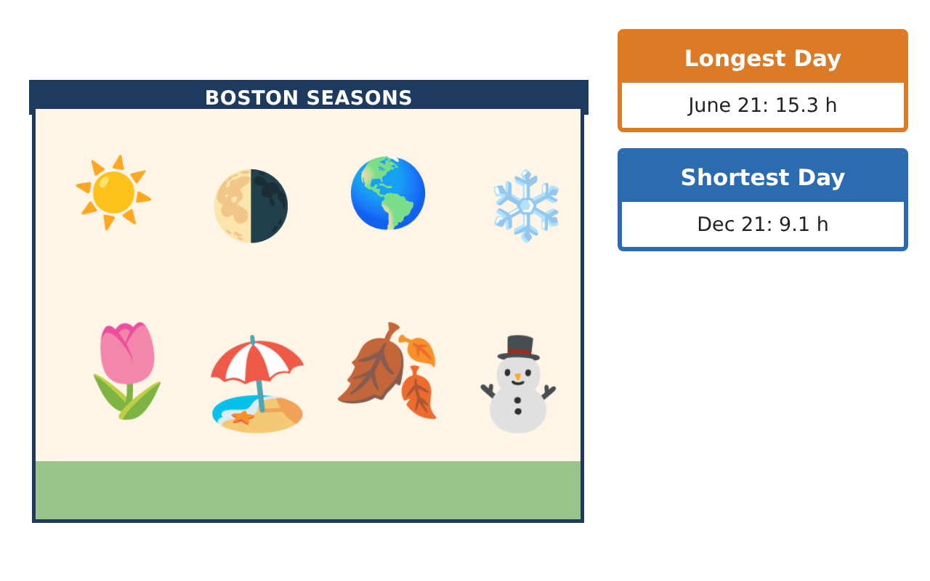
Learning Goals
- I can use radians and the unit circle to evaluate trig functions.
- I can build sinusoidal models with amplitude, period, phase shift, and midline.
- I can solve trigonometric equations in context.
Project Timeline
When | What you will do
Day 1 | Unit Circle
Day 2 | Build the Models
Day 3 | Solve for Dates
Final | Seasonal Planning Report + reflection
Part 1: Unit Circle
Day 1 · Use radians.
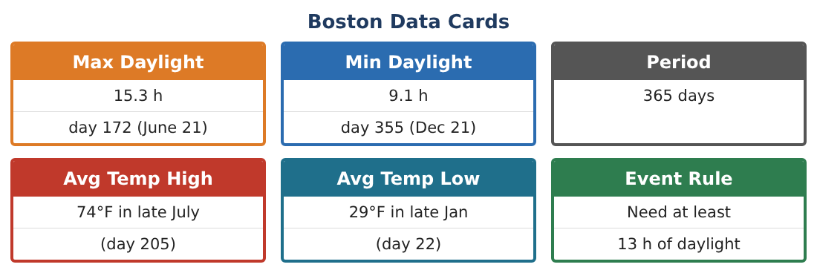
1. Through what angle in radians does Earth travel in 73 days?

2. Find the exact values of sin $\frac{2π}{3}$, cos $\frac{7π}{6}$, and tan $\frac{5π}{4}$.

3. A point on Earth’s orbit (radius 1 AU) is at angle $\frac{5π}{3}$. Find its coordinates.

4. Explain why sin θ = sin(π − θ) using the unit circle.

Part 2: Build the Models
Day 2 · Use the Boston Data Cards.
5. Write a cosine model for daylight with its maximum on day 172.

6. Write a cosine model for average high temperature (max 74°F on day 205, min 29°F).

7. Find D(100) and T(100).

8. Why do the daylight and temperature models have different phase shifts?

Part 3: Solve for Dates
Day 3 · Need at least 13 h of daylight and a temperature of at least 60°F.
9. Solve D(t) = 13 for the two days in the year.

10. Solve T(t) = 60 for the two days.

11. Find the event window where both conditions hold, and give it as calendar dates.

Final Product: Seasonal Planning Report
Your final product must include:
- Unit-circle work
- Daylight and temperature models
- Predictions
- Solutions of trig equations
- Event window recommendation
Reflection
R1. How did you find the phase shift from the data?

R2. Why does a trig equation have two solutions in a year?

Scoring Rubric
Criteria | 4 – Exceeds | 3 – Meets | 2 – Approaching | 1 – Beginning
Mathematical Accuracy | All calculations and solutions are correct; answers include units and are checked. | Nearly all work is correct; minor errors do not change conclusions. | Several errors; some conclusions are affected. | Many errors or missing work.
Reasoning & Justification | Clear, complete explanations connect every answer to the situation; uses precise vocabulary. | Explanations are mostly clear and connected to the situation. | Explanations are brief or partly unclear. | Little or no explanation.
Application & Design | Sinusoidal models are built from data and used correctly to predict and solve for event dates. Goes beyond the minimum with a creative, realistic choice. | Sinusoidal models are built from data and used correctly to predict and solve for event dates. | Design is incomplete or only partly uses the math from the unit. | Design is missing or unrelated to the unit math.
Communication & Presentation | Report includes models, graphs, solutions, and a clear recommendation. Polished, organized, and visually engaging. | Report includes models, graphs, solutions, and a clear recommendation. Organized and easy to follow. | Product is missing required parts or is hard to follow. | Product is mostly missing.

