PRECALCULUS · UNIT 7: VECTORS  Flight Path Navigator  Use vectors to fly a small plane through wind, find ground speed, and plan a delivery route. | CP1  2–3 class periods

Name: ________________________________ Date: ______________ Period: ______
The Scenario
You are the flight planner for Coastal Air Delivery. Small planes fly between islands, and the wind pushes them off course. Pilots need to know which way to point the plane and how long each leg will take.
You will use vectors to plan safe, efficient flights.
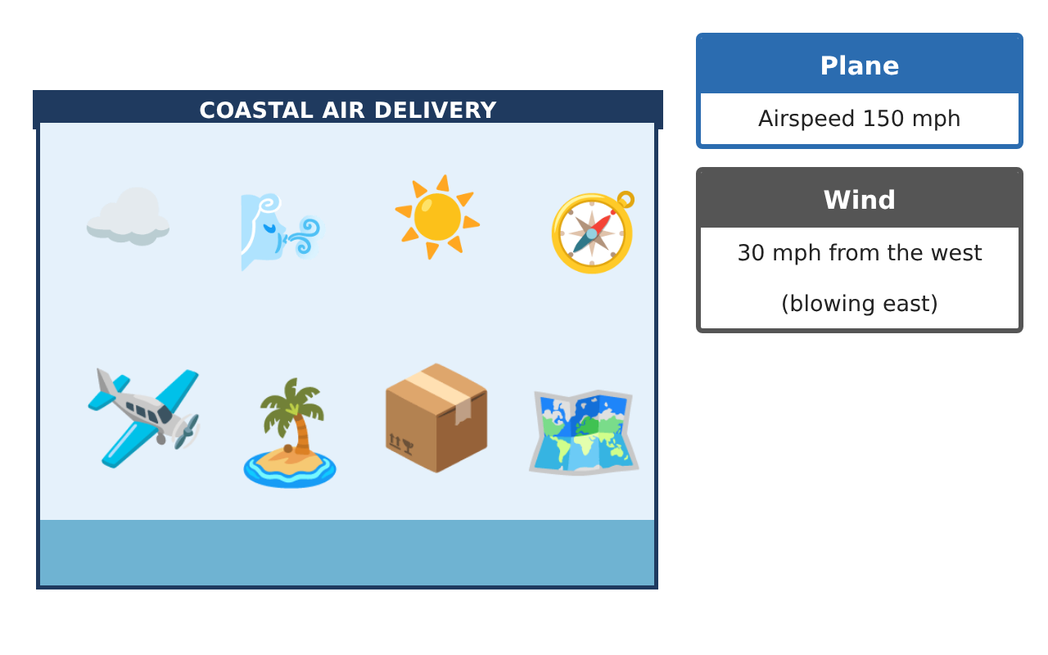
Learning Goals
- I can add and scale vectors and find magnitude and direction.
- I can find the heading that corrects for wind.
- I can use the dot product to find angles and work.
Project Timeline
When | What you will do
Day 1 | Route Vectors
Day 2 | Wind Correction
Day 3 | Cargo & Work
Final | Flight Plan + reflection
Part 1: Route Vectors
Day 1 · Use the Flight Data Cards.
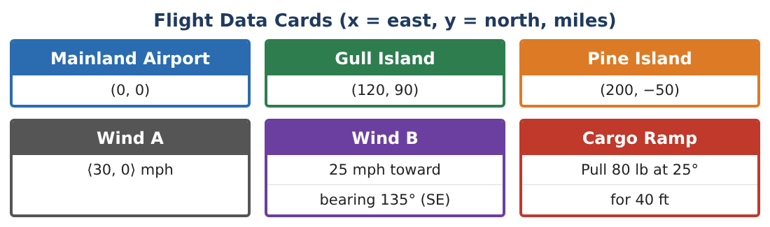
1. Find the vectors and distances for Mainland → Gull → Pine → Mainland.

2. Show that the three vectors add to the zero vector. Why?

3. Find the bearing (clockwise from north) from Mainland to Gull Island.

4. Find the angle at Gull Island between the incoming and outgoing legs using the dot product.

Part 2: Wind Correction
Day 2 · Airspeed 150 mph; wind ⟨30, 0⟩. Fly from Mainland to Gull Island.
5. If the pilot aims straight at Gull Island, what is the ground velocity and where does the plane actually go?

6. Find the heading so the ground track points at Gull Island. (Let the air velocity be 150⟨cos θ, sin θ⟩.)

7. Find the ground speed with that heading and the flight time.

8. Explain why the corrected heading points into the wind.

Part 3: Cargo & Work
Day 3 · Use the dot product: W = F · d.
9. A worker pulls a cart with 80 lb of force at 25° above the ramp for 40 ft. Find the work.

10. Are ⟨3, 4⟩ and ⟨−8, 6⟩ perpendicular? Use the dot product.

11. Write your flight plan for the full route with headings, ground speeds, and times.

Final Product: Flight Plan
Your final product must include:
- Route vectors and closure
- Bearings and angles via dot product
- Wind-corrected heading and time
- Work calculation
- Flight plan
Reflection
R1. How does the dot product reveal the angle between two vectors?

R2. What is the difference between heading and course?

Scoring Rubric
Criteria | 4 – Exceeds | 3 – Meets | 2 – Approaching | 1 – Beginning
Mathematical Accuracy | All calculations and solutions are correct; answers include units and are checked. | Nearly all work is correct; minor errors do not change conclusions. | Several errors; some conclusions are affected. | Many errors or missing work.
Reasoning & Justification | Clear, complete explanations connect every answer to the situation; uses precise vocabulary. | Explanations are mostly clear and connected to the situation. | Explanations are brief or partly unclear. | Little or no explanation.
Application & Design | Vectors, resultants, headings, and dot products are computed correctly and produce a workable flight plan. Goes beyond the minimum with a creative, realistic choice. | Vectors, resultants, headings, and dot products are computed correctly and produce a workable flight plan. | Design is incomplete or only partly uses the math from the unit. | Design is missing or unrelated to the unit math.
Communication & Presentation | Flight plan includes diagrams, components, headings, speeds, and times. Polished, organized, and visually engaging. | Flight plan includes diagrams, components, headings, speeds, and times. Organized and easy to follow. | Product is missing required parts or is hard to follow. | Product is mostly missing.

