PRECALCULUS · UNIT 7: VECTORS  Flight Path Navigator  Use vectors to fly a small plane through wind, find ground speed, and plan a delivery route. | CP2  2–3 class periods

Name: ________________________________ Date: ______________ Period: ______
The Scenario
You are the flight planner for Coastal Air Delivery. Small planes fly between islands, and the wind pushes them off course. Pilots need to know which way to point the plane and how long each leg will take.
You will use vectors to plan safe, efficient flights.
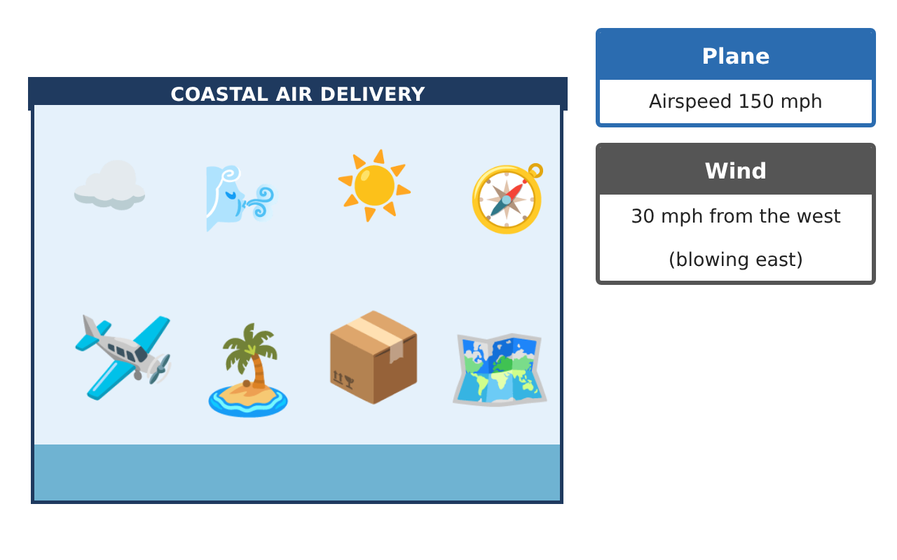
Learning Goals
- I can write vectors in component form and find magnitude and direction.
- I can add vectors to find a resultant.
- I can interpret ground speed and course.
Project Timeline
When | What you will do
Day 1 | Vectors on the Map
Day 2 | Wind
Day 3 | Plan a Flight
Final | Flight Plan + reflection
Part 1: Vectors on the Map
Day 1 · Use the Flight Data Cards.
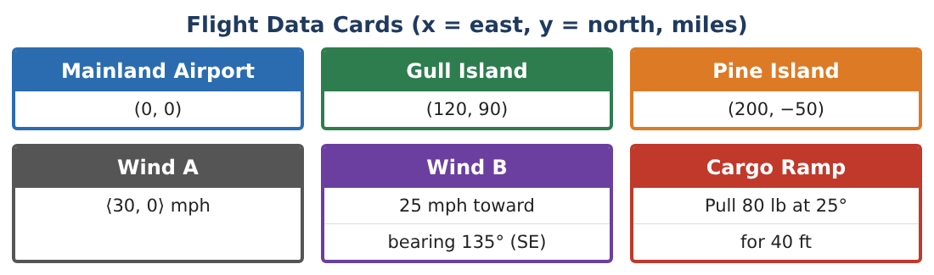
1. Write the vector from the Mainland Airport to Gull Island in component form.
Starter: ⟨x₂ − x₁, y₂ − y₁⟩

2. Find its magnitude (the distance in miles).

3. Find its direction angle from east.

4. Write the vector from Gull Island to Pine Island.

Part 2: Wind
Day 2 · The plane flies due north at 150 mph. The wind is ⟨30, 0⟩.
5. Write the plane’s air velocity as a vector.

6. Add the wind vector to find the ground velocity.

7. Find the ground speed.

8. By how many degrees does the wind push the plane off course?

Part 3: Plan a Flight
Day 3 · Use scalar multiplication.
9. If the ground velocity is ⟨30, 150⟩ mph, where is the plane after 2 hours?

10. Find a unit vector in the direction of Gull Island.

11. Draw a vector diagram of one flight and label the air velocity, wind, and ground velocity.

Final Product: Flight Plan
Your final product must include:
- Map vectors with magnitudes and directions
- Wind resultant and ground speed
- Position after a flight
- Labeled vector diagram
- Flight plan
Reflection
R1. What does the resultant vector represent for the plane?

R2. Why can the ground speed be faster than the airspeed?

Scoring Rubric
Criteria | 4 – Exceeds | 3 – Meets | 2 – Approaching | 1 – Beginning
Mathematical Accuracy | All calculations and solutions are correct; answers include units and are checked. | Nearly all work is correct; minor errors do not change conclusions. | Several errors; some conclusions are affected. | Many errors or missing work.
Reasoning & Justification | Clear, complete explanations connect every answer to the situation; uses precise vocabulary. | Explanations are mostly clear and connected to the situation. | Explanations are brief or partly unclear. | Little or no explanation.
Application & Design | Vectors, resultants, headings, and dot products are computed correctly and produce a workable flight plan. Goes beyond the minimum with a creative, realistic choice. | Vectors, resultants, headings, and dot products are computed correctly and produce a workable flight plan. | Design is incomplete or only partly uses the math from the unit. | Design is missing or unrelated to the unit math.
Communication & Presentation | Flight plan includes diagrams, components, headings, speeds, and times. Polished, organized, and visually engaging. | Flight plan includes diagrams, components, headings, speeds, and times. Organized and easy to follow. | Product is missing required parts or is hard to follow. | Product is mostly missing.

