PRECALCULUS · UNIT 7: VECTORS  Flight Path Navigator  Use vectors to fly a small plane through wind, find ground speed, and plan a delivery route. | Honors  2–3 class periods

Name: ________________________________ Date: ______________ Period: ______
The Scenario
You are the flight planner for Coastal Air Delivery. Small planes fly between islands, and the wind pushes them off course. Pilots need to know which way to point the plane and how long each leg will take.
You will use vectors to plan safe, efficient flights.
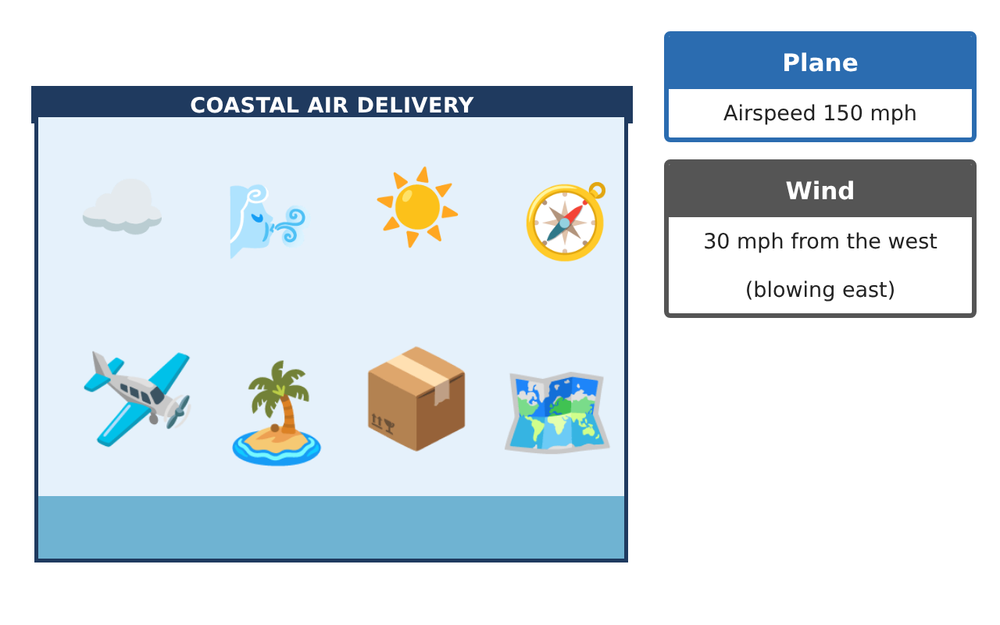
Learning Goals
- I can model navigation problems with vectors.
- I can solve for a heading algebraically and verify it.
- I can use projections and the dot product in physical contexts.
Project Timeline
When | What you will do
Day 1 | Wind Correction
Day 2 | Projections
Day 3 | Route Optimization
Final | Flight Plan + reflection
Part 1: Wind Correction
Day 1 · Airspeed 150 mph. Wind B: 25 mph toward bearing 135°.
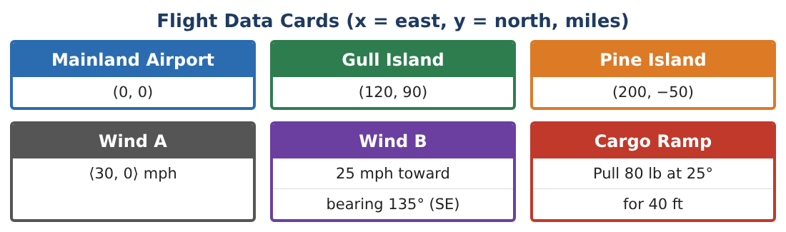
1. Write Wind B in component form.

2. Find the heading needed to fly from Gull Island to Pine Island (direction ⟨80, −140⟩) in Wind B.

3. Find the ground speed and time for the leg.

4. Verify your heading by adding vectors.

Part 2: Projections
Day 2 · Use proj_v u = ($\frac{u · v}{v · v}$)v.
5. Find the component of Wind A ⟨30, 0⟩ along the route to Gull Island ⟨120, 90⟩. Is it a tailwind?

6. Find the crosswind component (perpendicular part).

7. A 600-lb crate sits on a 15° ramp. Find the component of its weight that pulls it down the ramp.

8. How much force parallel to the ramp is needed to pull the crate 40 ft up the ramp, and how much work is done?

Part 3: Route Optimization
Day 3 · Mainland (0, 0), Gull (120, 90), Pine (200, −50).
9. Compare the total distance of Mainland → Gull → Pine → Mainland with Mainland → Pine → Gull → Mainland.

10. With Wind A ⟨30, 0⟩, which direction around the triangle takes less total time? For each leg, use ground speed ≈ √(150² − crosswind²) + tailwind.

11. Write the final flight plan with headings, ground speeds, times, and a vector diagram.

Final Product: Flight Plan
Your final product must include:
- Wind vectors in components
- Corrected heading with verification
- Tailwind and crosswind projections
- Ramp force and work
- Optimized flight plan
Reflection
R1. Why does splitting the wind into along-track and crosswind parts simplify navigation?

R2. How is the work done related to projection?

Scoring Rubric
Criteria | 4 – Exceeds | 3 – Meets | 2 – Approaching | 1 – Beginning
Mathematical Accuracy | All calculations and solutions are correct; answers include units and are checked. | Nearly all work is correct; minor errors do not change conclusions. | Several errors; some conclusions are affected. | Many errors or missing work.
Reasoning & Justification | Clear, complete explanations connect every answer to the situation; uses precise vocabulary. | Explanations are mostly clear and connected to the situation. | Explanations are brief or partly unclear. | Little or no explanation.
Application & Design | Vectors, resultants, headings, and dot products are computed correctly and produce a workable flight plan. Goes beyond the minimum with a creative, realistic choice. | Vectors, resultants, headings, and dot products are computed correctly and produce a workable flight plan. | Design is incomplete or only partly uses the math from the unit. | Design is missing or unrelated to the unit math.
Communication & Presentation | Flight plan includes diagrams, components, headings, speeds, and times. Polished, organized, and visually engaging. | Flight plan includes diagrams, components, headings, speeds, and times. Organized and easy to follow. | Product is missing required parts or is hard to follow. | Product is mostly missing.

