PRECALCULUS · UNIT 3: CONICS  Science Museum Conics  Design a science museum exhibit with a parabolic dish, an elliptical whispering gallery, and a hyperbolic tower. | CP1  2–3 class periods

Name: ________________________________ Date: ______________ Period: ______
The Scenario
The city science museum is adding a "Shapes of Science" wing. Each exhibit is built around a conic section: a round planetarium, a parabolic dish, an elliptical whispering room, and a hyperbolic cooling tower model.
You will write the equations, locate the foci, and make the measurements the builders need.
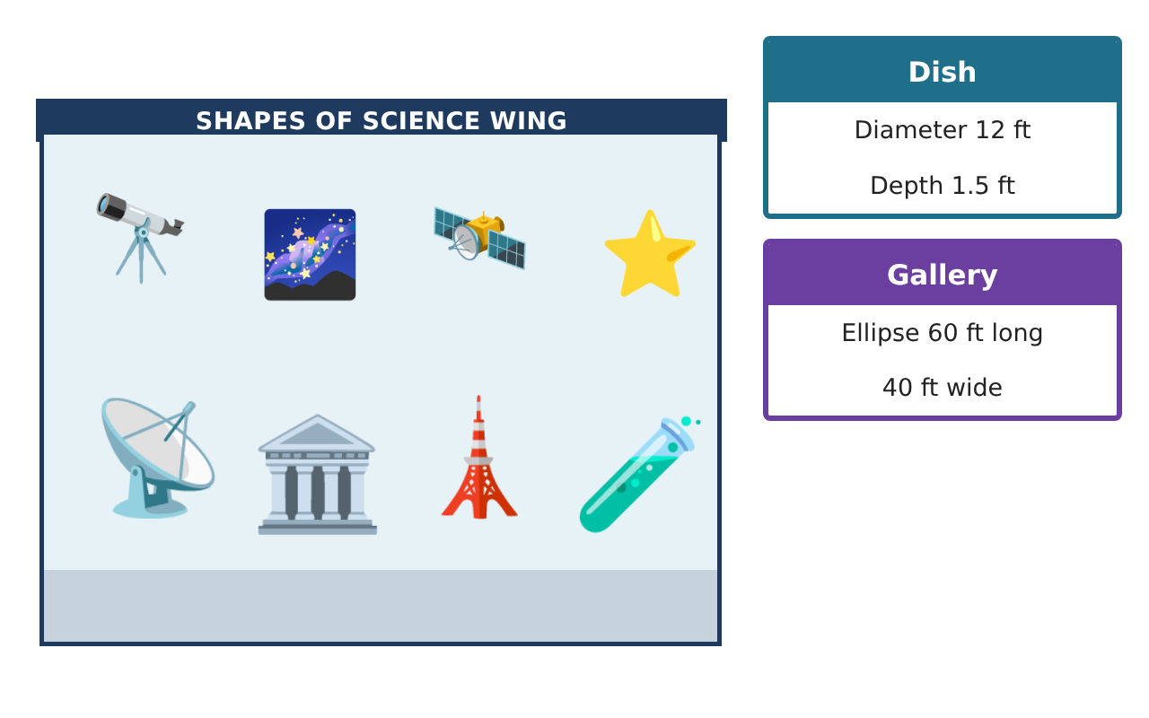
Learning Goals
- I can write equations of circles and parabolas from given information.
- I can find foci of ellipses and hyperbolas.
- I can apply conics to design problems.
Project Timeline
When | What you will do
Day 1 | Circle & Parabola
Day 2 | Whispering Gallery
Day 3 | Hyperbolas
Final | Exhibit Design Packet + reflection
Part 1: Circle & Parabola
Day 1 · Use the Specification Cards.
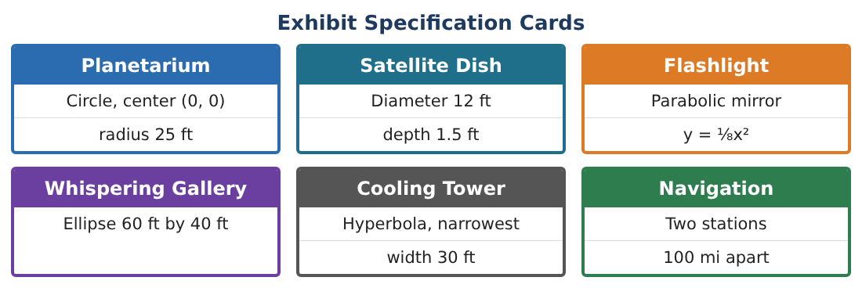
1. Rewrite x² + y² − 6x + 4y − 612 = 0 in standard form. Is it the planetarium?

2. The satellite dish is 12 ft across and 1.5 ft deep. Find the focal length.

3. How far from the vertex must the receiver be for a dish 10 ft across and 1 ft deep?

4. Write the equation of the flashlight mirror with focus (0, 3) and vertex (0, 0). Find its width at the focus.

Part 2: Whispering Gallery
Day 2 · The room is an ellipse 60 ft long and 40 ft wide.
5. Write the equation of the ellipse centered at the origin.

6. Find the foci. Where should two visitors stand to hear whispers?

7. Find the eccentricity. Is the room nearly circular?

8. How far does a whisper travel from one focus to the wall and to the other focus?

Part 3: Hyperbolas
Day 3 · Use the Specification Cards.
9. The cooling tower cross-section is $\frac{x²}{225}$ − $\frac{y²}{400}$ = 1. Find the narrowest width and the asymptotes.

10. Two navigation stations are 100 mi apart at (±50, 0). A ship is 60 mi closer to one than the other. Write the hyperbola.

11. Design one more exhibit with a conic. Write its equation and locate its focus or foci.

Final Product: Exhibit Design Packet
Your final product must include:
- Circle in standard form
- Dish and flashlight focal lengths
- Ellipse gallery with foci and eccentricity
- Hyperbola tower and navigation
- Exhibit packet
Reflection
R1. Explain the reflective property of the ellipse in the gallery.

R2. How are a, b, and c related differently in ellipses and hyperbolas?

Scoring Rubric
Criteria | 4 – Exceeds | 3 – Meets | 2 – Approaching | 1 – Beginning
Mathematical Accuracy | All calculations and solutions are correct; answers include units and are checked. | Nearly all work is correct; minor errors do not change conclusions. | Several errors; some conclusions are affected. | Many errors or missing work.
Reasoning & Justification | Clear, complete explanations connect every answer to the situation; uses precise vocabulary. | Explanations are mostly clear and connected to the situation. | Explanations are brief or partly unclear. | Little or no explanation.
Application & Design | Conic equations, foci, and measurements are correct and used to design working exhibits. Goes beyond the minimum with a creative, realistic choice. | Conic equations, foci, and measurements are correct and used to design working exhibits. | Design is incomplete or only partly uses the math from the unit. | Design is missing or unrelated to the unit math.
Communication & Presentation | Exhibit packet includes equations, labeled sketches, and builder measurements. Polished, organized, and visually engaging. | Exhibit packet includes equations, labeled sketches, and builder measurements. Organized and easy to follow. | Product is missing required parts or is hard to follow. | Product is mostly missing.

